 

GROUP ASSIGNMENT

**LEVEL 5**

**COMP50001: Commercial Computing Group assignment**

**Batch code Group Number : 06 Group members :**

* Mohamed ithhaf mohamed dhanish (CB009562)
* Pasindu lankanath pinidiya bandara (CB009454)
* Pooja selvaraj (CB010098)
* Arachchi appuhamillage done dulangi karunasekara (CB010550)

Table of Contents

Introduction 15

Technologies used. 16

GitHub Link 16

Figma 17

Primary students figma design 17

Lower secondary students figma design 18

Upper secondary students figma design 20

Teacher figma design 20

Admin figma design 24

Interface images 26

Admin side 27

Teacher’s side 35

35

36

36

37

38

39

Primary student’s side 40

40

40

Upper secondary students 41

41

General student features 41

41

42

42

User roles. 42

Use cases. 42

Student 42

Teacher 43

Administrator 43

Project management 43

Features implemented. 45

Creating, edit and deleting student users. 45

Creating , editing and deleting teachers 45

Students can view timetables 45

Students can view the activities created by their class teacher. 45

Students can upload submissions 45

Teachers can view submissions per activity 46

Event management 46

Attendance marking 46

Students can view attendance 46

Project charter 46

Goals 46

Project Scope: 47

Key stake holders: 48

Milestones 49

Limitations: 49

Work breakdown structure 49

Sprint 1 51

Work breakdown structure 51

Sprint goals. 54

Project management Sprint 1 55

Gantt chart 59

Functions carried out in Sprint 1 60

With the completion of the above tasks, we have successfully completed our sprint 1's goals. Below is a repetition of our sprint 1 goals and an assurance of whether they were completed or not. 61

High level use case diagrams sprint 1 62

Use case specifications sprint 1 69

Login for primary students 69

Login for lower secondary students 70

Login for upper secondary students 70

View timetable for primary students 71

Login for teachers 72

Login for administrators 73

Register students. 74

Register teachers. 75

Register administrator. 76

Edit student details. 77

Delete student. 78

Edit teacher details. 79

Delete teacher. 80

Edit administrator details. 80

Delete administrators. 81

Add a new event to the event calendar. 82

Edit calendar event details. 83

Delete calendar event. 84

Activity diagrams Sprint 1. 86

Login for primary students 86

Login for lower secondary students 87

Login for upper secondary (Collegiate) students 88

Login for teachers 89

Login for administrators 90

Student registration by administrators 91

Teacher registration by administrators 92

Admin registration by administrators 93

View timetable feature for primary students 94

Edit student details. 95

Delete student. 96

Edit teacher details. 97

Delete teacher. 98

Edit admin details. 99

Delete admin. 100

Create calendar event. 101

Edit calendar event. 102

Delete calendar event. 103

Sequence diagrams 104

Login function 104

Time management sprint 1. 106

AOA diagram Sprint 1 108

AON diagram 109

Implementations Sprint 1. 110

VS code folder structure 110

Mongo db connection 111

Login function with multiuser authentication 112

User management 115

Event management 118

Timetable feature for primary students 123

Work Breakdown Structure sprint 2. 141

Sprint goals sprint 2. 143

Gantt Chart sprint 2. 144

Use case diagrams sprint 2. 145

Create subject. 149

Edit subject. 150

Delete subject. 151

Teacher’s function to create an activity. 152

Activity diagrams sprint 2 160

Time management Sprint 2 168

AOA Diagram Sprint 2 169

AON Diagram Sprint 2 170

Communication plan Sprint 2 171

Code images sprint 2 173

Submission file download 173

Create activity. 174

Edit activity. 175

Add submissions. 176

Create subject. 177

Edit subject. 177

Delete subject. 178

Product backlog sprint 2 179

Project management sprint 2 180

Test Logs Sprint 2 183

Create, edit and delete subjects. 185

Create quiz 186

Add classes and subjects to students 186

Create activity 187

edit and delete activity. 187

Add submissions. 188

Download and Delete submission. 188

Cost management sprint 2 189

Sprint retrospective Sprint 2 193

Work Breakdown Structure Sprint 3 195

Sprint goals sprint 3 198

Communication Plan sprint 3 199

Code Images sprint 3 200

Show chosen subjects for each upper secondary student. 201

Analytics for the LMS 202

Attendance view for each subject for each Upper secondary student 202

Product backlog sprint 3 204

Project Management sprint 3 205

Test Cases sprint 3 207

Selenium Testing sprint 4 209

Teacher mark attendance 209

Cost Management sprint 3 211

Sprint Retrospective sprint 3 214

What we achieved 214

Further accomplishments 214

What we can improve 214

Overall system testing 216

Selenium testing 222

Register student 222

Register teacher 223

Register admin 224

Create event 225

Edit student 226

Edit teacher 227

Edit administrator 227

Add a submission 228

Add grades and feedback 228

Attendance Marking 229

229

230

Conclusion 231

Figure 1 Primary students figma design 13

Figure 2 Lower secondary students figma design part 1 14

Figure 3 Lower secondary students figma design part 2 15

Figure 4 Upper secondary students figma design 16

Figure 5 teacher figma design part 1 17

Figure 6 teacher figma design part 2 18

Figure 7 teacher figma design part 3 19

Figure 8 admin figma design part 1 20

Figure 9 admin figma design part 2 20

Figure 10 admin figma design part 3 21

Figure 11 admin figma design part 4 22

Figure 12 admin figma design part 5 22

Figure 13 admin dashboard 23

Figure 14 view student users by admin 24

Figure 15 view teachers by admin 25

Figure 16 view admins by admin 25

Figure 17 view subjects by admin 26

Figure 18 register student by admin 26

Figure 19 register a teacher by admin 27

Figure 20 register an administrator by admin 27

Figure 21 create subject by admin 28

Figure 22 edit student details by admin 29

Figure 23 edit teacher details by admin 29

Figure 24 edit admin details by admin 30

Figure 25 edit subject details by admin 30

Figure 26 admin analytics dashboard 31

Figure 27 teacher dashboard 31

Figure 28 view activities created by teacher 32

Figure 29 create activity 32

Figure 30 edit activity 33

Figure 31 view submissions per activity 34

Figure 32 view chosen subjects by teacher 35

Figure 33 mark attendance by teacher 35

Figure 34 primary student dashboard 36

Figure 35 primary students timetable 36

Figure 36 upper secondary student dashboard 37

Figure 37 view activities by students 37

Figure 38 add a submission by students 38

Figure 39 view attendance per subject by student 38

Figure 40 40

Figure 41 WBS 45

Figure 42 WBS 46

Figure 43 WBS 46

Figure 44 Trello board sprint 1 51

Figure 45 Trello board sprint 1 51

Figure 46 Trello board sprint 1 52

Figure 47 Trello board sprint 1 52

Figure 48 Trello board sprint 1 53

Figure 49 Trello board sprint 1 53

Figure 50 product backlog sprint 1 part 1 54

Figure 51 product backlog sprint 1 part 2 54

Figure 52 product backlog sprint 1 part 3 54

Figure 53 Sprint 1 55

Figure 54 55

Figure 55 Sprint 1 use case 1 58

Figure 56 Sprint 1 use case 2 59

Figure 57 Sprint 1 use case 3 60

Figure 58 Sprint 1 use case 4 61

Figure 59 Sprint 1 use case 5 62

Figure 60 Sprint 1 use case 6 63

Figure 61 Sprint 1 use case 7 64

Figure 62 activity diagram sprint 1 login for primary students 82

Figure 63 activity diagram sprint 1 login for primary students 83

Figure 64 activity diagram sprint 1 login for upper secondary (Collegiate) students 84

Figure 65 activity diagram sprint 1 login for teachers 85

Figure 66 activity diagram sprint 1 login for admin 86

Figure 67activity diagram sprint 1 student registration 87

Figure 68 activity diagram sprint 1 teacher registration 88

Figure 69 activity diagram sprint 1 admin registration 89

Figure 70 activity diagram sprint 1 view timetable 90

Figure 71 activity diagram sprint 1 edit student user details 91

Figure 72 activity diagram sprint 1 delete student 92

Figure 73 activity diagram sprint 1 edit teacher details 93

Figure 74 activity diagram sprint 1 delete teacher 94

Figure 75 activity diagram sprint 1 edit admin details 95

Figure 76 activity diagram sprint 1 delete admin 96

Figure 77 activity diagram sprint 1 create calender event 97

Figure 78 activity diagram sprint 1 edit calender event 98

Figure 79 activity diagram sprint 1 delete calender event 99

Figure 80 login function sequence diagram sprint 1 100

Figure 81 AOA diagram sprint 1 104

Figure 82 AON diagram Sprint 1 105

Figure 83 code Implementations sprint 1 106

Figure 84 code Implementations sprint 1 107

Figure 85 code Implementations sprint 1 107

Figure 86 code Implementations sprint 1 108

Figure 87 code Implementations sprint 1 108

Figure 88 code Implementations sprint 1 109

Figure 89 code Implementations sprint 1 109

Figure 90 code Implementations sprint 1 110

Figure 91 code Implementations sprint 1 110

Figure 92 code Implementations sprint 1 111

Figure 93 code Implementations sprint 1 111

Figure 94 code Implementations sprint 1 112

Figure 95 code Implementations sprint 1 112

Figure 96 code Implementations sprint 1 113

Figure 97 code Implementations sprint 1 113

Figure 98 code Implementations sprint 1 114

Figure 99 code Implementations sprint 1 115

Figure 100 code Implementations sprint 1 115

Figure 101 code Implementations sprint 1 116

Figure 102 code Implementations sprint 1 116

Figure 103 code Implementations sprint 1 117

Figure 104 code Implementations sprint 1 117

Figure 105 code Implementations sprint 1 118

Figure 106 code Implementations sprint 1 118

Figure 107 code Implementations sprint 1 119

Figure 108 code Implementations sprint 1 119

Figure 109 code Implementations sprint 1 120

Figure 110 code Implementations sprint 1 120

Figure 111 Gantt chart sprint 2. 140

Figure 112 Use case diagram sprint 2 Teacher Create activity for students 141

Figure 113 Use case diagram sprint 2 view submission 142

Figure 114 Use case diagram sprint 2 view activites 143

Figure 115 Use case diagram sprint 2 for create subject 144

Figure 116 Activity Diagram sprint 2 Create subject for admin 156

Figure 117 Acitvity diagram sprint 2 Edit subject for admin 157

Figure 118 Acitivty diagram sprint 2 Delete subject for admin 158

Figure 119 Activity diagram sprint 2 Create Activity 159

Figure 120 Acitivty diagram sprint 2 Edit Acitivity 160

Figure 121 Acitivty diagram sprint 2 Delete Acitivtiy 161

Figure 122 Acitivty diagram sprint 2 View acitivty for students 162

Figure 123 sequence diagram sprint 2 163

Figure 124 AOA Diagram Sprint 2 165

Figure 125 AON Diagram Sprint 2 166

Figure 126 code sprint 2 submission file download 169

Figure 127 sprint 2 Code Create activity 170

Figure 128 sprint 2 Code Edit actiivity 171

Figure 129 sprint 2 Code Add submissions 172

Figure 130 sprint 2 Code Create subject 173

Figure 131 sprint 2 Code Edit subject 173

Figure 132 sprint 2 Code Delete subject 174

Figure 133 product backlog sprint 2 part 1 175

Figure 134 product backlog sprint 2 part 2 175

Figure 135 Trello board sprint 2 part 1 176

Figure 136 Trello board sprint 2 part 2 177

Figure 137 Trello board sprint 2 part 3 178

Figure 138 sprint 2 Selenium Testing CRUD for subjects 181

Figure 139 sprint 2 Selenium Testing Create Quiz 182

Figure 140 sprint 2 Selenium Testing Add classes and subject to students 182

Figure 141 sprint 2 Selenium Testing Create acitivity 183

Figure 142 sprint 2 Selenium Testing Edit and delete acitivity 183

Figure 143 sprint 2 Selenium Testing Add submissions 184

Figure 144 sprint 2 Selenium Testing Download and delete submissions 184

Figure 145 sprint 3 Code Teacher attendance marking view. 196

Figure 146 sprint 3 Code Show chosen subjects for each upper secondary student. 197

Figure 147 sprint 3 Code Analytics 198

Figure 148 sprint 3 Code Attendance view for each subject for each Upper secondary student 199

Figure 149 sprint 3 backlog part 1 200

Figure 150 sprint 3 backlog part 2 200

Figure 151 Trello board sprint 3 part 1 201

Figure 152 Trello board sprint 3 part 2 202

Figure 153 sprint 3 selenium testing part 1 205

Figure 154 sprint 3 selenium testing part 2 206

Figure 155 selenium testing 218

Figure 156 selenium testing 218

Figure 157 selenium testing 219

Figure 158 selenium testing 219

Figure 159 selenium testing 220

Figure 160 selenium testing 220

Figure 161 selenium testing 221

Figure 162 selenium testing 221

Figure 163 selenium testing 222

Figure 164 selenium testing 222

Figure 165 selenium testing 223

Figure 166 selenium testing 223

Figure 167 selenium testing 224

Figure 168 selenium testing 224

Figure 169 selenium testing 225

Figure 170 selenium testing 225

Figure 171 selenium testing 226

# Introduction

In this fast-paced world of evolving IT based solutions to every real world It is only practical to use this advancement to improve our country’s education industry. This application of modern IT into a hectic Industry will help elevate the complexities of manual use and resource management and simplify the tasks that a school functions with. Some examples are making study materials available to students, allowing students to perform submissions, allowing teachers to mark submissions and mark student attendance.

It is with the intention of allowing Sri Lankan school to perform these fundamental operations that we built LMS DOJO .With LMS DOJO schools can now manage students, teachers and administrators alike with simplicity and less effort. The complete automation of a school system creates a more efficient management system we can develop over years and expand to meet growing or evolving requirements.

LMS DOJO was developed across three sprints and each of which had 4 roles divided dynamically among the team members.

The four roles included:

* Strum master
* Developer
* Business analyst
* Quality assurance

Below Is a tabulation of the roles each team member bore per sprint.

|  |  |  |  |  |
| --- | --- | --- | --- | --- |
| Sprint ID | Strum master | Developer | Business analyst | Quality assurance |
| Sprint 1 | Pasindu lankanath pinidiya bandara (CB009454) | Mohamed ithhaf mohamed dhanish (CB009562) | Arachchi appuhamillage done dulangi karunasekara (CB010550) | Pooja selvaraj (CB010098) |
| Sprint 2 | Pooja selvaraj (CB010098) | Arachchi appuhamillage done dulangi karunasekara (CB010550) | Pasindu lankanath pinidiya bandara (CB009454) | Mohamed ithhaf mohamed dhanish (CB009562) |
| Sprint 3 | Mohamed ithhaf mohamed dhanish (CB009562) | Pasindu lankanath pinidiya bandara (CB009454) | Pooja selvaraj (CB010098) | Arachchi appuhamillage done dulangi karunasekara (CB010550) |

# Technologies used.

For the development of LMS DOJO we used the following full stack kit that we thought would help us improve our knowledge of the coding world. With this project we wanted to use a programming language that was foreign to us so that it could help us open-up to new technologies and experiences. Knowledge of new coding languages will help us in the long run to explore the industry a bit more extensively. Furthermore we used Selenium testing to ascertain if our LMS is functional as expected.

Given below is the technology stack we used.

|  |  |  |
| --- | --- | --- |
| Backend | Front end | Database |
| Node JS | Vue JS, Tailwind CSS, HTML , CSS | Mongo DB |

# GitHub Link

[Click here to visit github repository](https://github.com/pasindu09/LMS-DOJO.git)

# Figma

[click here to visit design file](https://www.figma.com/file/3AqChdbBeExFFrrlOqg6BN/Untitled?type=design&node-id=132%3A1490&mode=design&t=BLao2rIUErd3oWAl-1)

### Primary students figma design

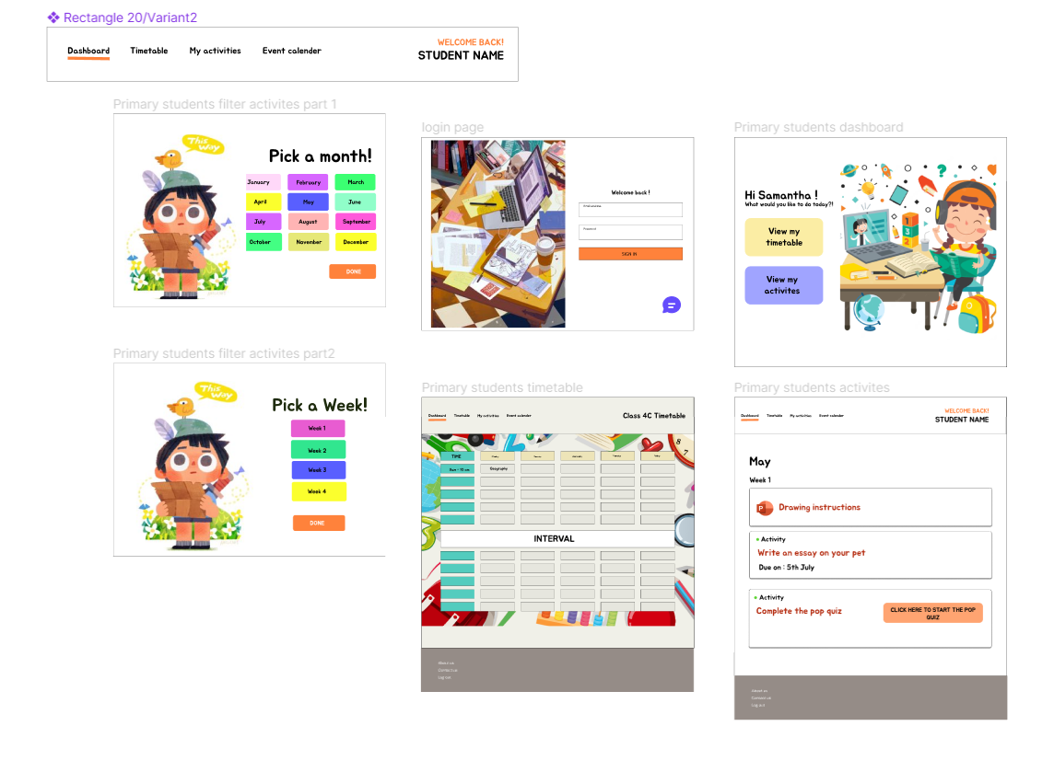

Figure 1 Primary students figma design

Lower secondary students figma design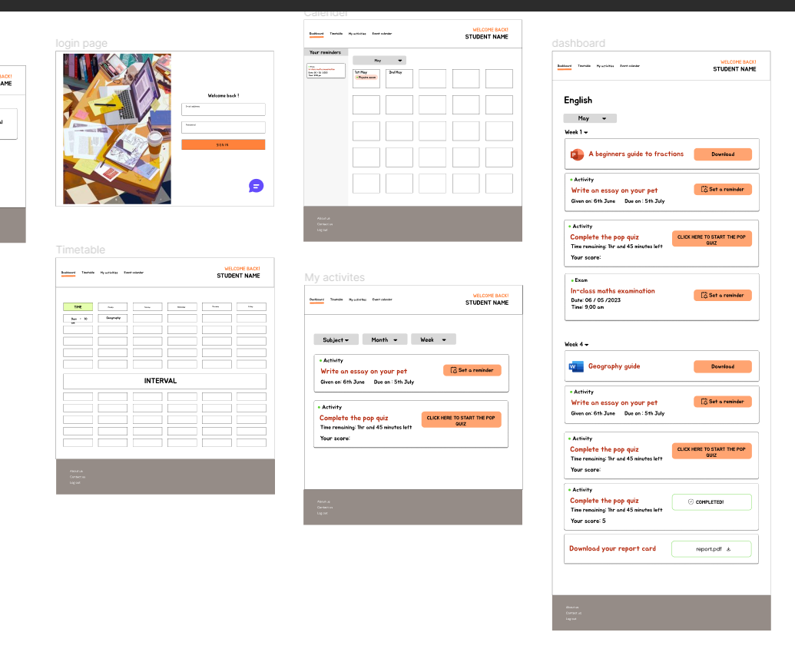

Figure 2 Lower secondary students figma design part 1

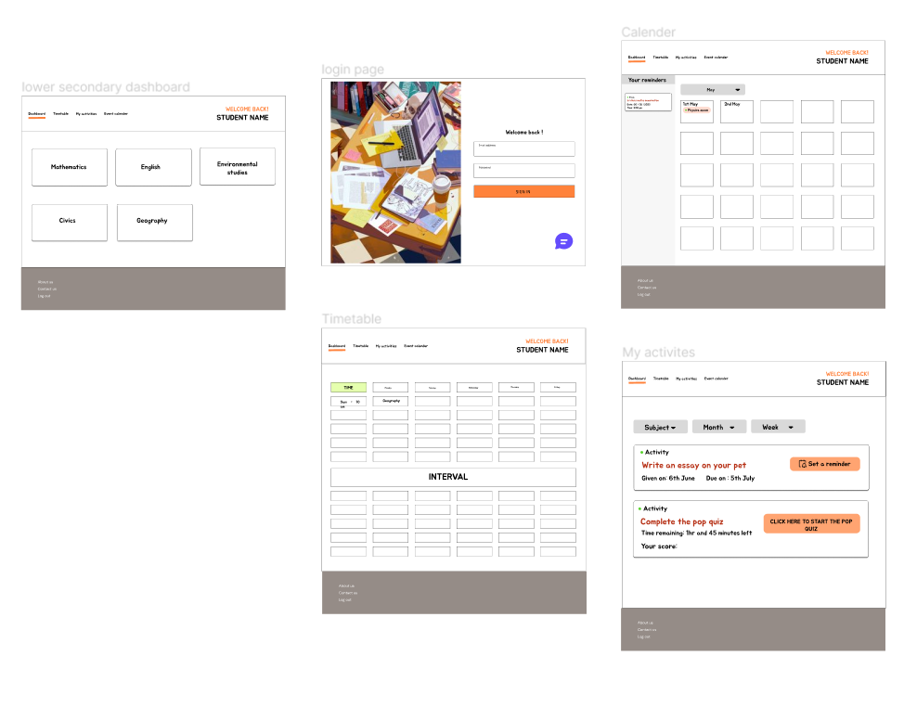

Figure 3 Lower secondary students figma design part 2

### Upper secondary students figma design

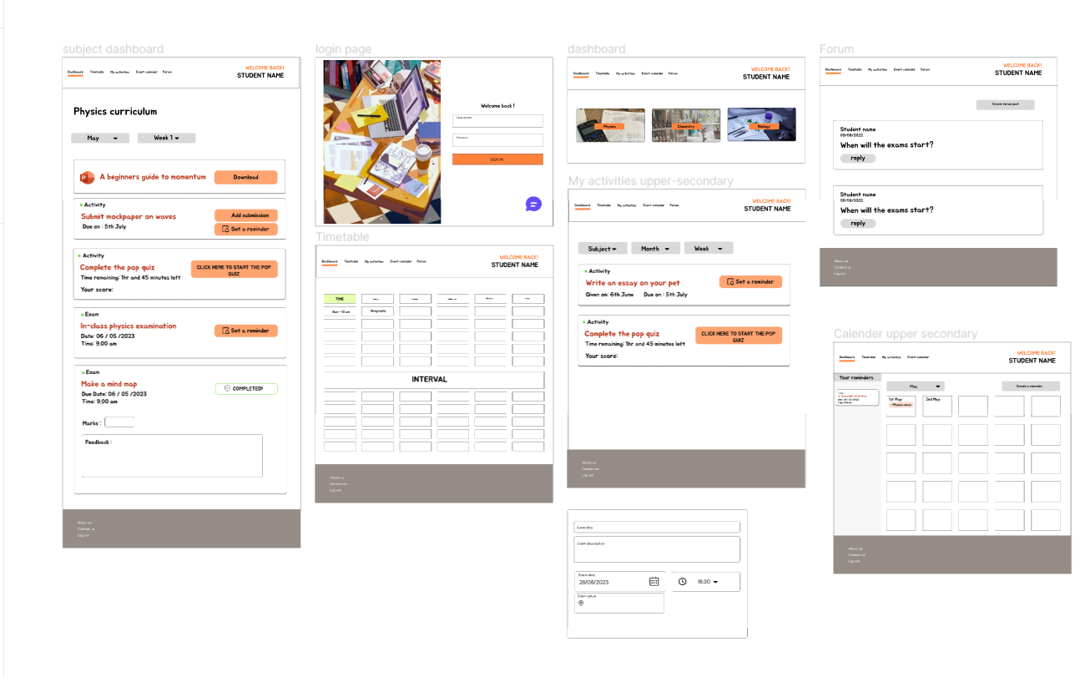

Figure 4 Upper secondary students figma design

### Teacher figma design

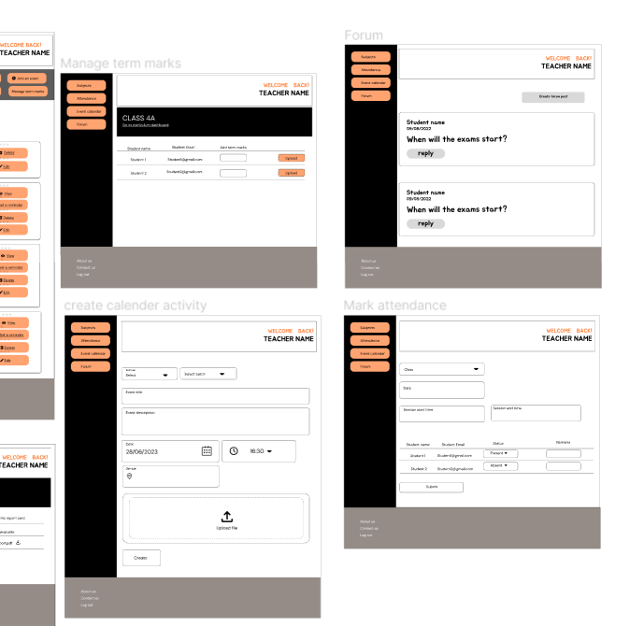

Figure 5 teacher figma design part 1

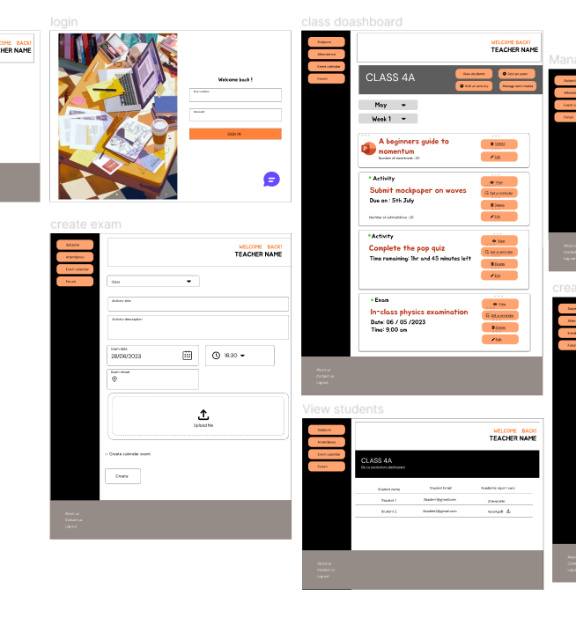

Figure 6 teacher figma design part 2

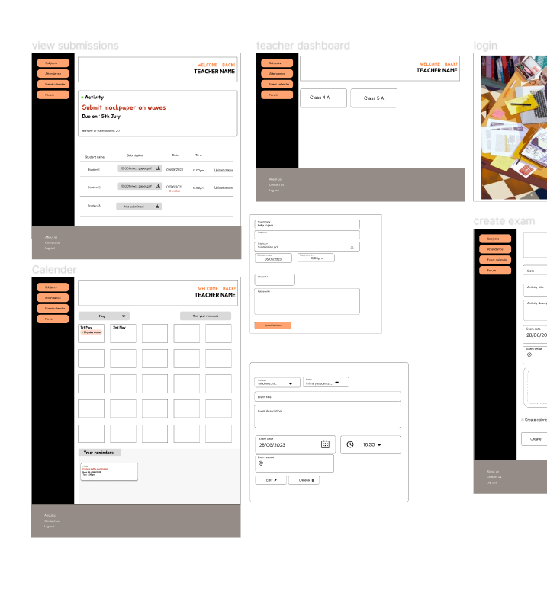

Figure 7 teacher figma design part 3

### Admin figma design

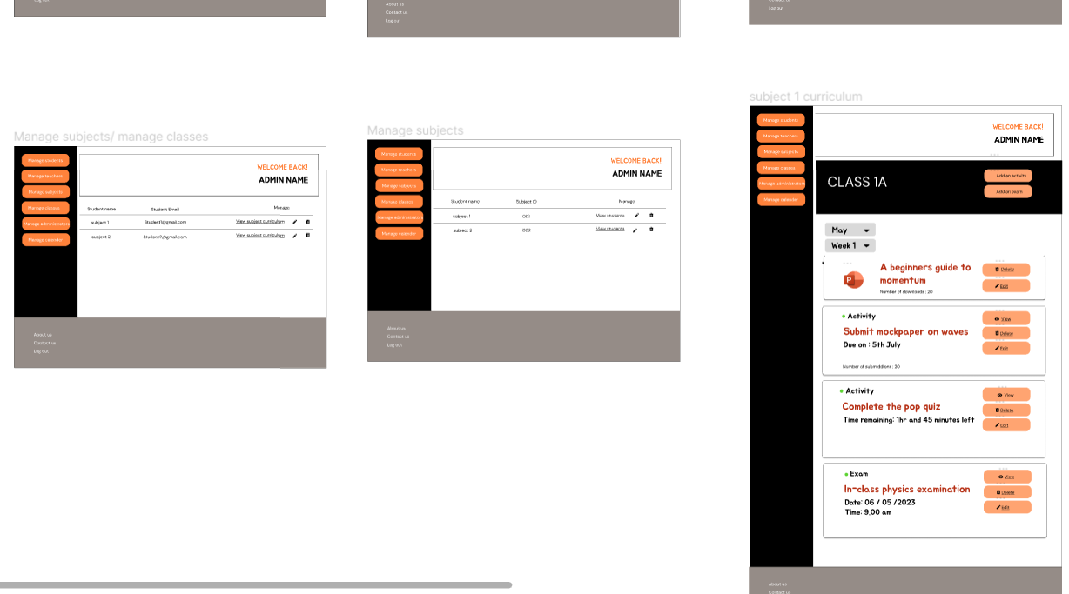

Figure 8 admin figma design part 1

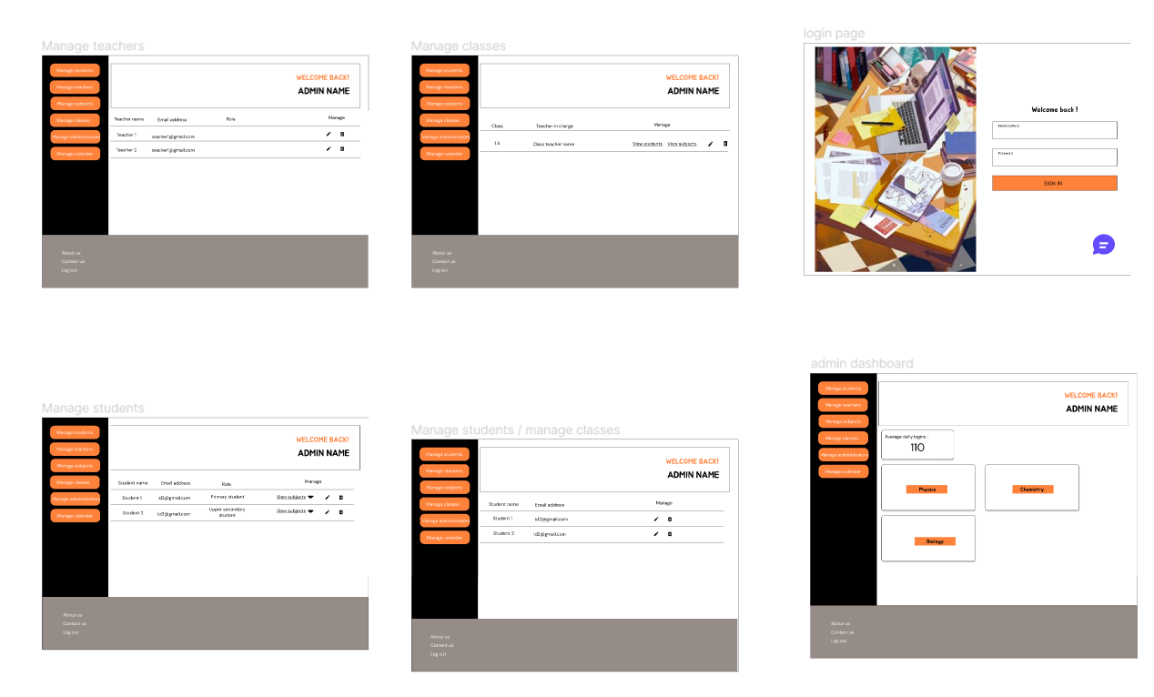

Figure 9 admin figma design part 2

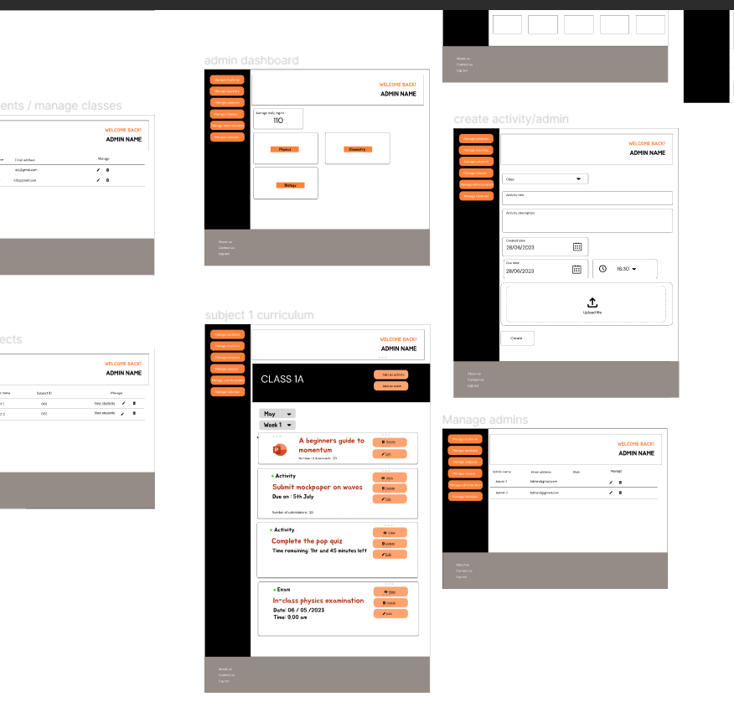

Figure 10 admin figma design part 3

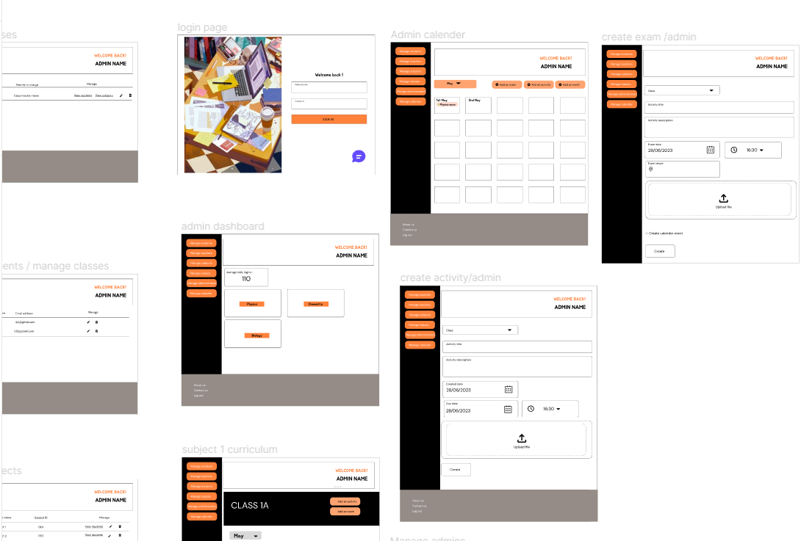

Figure 11 admin figma design part 4

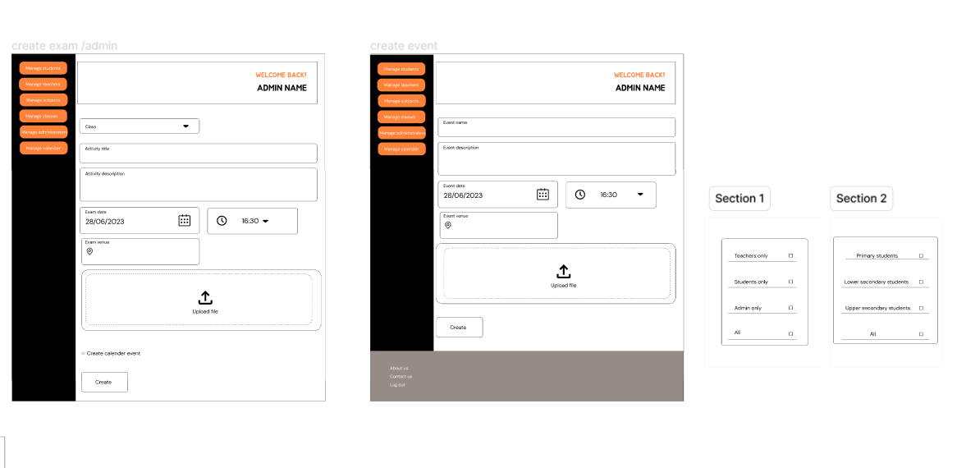

Figure 12 admin figma design part 5

# Interface images

### Admin side

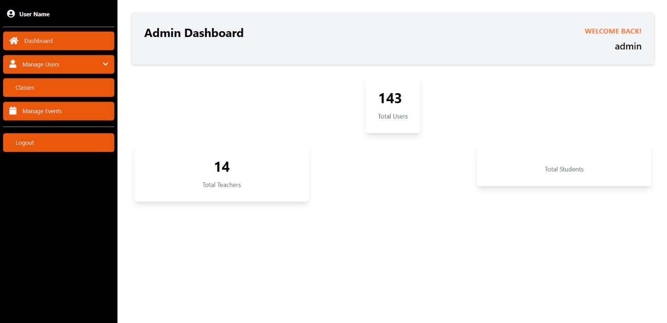

Figure 13 admin dashboard

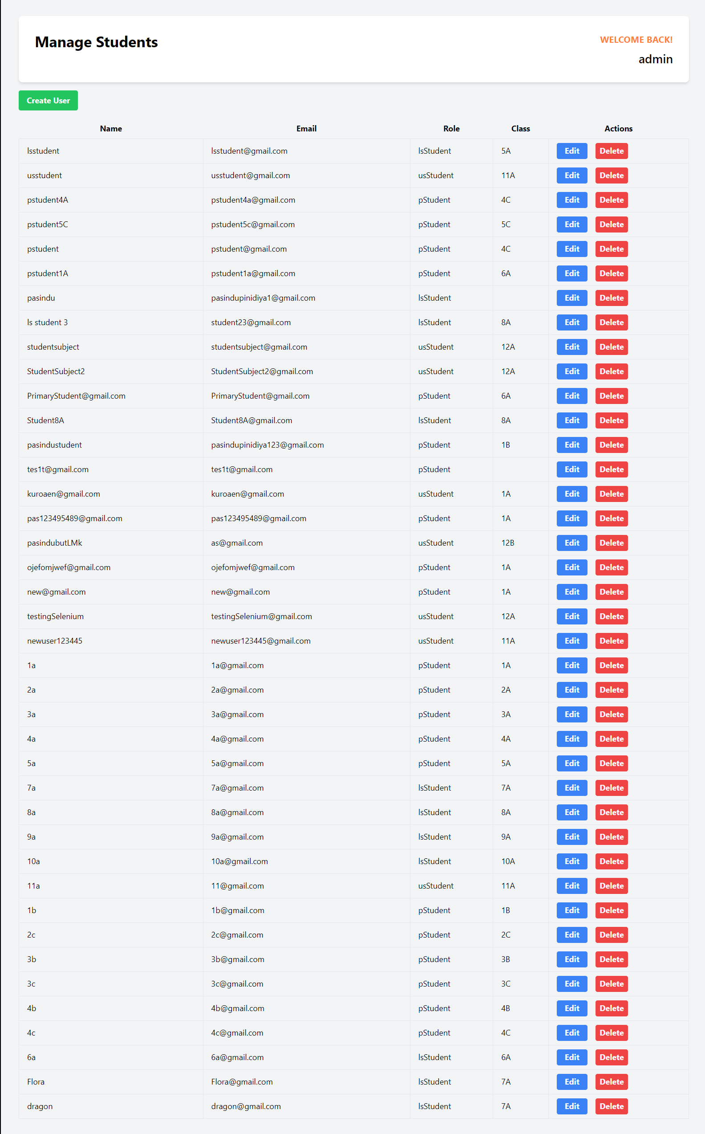

Figure 14 view student users by admin

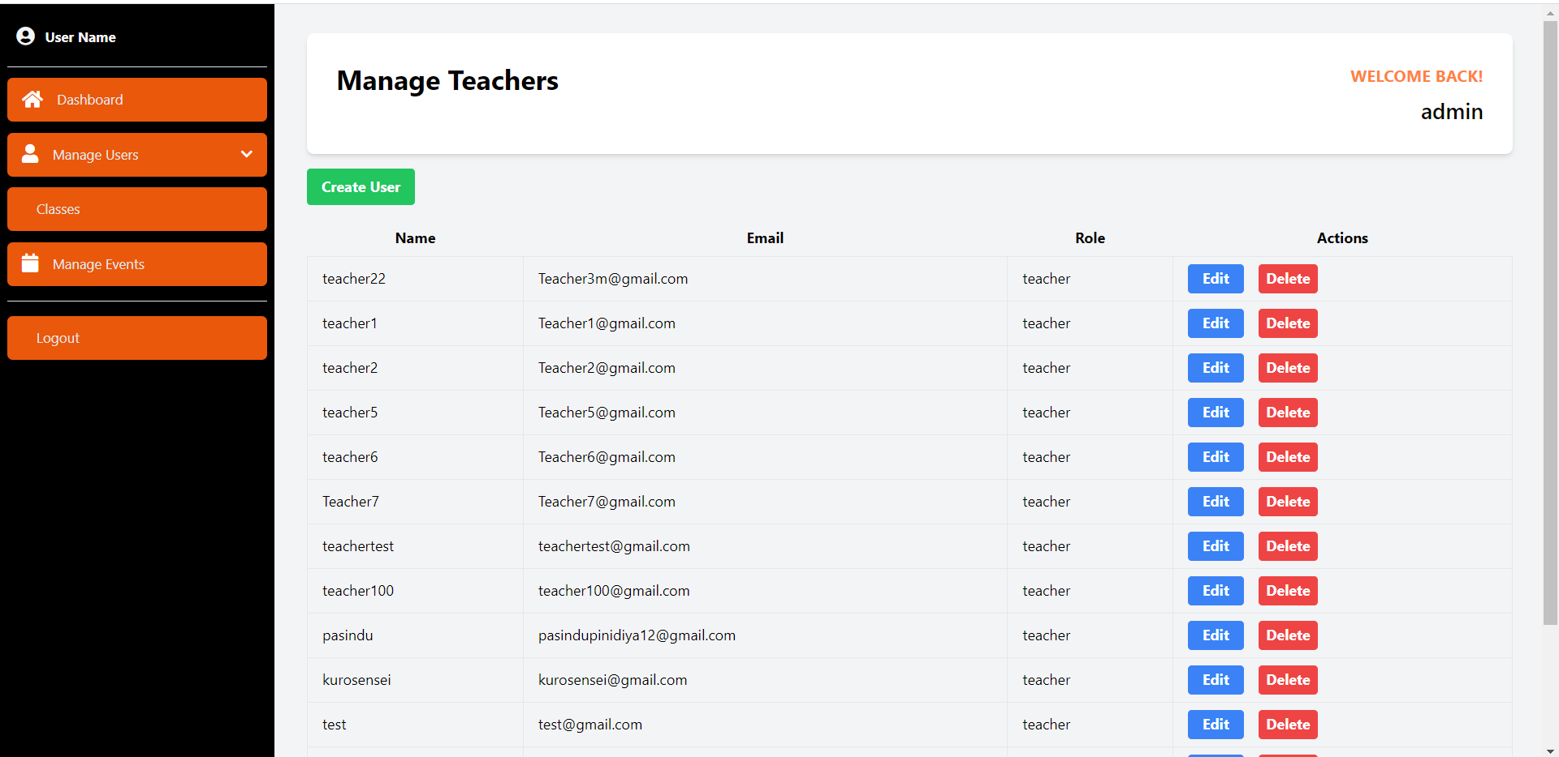

Figure 15 view teachers by admin

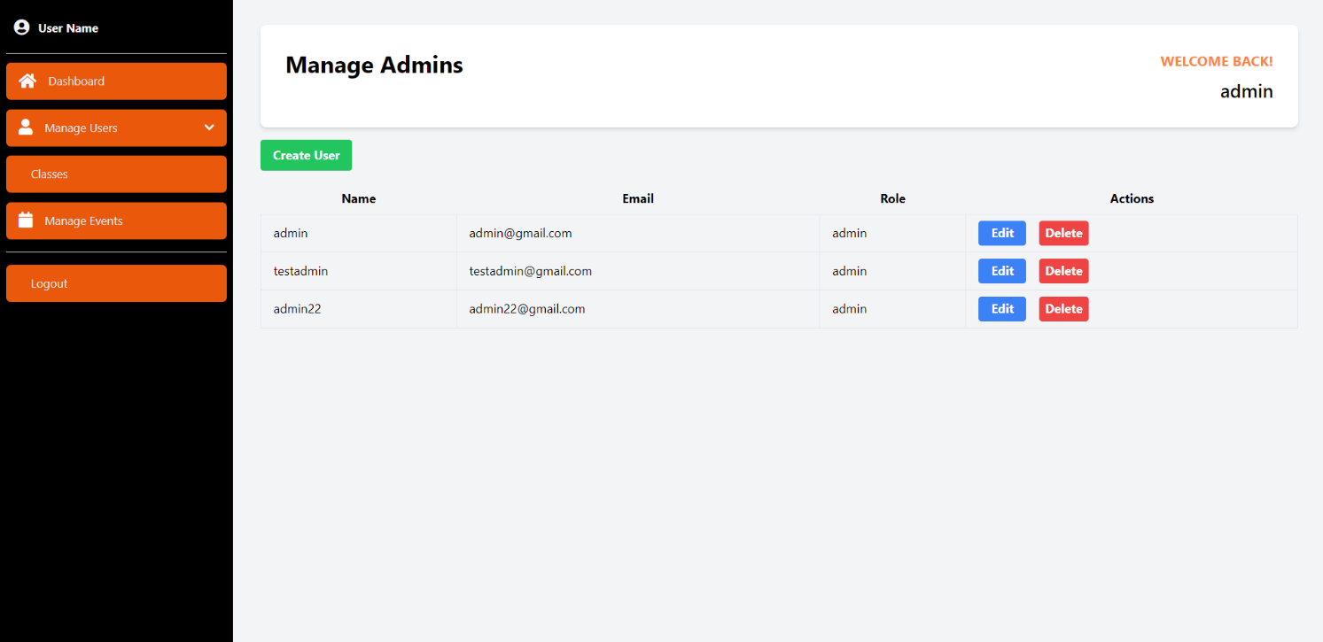

Figure 16 view admins by admin

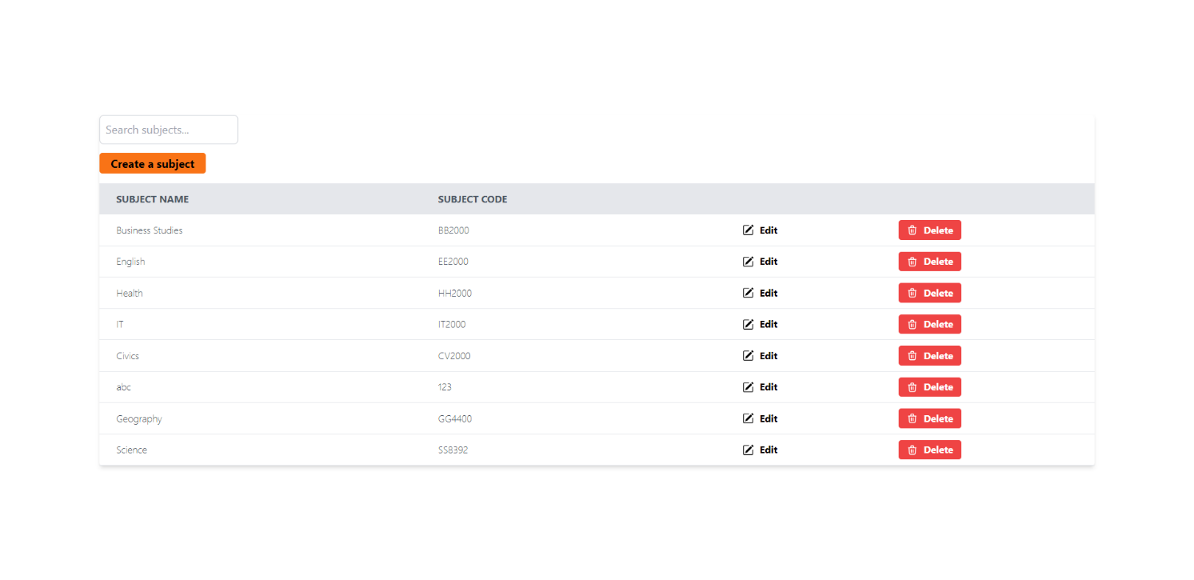

Figure 17 view subjects by admin

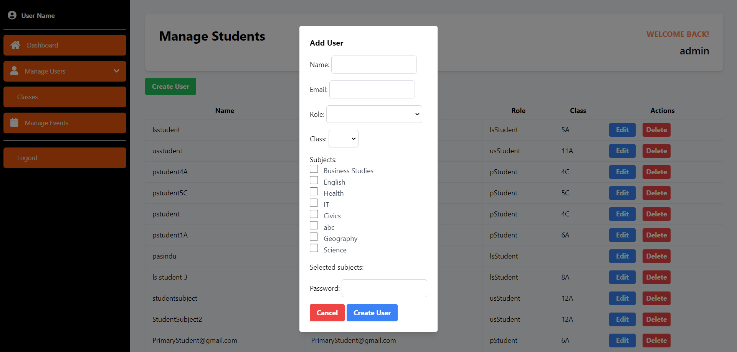

Figure 18 register student by admin

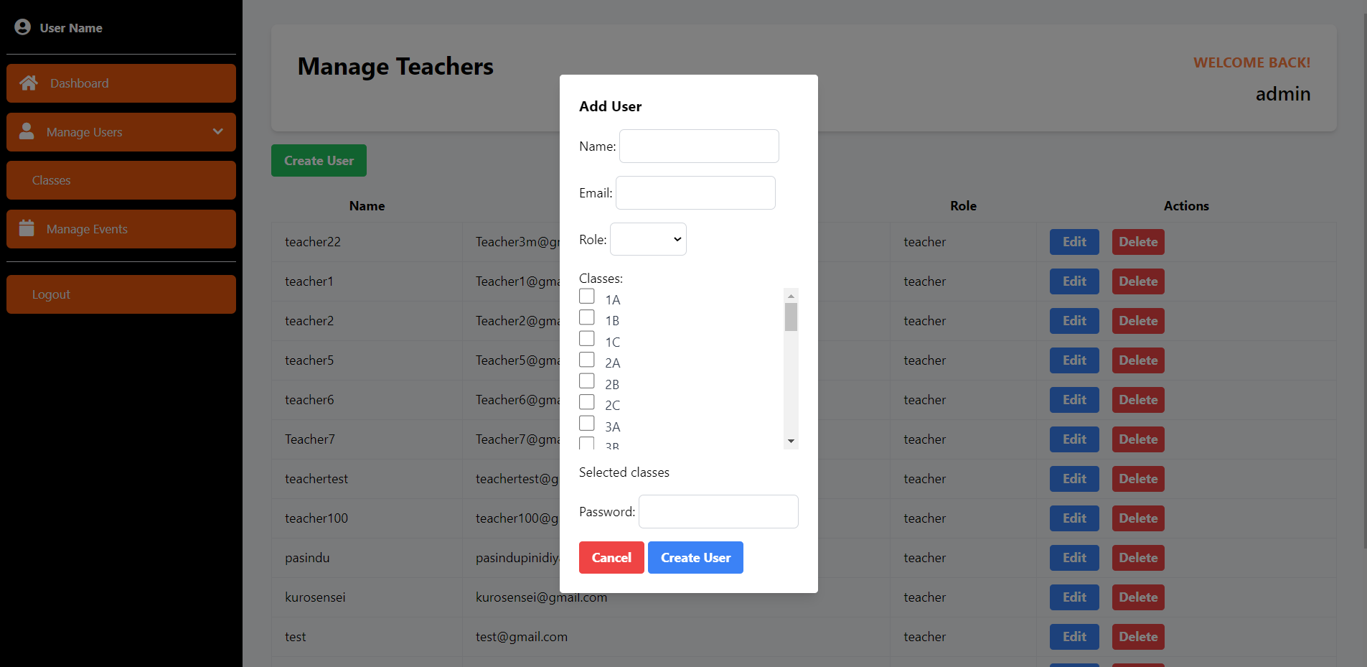

Figure 19 register a teacher by admin

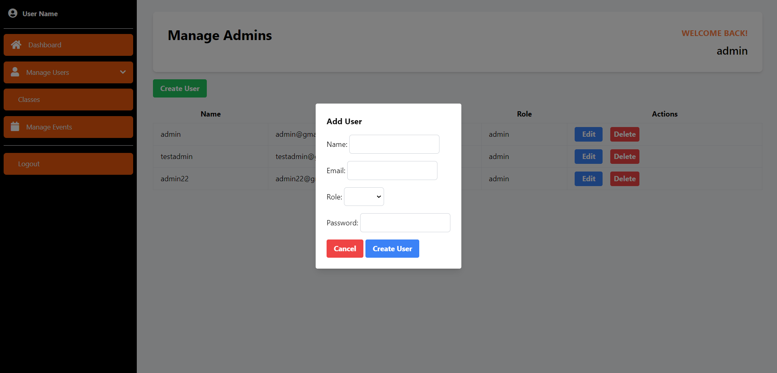

Figure 20 register an administrator by admin

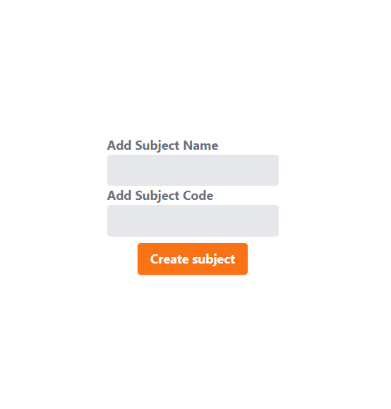

Figure 21 create subject by admin

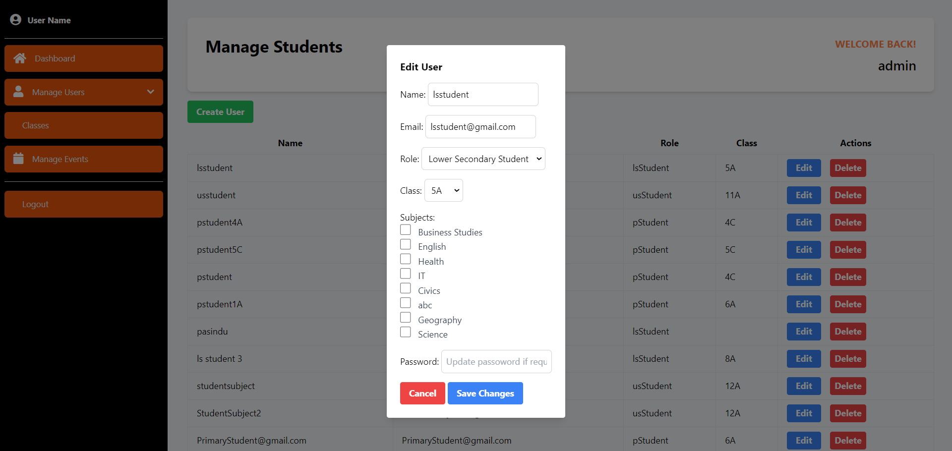

Figure 22 edit student details by admin

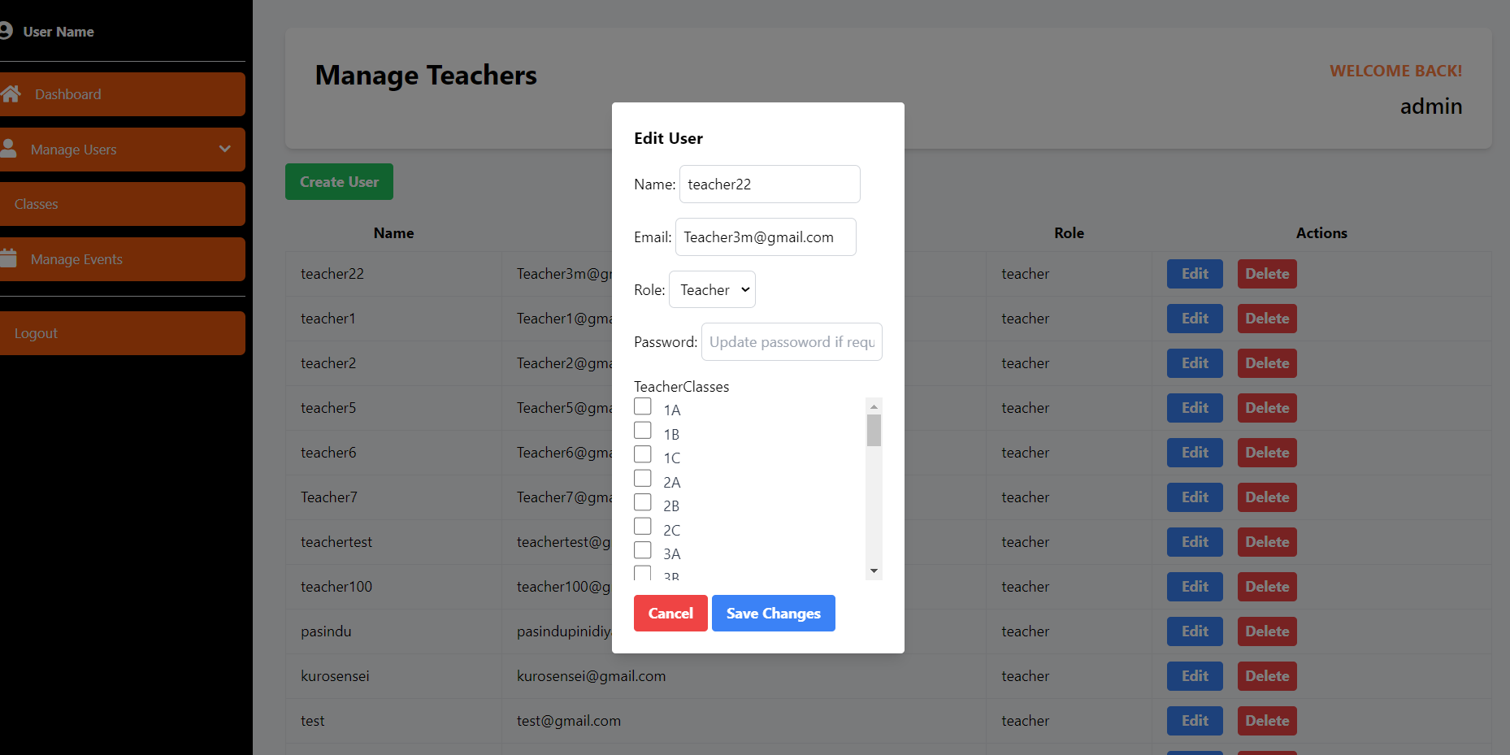

Figure 23 edit teacher details by admin

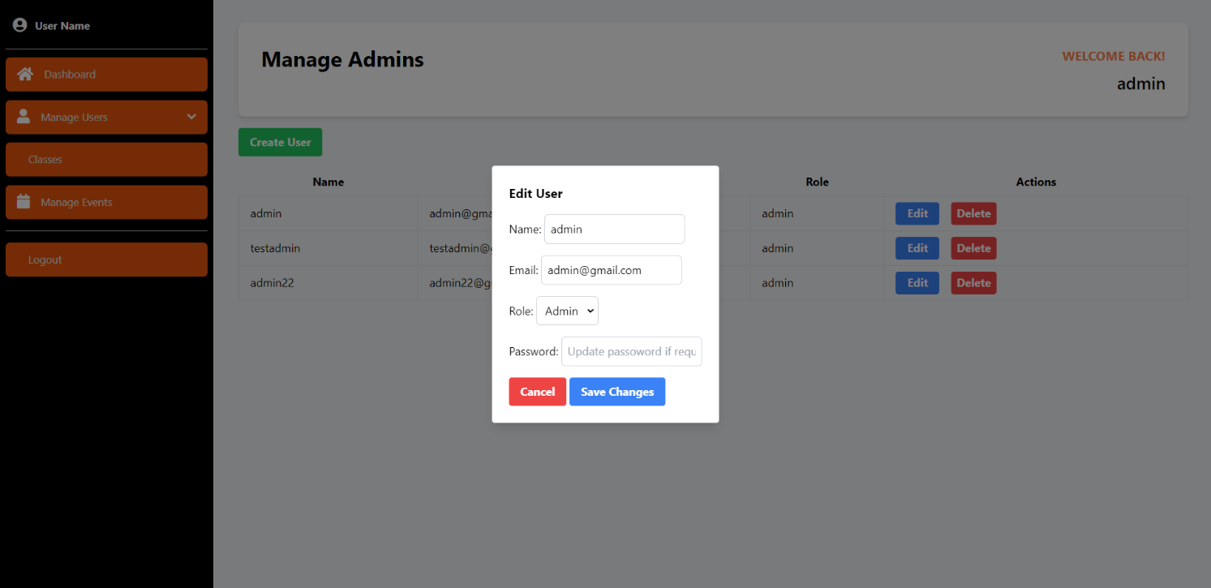

Figure 24 edit admin details by admin

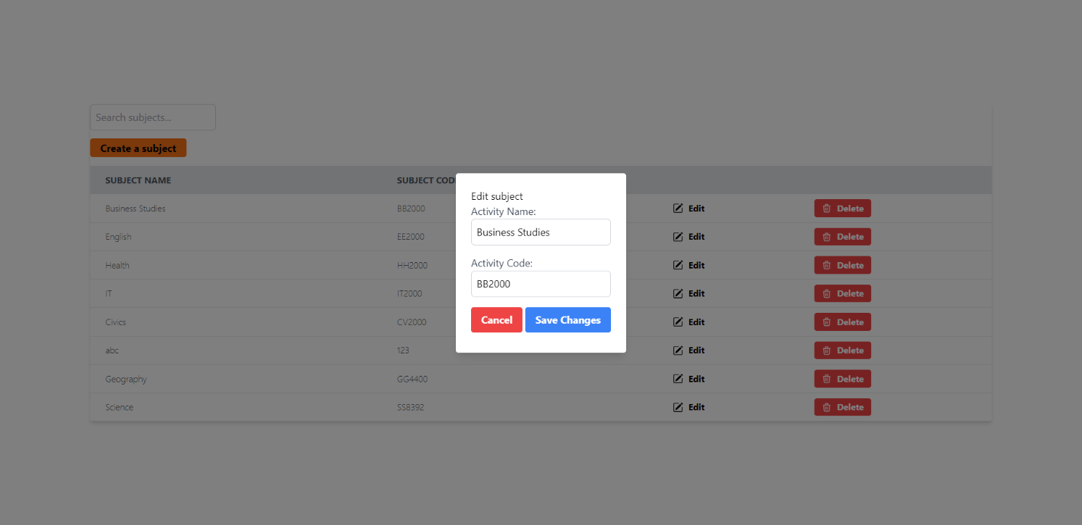

Figure 25 edit subject details by admin

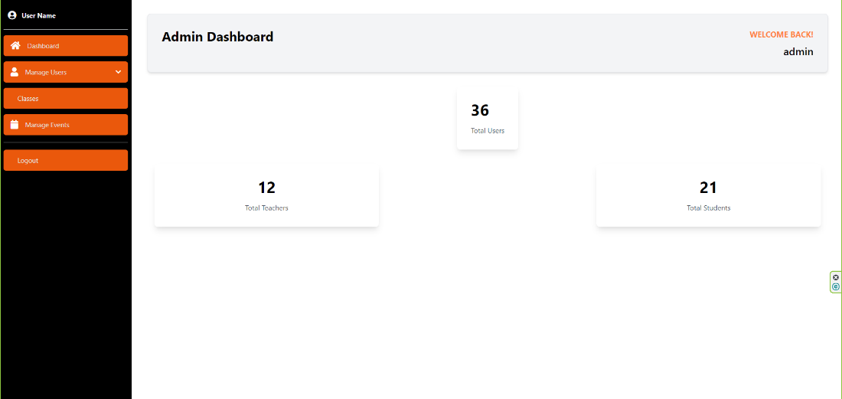

Figure 26 admin analytics dashboard

### Teacher’s side

Figure 27 teacher dashboard

Figure 28 view activities created by teacher

Figure 29 create activity

Figure 30 edit activity

Figure 31 view submissions per activity

Figure view chosen subjects by teacher

Figure mark attendance by teacher

### Primary student’s side

### 

Figure 34 primary student dashboard

### 

Figure 35 primary students timetable

### Upper secondary students

### 

Figure upper secondary student dashboard

### General student features

Figure 37 view activities by students

Figure 38 add a submission by students

Figure view attendance per subject by student

# User roles.

User roles of LMS DOJO are as follows.

* Student

LMS DOJO caters to three types of students namely primary , secondary and upper secondary students.

* Teacher
* Administrator

# Use cases.

### Student

* As a student I can view my timetable, so I know my daily schedule.
* As a student I want to view activities that my teacher has created for me
* As a student I want to add submissions if necessary, so that the teacher can then assign me a grade.
* As a student I can view my attendance per subject so I can improve my attendance where it’s lacking

### Teacher

* As a teacher I want to create activities for my students so that they will be able to complete them to get good grades .
* As a teacher I want to view any submissions I have received for activities I have allocated for my students so that I can view them and grade them.
* As a teacher I want to mark attendance for my students to keep of students who might not be attending classes.

### Administrator

* As administrator I want to register students to the LMS
* As administrator I want to register teachers to the LMS
* As administrator I want to update details of students when the need arises.
* As administrator I want to update details of teachers when the need arises.
* As administrator I want to delete student users from the database when the need arises
* As administrator I want to delete teachers from the LMS and revoke access when the need arises.
* As administrator I want to create events to maintain an event calendar
* As administrator I want to update the details of events I have created upon any event data changes.
* As administrator I want to delete any cancelled events off the calendar.

# Project management

Throughout the development process of LMS DOJO we used Trello as our project management tool to keep the team on track and up to date. Using Trello, it was easy to see the tasks delegated to each member and other members were able to see if the tasks were completed or not.

Below is a snapshot of the Trello board we created with categorization based on the three sprints.

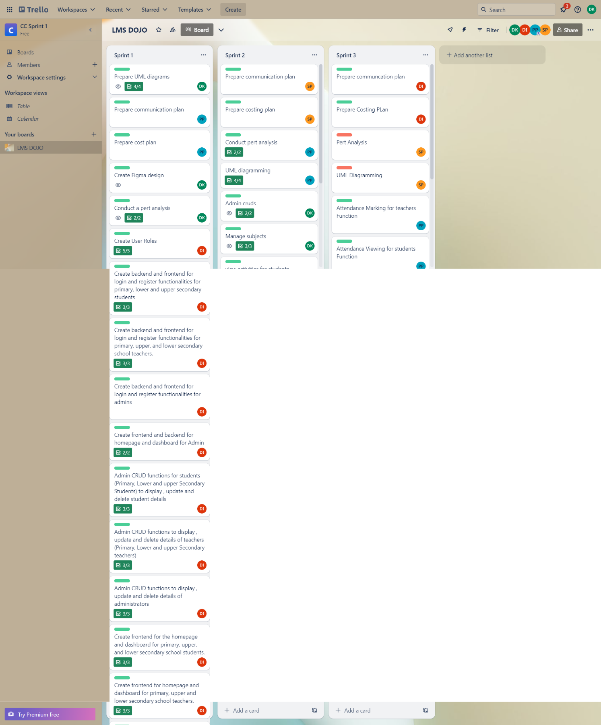

Figure 40

# Features implemented.

## Creating, edit and deleting student users.

With this functionality a certified individual can register only the required students to the system.

An updates to the user details such as their email , class or subjects chosen can be deftly changed on request.

Likewise the student can be removed from the system so that any access to the lms will be revoked.

## Creating , editing and deleting teachers

Similar to managing students Administration can register teachers to the LMS allowing them to add activities to the lms which the students can view.

Administration can make changes to a teachers details in the database and update them across the entire system.

As with students a teacher can be removed from the database and access to the lms successfully revoked with the delete functionality

## Students can view timetables

Primary , lower secondary and upper secondary students can view their set timetables upon click the “view timetable “ option on the navigation bar. The timetable shows the subject day and time the of the students set periods.

## Students can view the activities created by their class teacher.

With this feature students can view activities set unto them and the details related to each. Such as if a submission is due the submission date ,time and the activity title etc.

## Students can upload submissions

If a submission requires uploading a file the student can do so easily with by filling a form. Upon submission the file added along with the submission details are then sent to the database for retrieval on the teachers side.

A student can successfully upload images , word documents and pdfs and these are later downloadable but the teachers.

## Teachers can view submissions per activity

With this feature a teacher view any submissions a student has made for a certain activity. The submission details and the submission file is visible to the teacher and the teacher can then download the file for working.

## Event management

* The administrator can create an even by adding details such as event name , destination, time and placeholder image.
* The event details can then later be modified and updated at will.
* Any created events can also be deleted by the administrator if the need arises .

## Attendance marking

With this feature a teacher can mark a student as available or not for a particular session.

## Students can view attendance

Students can get a percentage wise tabulation of their as attendance pers subject. This percentage is updated real time each time the teacher marks attendance.

# Project charter

## Goals

* Provide a cohesive platform for students and teachers to interact with the school and curriculum.
* Easier access to learning materials
* Organize subject materials and resources. Present them in an attractive manner to the users.
* Facilitate blended learning.
* Generate reports and data analytics to understand the student community and make changes to the curriculum and learning materials accordingly.
* Use data analytics to see the underperforming students and work towards helping them.
* Generate data analytics for teachers to get an insight into a student’s progress levels.
* Make remote communication with teachers and classmates easier.
* Limited restrictions related to uploading materials such as file types.
* Resource sharing is easier and more convenient.
* Provide a safe environment for students to communicate with teachers and fellow peers.
* Make the learning experience fun for young students by catering to their psychological needs.
* Digitalize the attendance marking process making it more convenient and generating insightful reports.
* Provide means for teachers to continue teaching despite being physically unavailable.
* Grading and scoring are easier and more convenient.

## Project Scope:

User roles:

* Our system has 3 user roles with unique features and permissions. Namely student, teacher, and administrator
* The user interface will be different per user and per student category. For example, the user interface for primary students will include more graphics and vibrant colors.
* Teachers and administrators can create subjects and classes. They can assign students to each and personalize student dashboards accordingly.

Data and analytics

* Data and analytics generation – User data such as login frequency, activity completion rates, most used LMS features, views on learning resources, etc. are auto generated upon request and these are used to measure student progress levels and their interaction levels with the LMS.
* Gamification to improve user engagement among primary students.
* Gamification is brought forth in the way of awarding virtual badges based on analytics such as number of completed tasks, number of page visits.

File uploads:

* Teachers and admin will create content and upload to the LMS making it available for students to read or download. The content can be in different formats such as word documents, excel sheets, pdfs, ppts, images, diagrams and videos. The quality and resolution of files will not be affected negatively.
* Students can upload submissions with a size limit of 2 GB and will receive feedback and scores from the teachers.
* The system will support word documents, excel sheets, pdfs, ppts, images, diagrams and videos without affecting their resolution and quality.

Communication:

* Availability of an online chat option for students and teachers to communicate remotely.

Attendance marking:

* Performed digitally and more easily. Reports and analytics related to student attendance will be generated at the end of each month.

Accessibility:

* LMS DOJO mobile responsive web application that can be used across many devices.

Compatibility:

* Compatible with multiple operating systems such as android, IOS, windows etc.

Security:

* Constant system monitoring by the admin will make the system more secure and safe.
* Security implementations include two-factor authentication, login with password and data encryption.

Availability:

* The system will be available 24*7.

Scalability:

* The system will load balance properly and be able to handle multiple incoming requests at the same time.
* The system will be able to support at least 1000 users at the same time.

## Key stake holders:

* Mohamed ithhaf mohamed dhanish (CB009562)
* Pasindu lankanath pinidiya bandara (CB009454)
* Pooja selvaraj (CB010098)
* Arachchi appuhamillage done dulangi karunasekara (CB010550)

## Milestones

* 1st sprint - 4th July
* 2nd sprint - 5th august
* 3rd sprint – 1st September
* Final documentation – 21st September

## Limitations:

* System downtimes are unavoidable.
* Users may not use the system hence will not be able to generate personalized analytics.
* A student can log in to the system from the account of another student and complete tasks.
* Security issues such as brute force
* Cannot upload files that exceed the maximum file size of 2 GB.

# Work breakdown structure

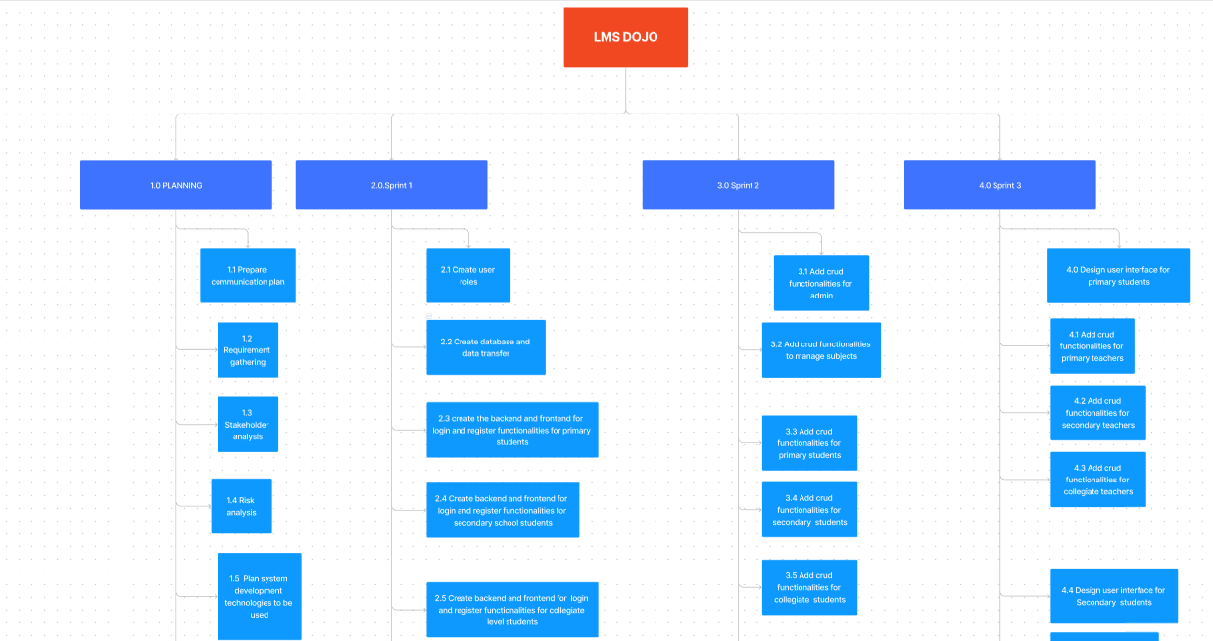

Figure WBS

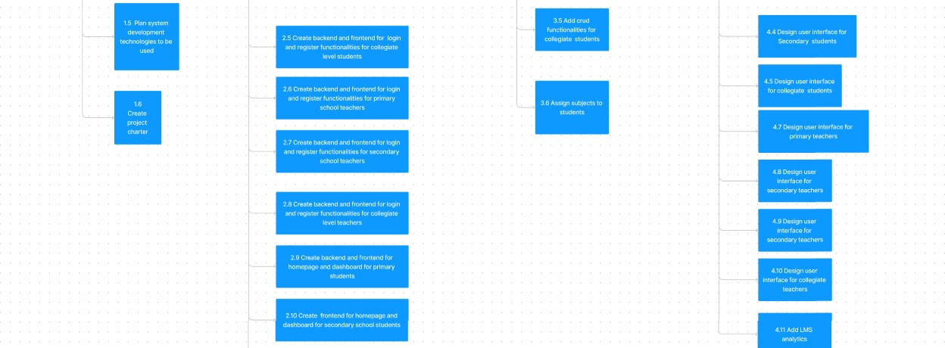

Figure 42 WBS

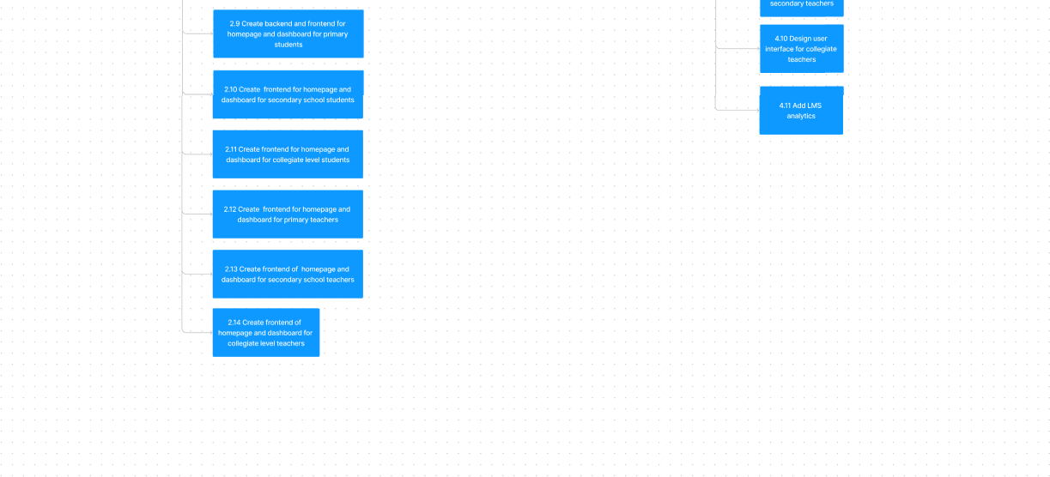

Figure WBS

# Sprint 1

# Work breakdown structure

|  |  |  |  |  |
| --- | --- | --- | --- | --- |
| Task | **Scrum master** Pasindu lankanath pinidiya bandara (CB009454) | **Developer** Mohamed ithhaf Mohamed dhanish (CB009562) | **Business analyst** Arachchi appuhamillage done dulangi karunasekara (CB010550) | **Quality**  assurance  Pooja selvaraj (CB 010098) |
| Figma design |  |  | 100% |  |

|  |  |  |  |  |
| --- | --- | --- | --- | --- |
| UML  diagramming ( use case diagrams , use case specification  ,activity diagrams, sequence  diagrams) |  |  | 100% |  |
| Setting up project management  platform | 100% |  |  |  |
| Communication  plan | 100% |  |  |  |
| Time management  (Pert analysis) |  |  | 100% |  |
| Project initialization with the creation of GitHub  repository |  | 100% |  |  |
| Setting up the  database |  | 100% |  |  |
| Frontend  development |  | 100% |  |  |
| Backend of Login  functionality |  | 100% |  |  |
| Backend of user  registration |  | 100% |  |  |
| Multiuser  authentication |  | 100% |  |  |
| Backend of user  management |  | 100% |  |  |

|  |  |  |  |  |
| --- | --- | --- | --- | --- |
| Backend of event  management |  | 100% |  |  |
| Backend of primary student’s  dashboard |  | 100% |  |  |
| Costing calculations  (Cost analysis) | 100% |  |  |  |
| Testing |  |  |  | 100% |
| Sprint review | 100% |  |  |  |

# Sprint goals.

The goal of our first sprint is to lay the foundation of LMS dojo by preparing use case diagrams, activity diagrams, and sequence diagrams to coherently understand the functionality of our LMS and the logical order of tasks. By preparing a Figma design we were able to build an idea of what the user interface of the system will look like and how the front end’s basic appearance must be structured.

For the system's development and implementation, we wished to set up the database and complete the register and login functions of the LMS. This will lay the basic groundwork of the LMS system from which the development can start off and continue in the other sprints.

After completing the authentication and login, it was our goal to complete the basic front-end dashboards of students and teachers and set up a function for the primary students to view their timetables.

Below is a comprehensive list of our sprint goals.

* Set up database.
* Set up project management platform.
* Create the login page for users.
* Created the login function for users with multiple user authentication.
* Registration for primary students
* Registration of Upper secondary (Collegiate) and Lower secondary students
* Registration of Teachers
* Registration of administrators
* Completion of the frontend for primary students, lower secondary students, Upper secondary students, and teachers

# Project management Sprint 1

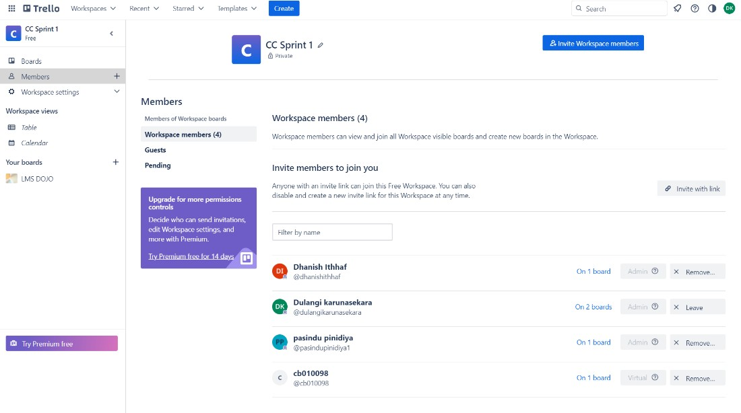

Figure Trello board sprint 1

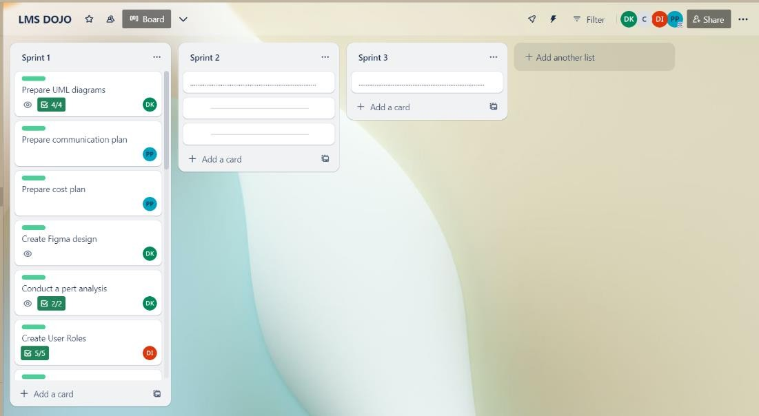

Figure Trello board sprint 1

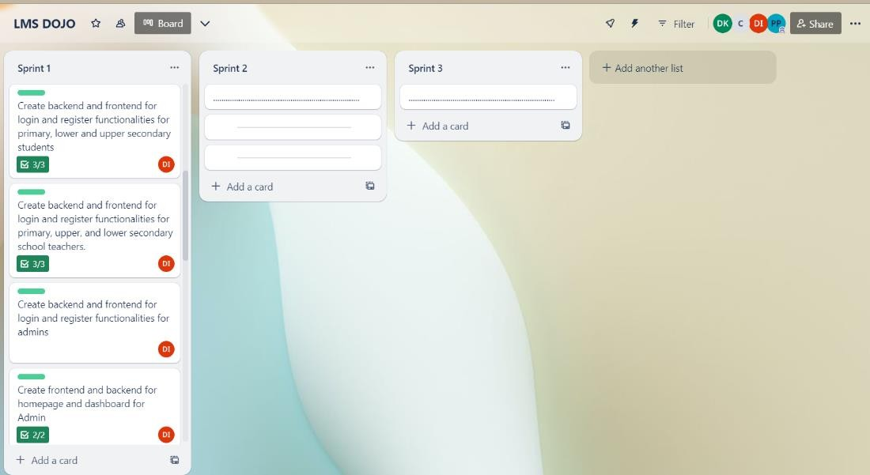

Figure 46 Trello board sprint 1

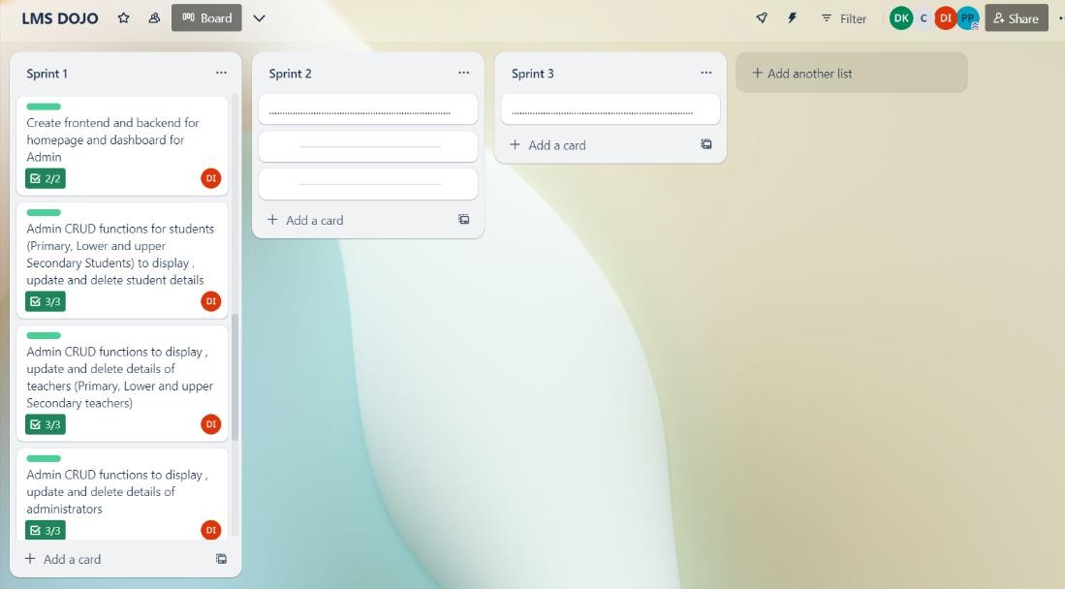

Figure Trello board sprint 1

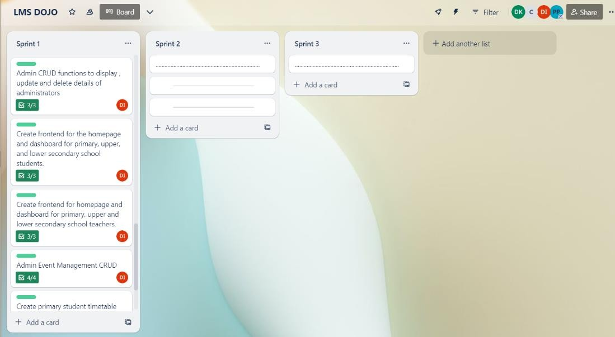

Figure 48 Trello board sprint 1

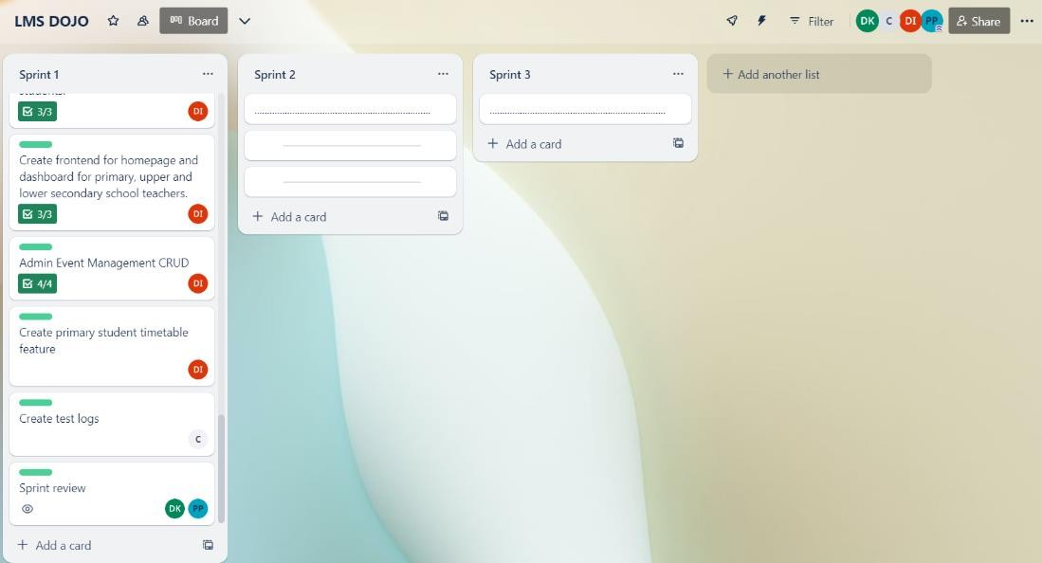

Figure Trello board sprint 1

Product backlog sprint 1

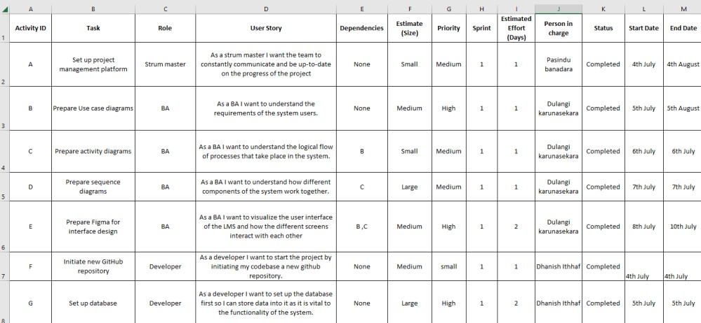

Figure product backlog sprint 1 part 1

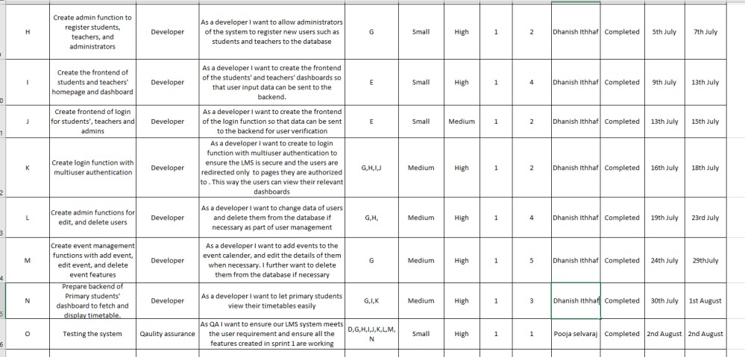

Figure product backlog sprint 1 part 2

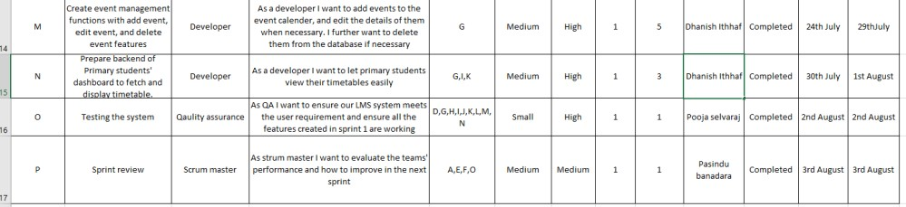

Figure product backlog sprint 1 part 3

# Gantt chart

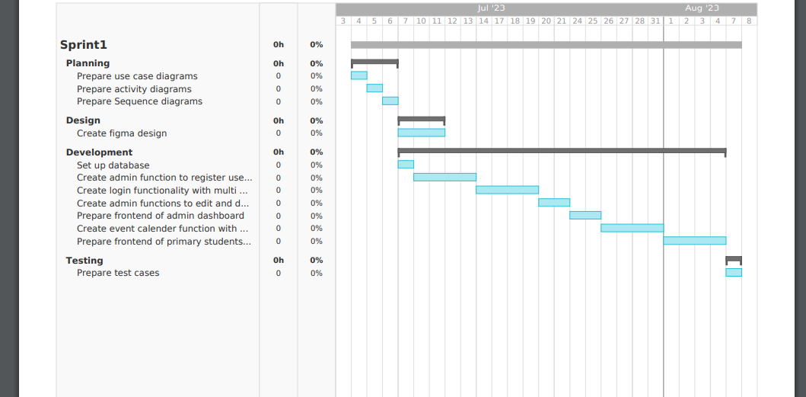

Figure Sprint 1

Figure

# Functions carried out in Sprint 1

* Prepared use case diagrams – To understand the requirements of each user and how the user interacts with the LMS.
* Prepared activity diagrams – To understand the flow of the system and the sequence of functions.
* Prepare sequence diagrams - To show the order of the processes being executed by the system.
* Prepared a communication plan – To set the required deadlines and review the progress of tasks assigned to each member.
* Conducted a pert analysis – To see the amount of time that will be required to complete the sprint and determine the earliest time we can complete the 1st sprint in.
* Administrator’s function to register students, teachers and administrators to the system – To register only authorized individuals to the LMS.
* Login function for students, teachers and administrators – To ensure only authorized registered individuals with proper access to the LMS can login to the system and use its features.
* Multiple user authentication – To allow multiple users to enjoy unique features based on their authority level and requirements.
* Admin functions to edit student details - Allow the administration to change a student’s details in the database when necessary.
* Admin functions to edit teacher details - Allow the administration to change a teacher’s details in the database when necessary.
* Admin functions to edit admin details - Allow the administration to change an administrator’s details in the database when necessary.
* Admin functions to delete student details - Allow the administration to remove a student from the database when necessary and revoke their access to the LMS.
* Admin functions to delete teacher details - Allow the administration to remove a teacher from the database when necessary and revoke their access to the LMS.
* Admin functions to delete admin details - Allow the administration to remove an administrator from the database when necessary and revoke their access to the LMS.
* Admin function to create an event - Allows the admin to add an event to the event calendar.
* Admin functions to edit event details - Allow the administration to change an event’s details in the database when necessary.
* Admin functions to delete event details - Allow the administration to remove an event from the database when necessary.
* Prepared the frontend of Primary, lower secondary, upper secondary (collegiate), teacher and admin dashboards – Users will be redirected to the relevant dashboard after login. Creation of the front end is vital to the LMS as it sends data to the backend to achieve its functionality.
* Created the backend of the “View timetable” option for primary students – Primary students can click on “View timetable “option on their dashboard to view their timetable.
* Prepared test logs - Tests were performed on the functions completed in Sprint 1 and the test results were accurately logged.

### With the completion of the above tasks, we have successfully completed our sprint 1's goals. Below is a repetition of our sprint 1 goals and an assurance of whether they were completed or not.

* Set up database - Completed.
* Set up project management platform – Completed.
* Create the login page for users - Completed.
* Created the login functions with multiple user authentication - Completed.
* Registration for primary students - Completed.
* Registration of Upper secondary (Collegiate) and Lower secondary students - Completed.
* Registration of Teachers – Completed
* Registration of administrators - Completed.
* Completion of the frontend for primary students, lower secondary students, Upper secondary students and teachers – Completed.

# High level use case diagrams sprint 1

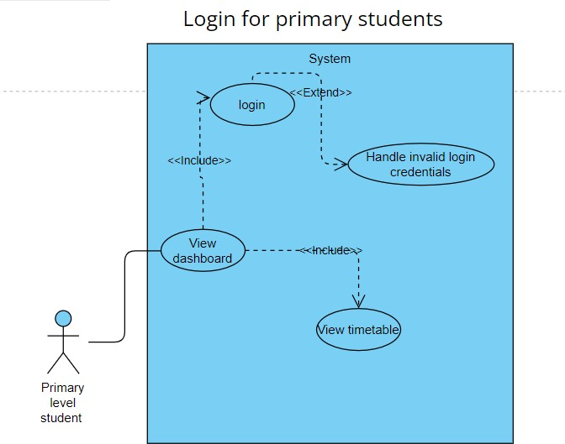

Figure Sprint 1 use case 1

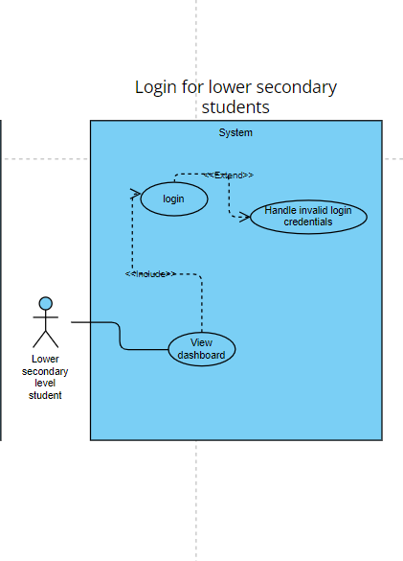

Figure 56 Sprint 1 use case 2

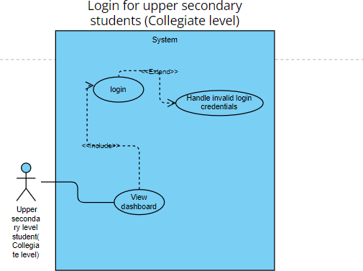

Figure 57 Sprint 1 use case 3

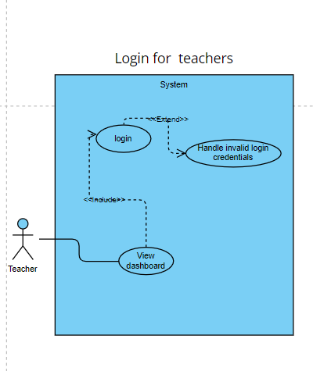

Figure 58 Sprint 1 use case 4

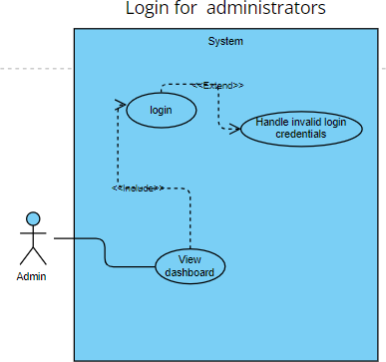

Figure 59 Sprint 1 use case 5

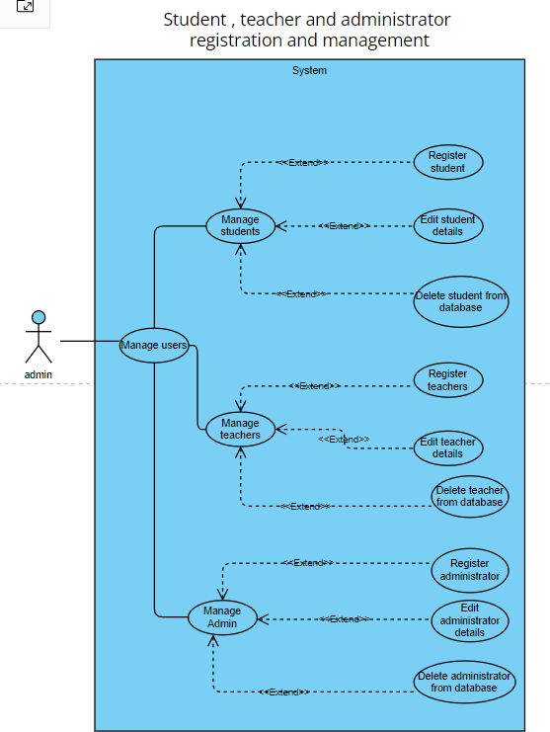

Figure 60 Sprint 1 use case 6

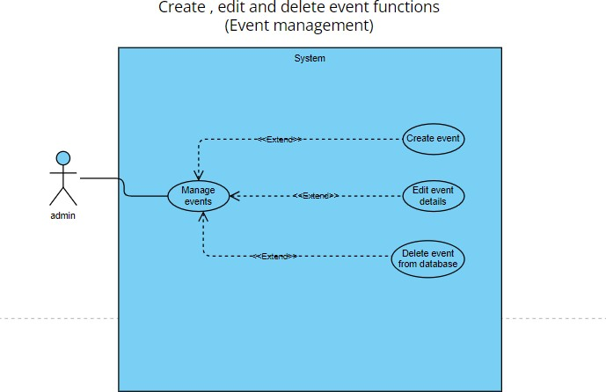

Figure 61 Sprint 1 use case 7

# Use case specifications sprint 1

## Login for primary students

|  |  |
| --- | --- |
| Use Case Name | Login for primary students |
| Description | Allows primary students to login to the system  and view their dashboards |
| Primary Actor | Primary student |
| Pre-conditions | The database must be functional, and the student must be registered to the system by an  administrator |
| Basic flow | 1. Use case starts when the student enters his or her email address and password into the login form. 2. The student clicks on the “sign in "button. 3. The system checks if the email and password are valid. 4. The student is redirected to the respective dashboard. 5. Use case ends. |
| Extensions | If some details are not entered:   1. System will display an error message. 2. Student is not logged in to the system. 3. Use case ends.   If the entered details are invalid   1. System will display an error message. 2. Student is not logged in to the system. 3. Use case ends. |
| Post conditions | The student can view their dashboard/  dashboard |
| Optional information |  |

## Login for lower secondary students

|  |  |
| --- | --- |
| Use Case Name | Login for lower secondary students |
| Description | Allows lower secondary level students to  login to the system and view their dashboards |
| Primary Actor | Lower secondary level student |
| Pre-conditions | The database must be functional, and the student must be registered to the system by an administrator. |
| Basic flow | 1. Use case starts when the student enters his or her email address and password into the login form. 2. The student clicks on the “sign in "button. 3. The system checks if the email and password are valid. 4. The student is redirected to the respective dashboard. 5. Use case ends |
| Extensions | If some details are not entered:   1. System will display an error message. 2. Student is not logged in to the system. 3. Use case end.   If the entered details are invalid   1. System will display an error message. 2. Student is not logged in to the system. 3. Use case ends. |
| Post conditions | The student can view their dashboard |
| Optional information |  |

## Login for upper secondary students

|  |  |
| --- | --- |
| Use Case Name | Login for upper secondary (collegiate) level  students |
| Description | Allows upper secondary level (collegiate)  students to login to the system and view their dashboards |

|  |  |
| --- | --- |
| Primary Actor | Upper secondary level student |
| Pre-conditions | The database must be functional, and the student must be registered to the system by an administrator.  . |
| Basic flow | 1. Use case starts when the student enters his or her email address and password into the login form. The student clicks on the “sign in "button. 2. The system checks if the email and password are valid. 3. The student is redirected to the respective dashboard. 4. Use case ends |
| Extensions | if some details are not entered:   1. System will display an error message. 2. Student is not logged in to the system. 3. Use case ends.   If the entered details are invalid   1. System will display an error message. 2. Student is not logged in to the system. 3. Use case ends. |
| Post conditions | The student can view their dashboard |
| Optional information |  |

## View timetable for primary students

|  |  |
| --- | --- |
| Use Case Name | View timetable for primary students |
| Description | Allows primary students to view their  timetables |

|  |  |
| --- | --- |
| Primary Actor | Primary student |
| Pre-conditions | The database must be functional. The primary  student must be logged into the system |
| Basic flow | 1. Use case starts when the student clicks on the “view my timetable “button in the dashboard 2. The student is redirected to the timetable page displaying the timetable of the respective class the student belongs in. 3. Use case ends |
| Extensions |  |
| Post conditions | The student can view their timetable |
| Optional information |  |

## Login for teachers

|  |  |
| --- | --- |
| Use Case Name | Login for teachers |
| Description | Allows teachers to login to the system and  view their dashboards |
| Primary Actor | teacher |
| Pre-conditions | The database must be functional. |
| Basic flow | 1. Use case starts when the teacher enters his or her email address and password into the login form. 2. Teacher clicks on the “Sign in” button. 3. The system checks if the email and password are valid. 4. Teacher is redirected to their respective login pages. 5. Use case ends |
| Extensions | if some details are not entered:   1. System will display an error message. 2. Teacher is not logged in to the system. 3. Use case ends.   If the entered details are invalid:   1. System will display an error message. 2. Teacher is not logged in to the system. 3. Use case ends. |

|  |  |
| --- | --- |
|  |  |
| Post conditions | The teacher can view their dashboard |
| Optional information |  |

## Login for administrators

|  |  |
| --- | --- |
| Use Case Name | Login for administrators |
| Description | Allows administrators to login to the system  and view their dashboards |
| Primary Actor | administrator |
| Pre-conditions | The database must be functional. |
| Basic flow | 1. The administrator enters his or her email address and password into the login form. 2. Administrator clicks on the “Sign in” button. 3. The system checks if the email and password are valid. 4. administrator is redirected to their respective login pages. 5. Use case ends |
| Extensions | if some details are not entered:   1. System will display an error message. 2. Teacher is not logged in to the system. 3. Use case ends.   If the entered details are invalid:   1. System will display an error message. 2. Teacher is not logged in to the system. 3. Use case ends. |
| Post conditions | The administrator can view their dashboard |
| Optional information |  |

## Register students.

|  |  |
| --- | --- |
| Use Case Name | Register students |
| Description | Allows the administrator to add new students to the LMS database. So, students can then  login to the system |
| Primary Actor | Administrator |
| Pre-conditions | The database must be functional. Admin must  be logged into the system |
| Basic flow | 1. Use case starts when the admin clicks on the “Manage Students “option in the admin side panel. 2. The admin clicks on the “create user” button. 3. A pop-up form appears to collect information of the new user. 4. Admin enters the details of the student. The specific data are name, email, password, class and role. 5. The admin clicks on the “create user” button. 6. The system adds a new student to the database and the new information is displayed in the admin’s student list. 7. Use case ends. |
| Extensions | if some details are not entered   1. system will display an error message. 2. Use case ends.   Or if the entered details are invalid,   1. system will display an error message. 2. Use case ends. if user already exists: 3. system will display an error message. 4. Use case ends. |
| Post conditions | The new student is added to the database and he or she can log into their account.  The admin’s student list will also be updated |
| Optional information |  |

## Register teachers.

|  |  |
| --- | --- |
| Use Case Name | Register teachers |
| Description | Allows the administrator to add new teachers to the LMS database. So that the new teacher  can login to the system |
| Primary Actor | Administrator |
| Pre-conditions | The database must be functional. Admin must  be logged into the system |
| Basic flow | 1. Use case starts when the admin clicks on the “Manage teachers “option in the admin side panel 2. The admin clicks on the “create user” button.   3.A pop up form appears to collect information of the new user.   1. Admin enters the details of the teacher. The specific data are name, email, password, and role. 2. The admin clicks on the “create user” button 6.The system adds a new teacher to the database and the added information is displayed in the admin’s teachers list.   7.Use case ends |
| Extensions | if some details are not entered   1. system will display an error message. 2. Use case ends.   If the entered details are invalid,   1. system will display an error message. 2. Use case ends.   if user already exists:   1. system will display an error message. 2. Use case ends. |
| Post conditions | The new teacher is added to the database and he or she can log into their account.  The admin’s teachers list will also be updated |
| Optional information |  |

## Register administrator.

|  |  |
| --- | --- |
| Use Case Name | Register administrators |
| Description | Allows the administrator to add new administrators to the LMS database. So,  administrators can then login to the system |
| Primary Actor | Administrator |
| Pre-conditions | The database must be functional. Admin must  be logged into the system |
| Basic flow | 1. The use case starts when the admin clicks on the “Manage administrators “option in the admin side panel. 2. The admin clicks on the “create user” button. 3. A pop-up form appears to collect information of the new user. 4. Admin enters the details of the administrator. The specific data are name, email, password , and role. 5. The admin clicks on the “create user” button. 6. The system adds a new administrator to the database and the new information is displayed in the admin’s administrators list. 7. Use case ends |
| Extensions | if some details are not entered   1. system will display an error message. 2. Use case ends.   If the entered details are invalid,   1. system will display an error message. 2. Use case ends. if user already exists: 3. system will display an error message. 4. Use case ends. |

|  |  |
| --- | --- |
| Post conditions | The new administrator is added to the database and he or she can log into their account.  The admin’s administrators list will also be  updated |
| Optional information |  |

## Edit student details.

|  |  |
| --- | --- |
| Use Case Name | Edit student details |
| Description | Allows the administrator to edit details of  existing students in the LMS database. |
| Primary Actor | Administrator |
| Pre-conditions | The database must be functional. Admin must  be logged into the system |
| Basic flow | 1. The use case starts when the admin clicks on the “Manage students” option in the admin side panel. 2. The admin clicks on the “edit” button next to the student’s name. 3. A pop-up form appears containing information on the student. 4. Admin makes changes to the old information. 5. The admin clicks on the “save changes” button. 6. The system updates the student’s information. 7. Use case ends |
| Extensions | If the entered details are invalid   1. An error message is displayed. 2. Student’s data is not changed, and original data is displayed. 3. Use case ends. |
| Post conditions | The student’s data in the database will be updated.  The admin’s students list will also be updated |
| Optional information |  |

## Delete student.

|  |  |
| --- | --- |
| Use Case Name | Delete student |
| Description | Allows the administrator to remove existing  students from the LMS database. |
| Primary Actor | Administrator |
| Pre-conditions | The database must be functional. Admin must  be logged into the system |
| Basic flow | 1. Use case starts when admin clicks on the “Manage students“ option in the admin side panel. 2. The admin clicks on the “delete” button next to the student’s name. 3. The system is updated, and the student is removed from the database and administrators’ students list. 4. Use case ends |
| Extensions |  |
| Post conditions | The student’s data in the database will be deleted.  The admin’s students list will also be updated |
| Optional information |  |

## Edit teacher details.

|  |  |
| --- | --- |
| Use Case Name | Edit teacher details |
| Description | Allows the administrator to edit details of  existing teachers in the LMS database. |
| Primary Actor | Administrator |
| Pre-conditions | The database must be functional. Admin must  be logged into the system |
| Basic flow | 1. Use case starts when the admin clicks on the “Manage teachers“ option in the admin side panel 2. The admin clicks on the “edit” button next to the teacher's name. 3. A pop-up form appears with information about the teacher. 4. Admin makes changes to the old information. 5. The admin clicks on the “save changes” button. 6. The system updates the teacher's information. 7. Use case ends |
| Extensions | If the entered details are invalid:   1. An error message is displayed. 2. Teacher’s data is not changed, and original data is displayed. 3. Use case ends. |
| Post conditions | The teacher's data in the database will be updated.  The admin’s teachers list will also be updated |
| Optional information |  |

## Delete teacher.

|  |  |
| --- | --- |
| Use Case Name | Delete teacher |
| Description | Allows the administrator to remove existing  teachers from the LMS database. |
| Primary Actor | Administrator |
| Pre-conditions | The database must be functional. Admin must  be logged into the system |
| Basic flow | 1. Use case starts when the admin clicks on the “Manage teachers “option in the admin side panel. 2. The admin clicks on the “delete” button next to the teacher's name. 3. The system is updated, and the teacher is removed from the database and administrator’s teachers list. 4. Use case ends |
| Extensions |  |
| Post conditions | The teacher’s data in the database will be deleted.  The admin’s teachers list will also be updated |
| Optional information |  |

## Edit administrator details.

|  |  |
| --- | --- |
| Use Case Name | Edit administrator details |
| Description | Allows the administrator to edit details of  existing administrators in the LMS database. |
| Primary Actor | Administrator |

|  |  |
| --- | --- |
| Pre-conditions | The database must be functional. Admin must  be logged into the system |
| Basic flow | 1. Use case starts when the admin clicks on the “Manage administrators “option in the admin side panel. 2. The admin clicks on the “edit” button next to the administrator’s name. 3. A pop-up form appears with information about the administrator. 4. Admin makes changes to the old information. 5. The admin clicks on the “save changes” button. 6. The system updates the administrator's information. 7. Use case end |
| Extensions | If the entered details are invalid:   1. An error message is displayed. 2. Admin’s data is not changed, and original data is displayed. 3. Use case ends. |
| Post conditions | * The administrator’s data in the database will be updated. * The admin’s administrators list will also be updated |
| Optional information |  |

## Delete administrators.

|  |  |
| --- | --- |
| Use Case Name | Delete administrators |
| Description | Allows the administrator to remove existing  administrators from the LMS database. |
| Primary Actor | Administrator |
| Pre-conditions | The database must be functional. Admin must  be logged into the system |
| Basic flow | 1. Use case starts when the admin clicks  on the “Manage administrators “ option in the admin side panel |

|  |  |
| --- | --- |
|  | 1. The admin clicks on the “delete “button next to the administrator’s name. 2. The system is updated, and the administrator is removed from the database and administrators' administrators list. 3. Use case ends |
| Extensions |  |
| Post conditions | * The administrator’s data in the database will be deleted. * The admin’s administrators list will also be updated |
| Optional information |  |

## Add a new event to the event calendar.

|  |  |
| --- | --- |
| Use Case Name | Add a new event to the event calendar. |
| Description | Allows the administrator to add new events to  the LMS database. |
| Primary Actor | Administrator |
| Pre-conditions | The database must be functional. Admin must  be logged into the system |
| Basic flow | 1. Use case starts when the admin clicks on the “Manage events“ option in the admin side panel 2. Admin enters the details of the event in the event creation form such as name, date, time , description , location and upload an image. 3. The admin clicks on the “create event” button. 4. The system adds a new event to the database and the new information is displayed in the events list. 5. Use case ends |
| Extensions | if some details are not entered:   1. system will display an error message. 2. Use case ends. |

|  |  |
| --- | --- |
|  | If the entered details are invalid:   1. Form is not processed. 2. Use case ends. |
| Post conditions | * The new event is added to the database. * The admin’s events list will also be updated. |
| Optional information |  |

## Edit calendar event details.

|  |  |
| --- | --- |
| Use Case Name | Edit calendar event details |
| Description | Allows the administrator to edit details of  existing events in the LMS database. |
| Primary Actor | Administrator |
| Pre-conditions | The database must be functional. Admin must  be logged into the system |
| Basic flow | 1. Use case starts when admin clicks on the “Manage events “option in the admin side panel. 2. The admin clicks on the “edit” button next to the event name. 3. A pop up form appears with information of the event. 4. Admin makes changes to the old   information. |

|  |  |
| --- | --- |
|  | 1. The admin clicks on the “save changes” button. 2. The system updates the event information. 3. Use case ends |
| Extensions | If the entered details are invalid:   1. Changes are not saved. 2. Use case ends. |
| Post conditions | * The event’s data in the database will be updated. * The admin’s events list will also be updated |
| Optional information |  |

## Delete calendar event.

|  |  |
| --- | --- |
| Use Case Name | Delete calendar event |
| Description | Allows the administrator to remove events  from the calendar and LMS database |
| Primary Actor | Administrator |
| Pre-conditions | The database must be functional. Admin must  be logged into the system |
| Basic flow | * Use case starts when the admin clicks on the “Manage events “option in the   admin side panel. |

|  |  |
| --- | --- |
|  | * The admin clicks on the “delete” button next to the event name. * The system is updated, and the event is removed from the database and administrators’ events list. * Use case ends |
| Extensions |  |
| Post conditions | The event data in the database will be deleted.  The admin’s events list will also be updated |
| Optional information |  |

# Activity diagrams Sprint 1.

## Login for primary students

Figure activity diagram sprint 1 login for primary students

## Login for lower secondary students

Figure activity diagram sprint 1 login for primary students

## Login for upper secondary (Collegiate) students

Figure activity diagram sprint 1 login for upper secondary (Collegiate) students

## Login for teachers

Figure activity diagram sprint 1 login for teachers

*Activity diagram 4*

## Login for administrators

Figure activity diagram sprint 1 login for admin

## Student registration by administrators

Figure activity diagram sprint 1 student registration

## A diagram of a computer Description automatically generatedTeacher registration by administrators

Figure activity diagram sprint 1 teacher registration

## Admin registration by administrators

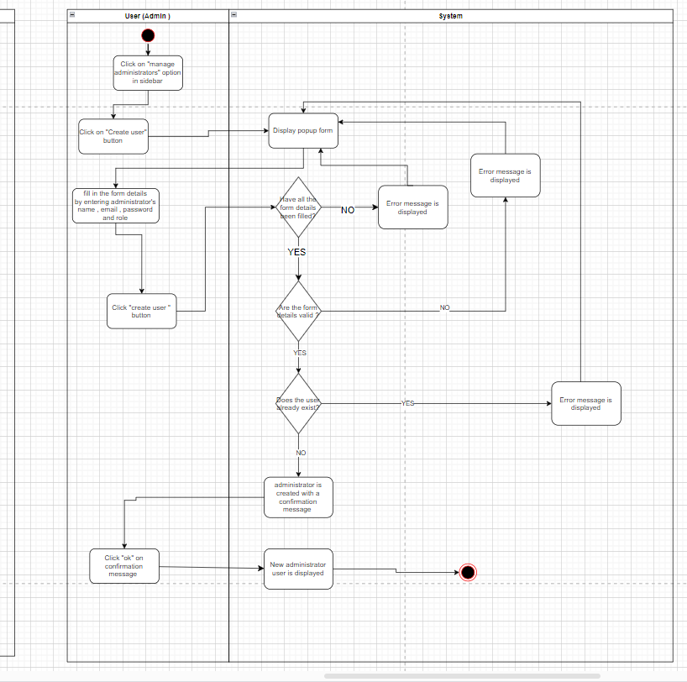

Figure activity diagram sprint 1 admin registration

## View timetable feature for primary students

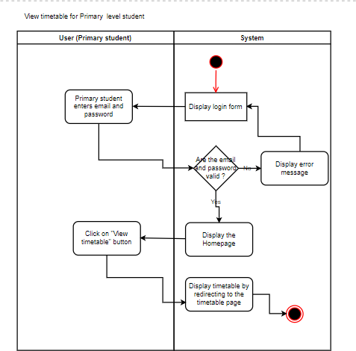

Figure activity diagram sprint 1 view timetable

## Edit student details.

Figure activity diagram sprint 1 edit student user details

## Delete student.

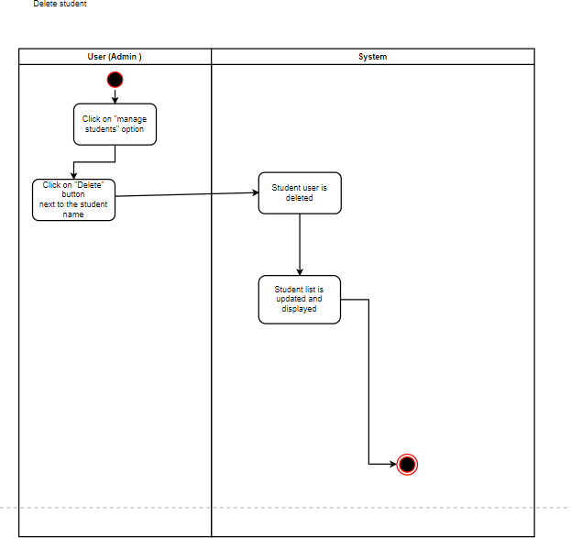

Figure activity diagram sprint 1 delete student

## Inserting image...Edit teacher details.

Figure activity diagram sprint 1 edit teacher details

## Inserting image...Delete teacher.

Figure activity diagram sprint 1 delete teacher

## Edit admin details.

Figure activity diagram sprint 1 edit admin details

## Delete admin.

Figure activity diagram sprint 1 delete admin

## Create calendar event.

Figure activity diagram sprint 1 create calender event

## Edit calendar event.

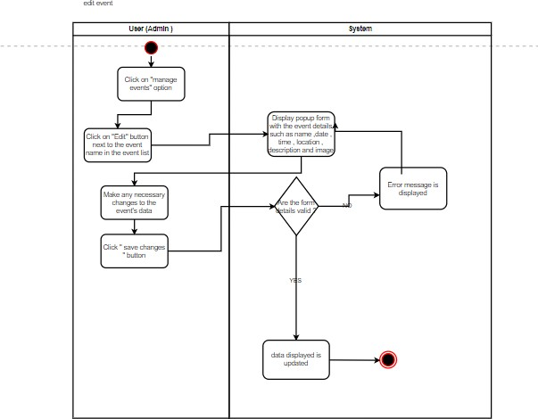

Figure activity diagram sprint 1 edit calender event

## Delete calendar event.

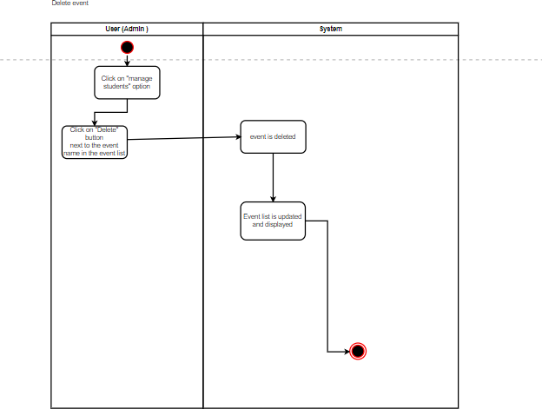

Figure activity diagram sprint 1 delete calender event

# Sequence diagrams

## Login function

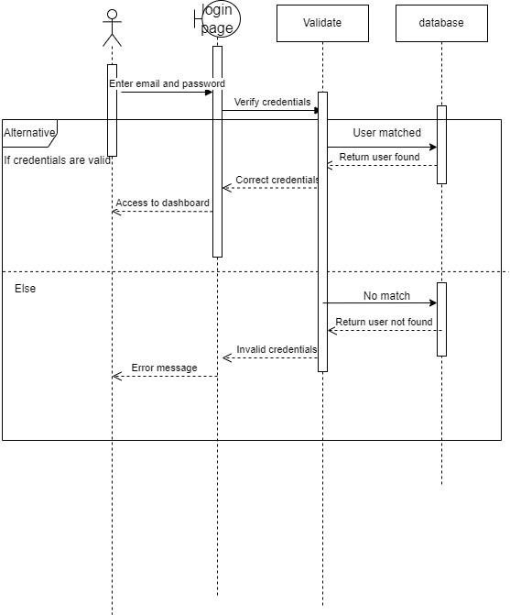

Figure login function sequence diagram sprint 1

# Time management sprint 1.

|  |  |  |  |
| --- | --- | --- | --- |
| Activity  ID | Activity | Predecessors | Duration |
| A | Set up project management platform | None | 1 |
| B | Prepare Use case diagrams | None | 1 |
| C | Prepare activity diagrams. | B | 1 |
| D | Prepare sequence diagrams | C | 1 |
| E | Prepare Figma for interface design. | C, B | 2 |
| F | Initiate new GitHub  repository | None | 1 |
| G | Set up database | none | 2 |

|  |  |  |  |
| --- | --- | --- | --- |
| H | Create admin function to register students, teachers, and administrators. | G | 2 |
| I | Create the frontend of students and teachers'  homepage and dashboard | E | 4 |
| J | Create frontend of login for students’, teachers and  admins | E | 2 |
| K | Create login function with multiuser authentication. | G, H, I, J | 2 |
| L | Create admin functions for  edit, and delete users | G, H | 4 |
| M | Create event management functions with add event, edit event, and delete event features. | G | 5 |
| N | Prepare backend of Primary  students' dashboard to fetch and display timetable. | G, I, K | 3 |
| O | Testing the system | D, G,H,I, J,K,  L,M,N | 1 |
| P | Sprint review | O, A, F , E | 1 |

## AOA diagram Sprint 1

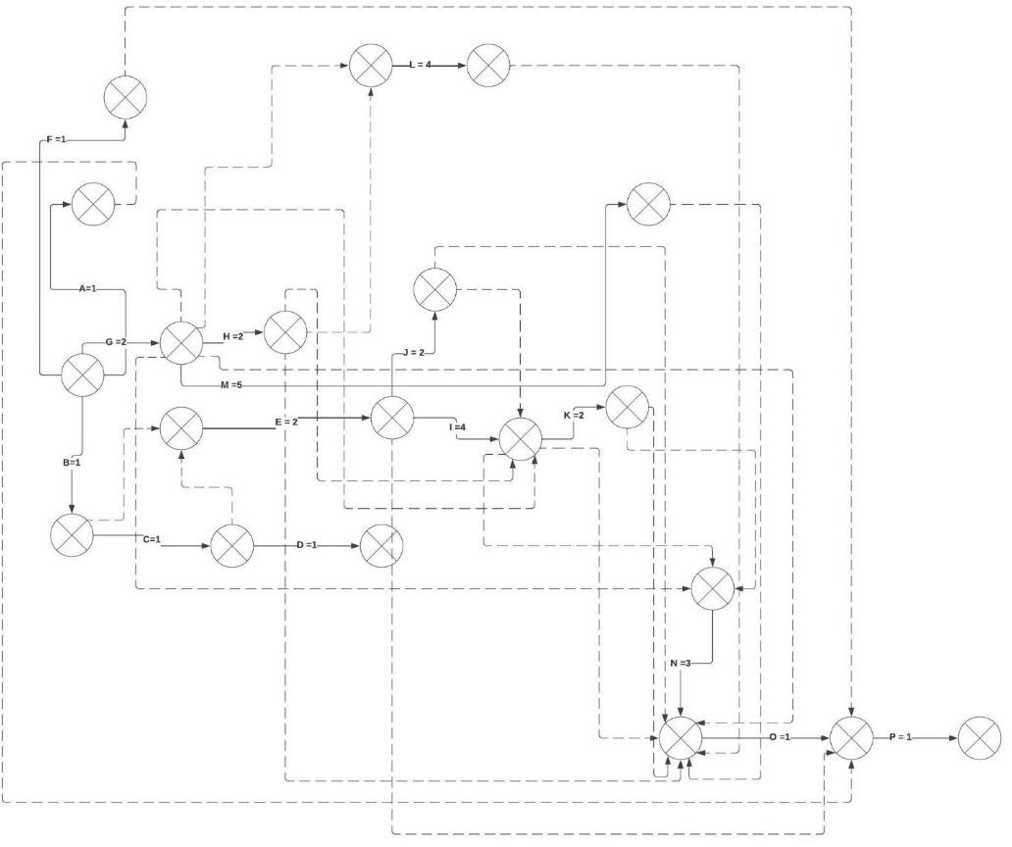

Figure AOA diagram sprint 1

## AON diagram

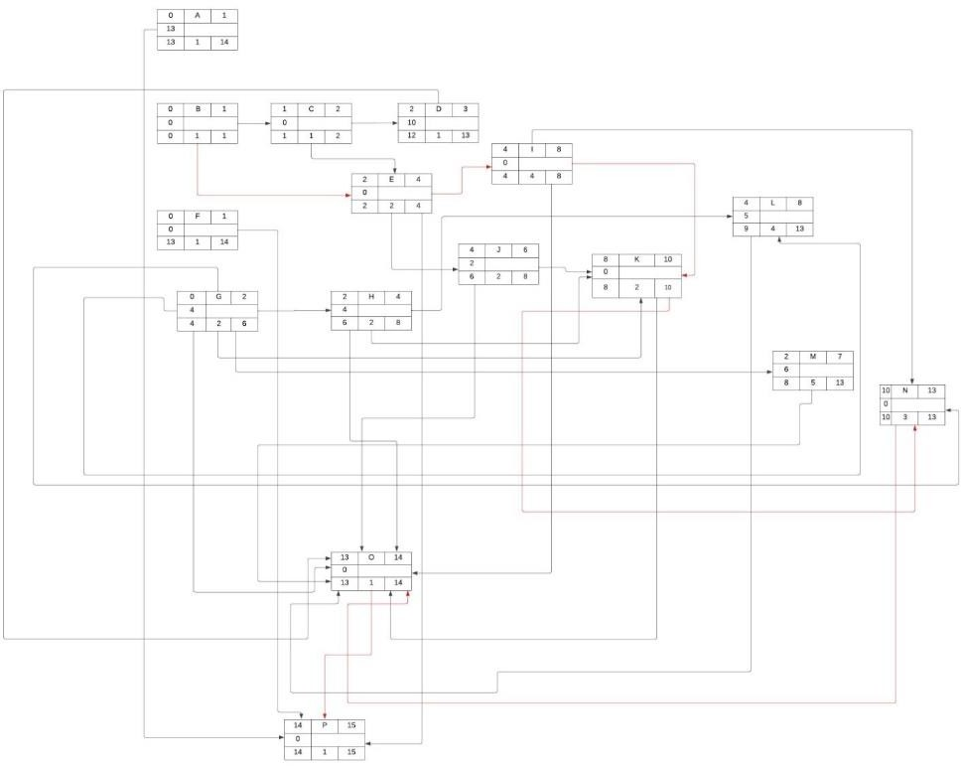

Figure AON diagram Sprint 1

# Implementations Sprint 1.

# VS code folder structure

Figure code Implementations sprint 1

## Mongo db connection

Figure code Implementations sprint 1

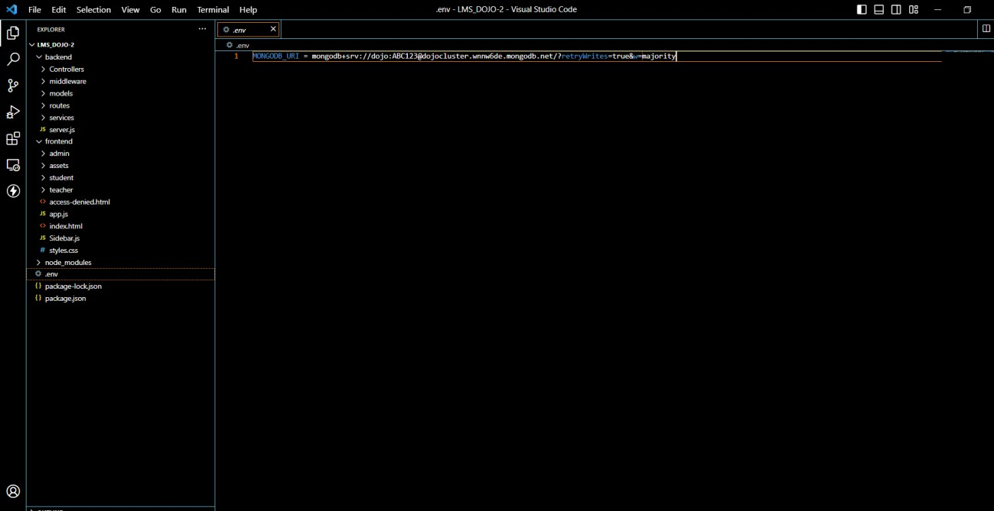

Figure code Implementations sprint 1

## Login function with multiuser authentication

Figure code Implementations sprint 1

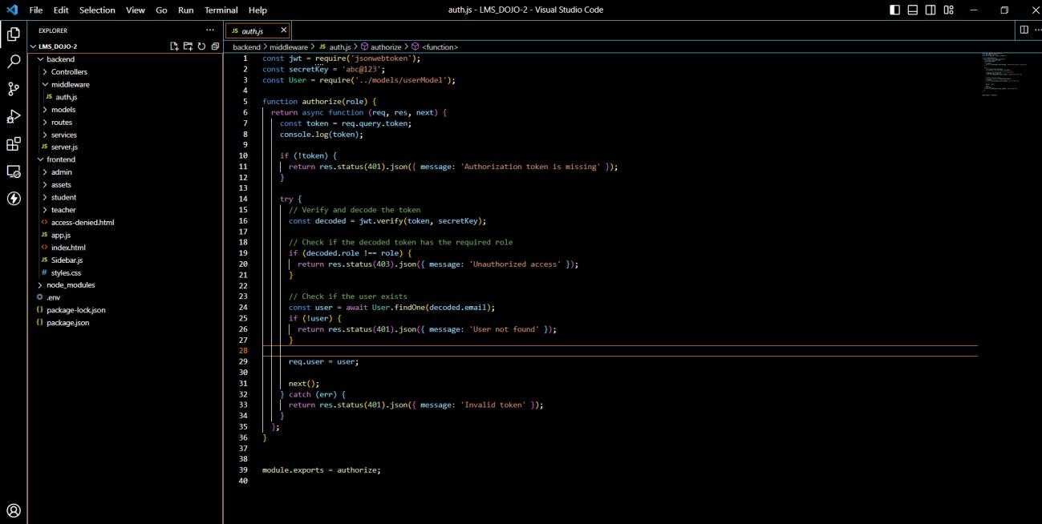

Figure code Implementations sprint 1

*Figure 33*

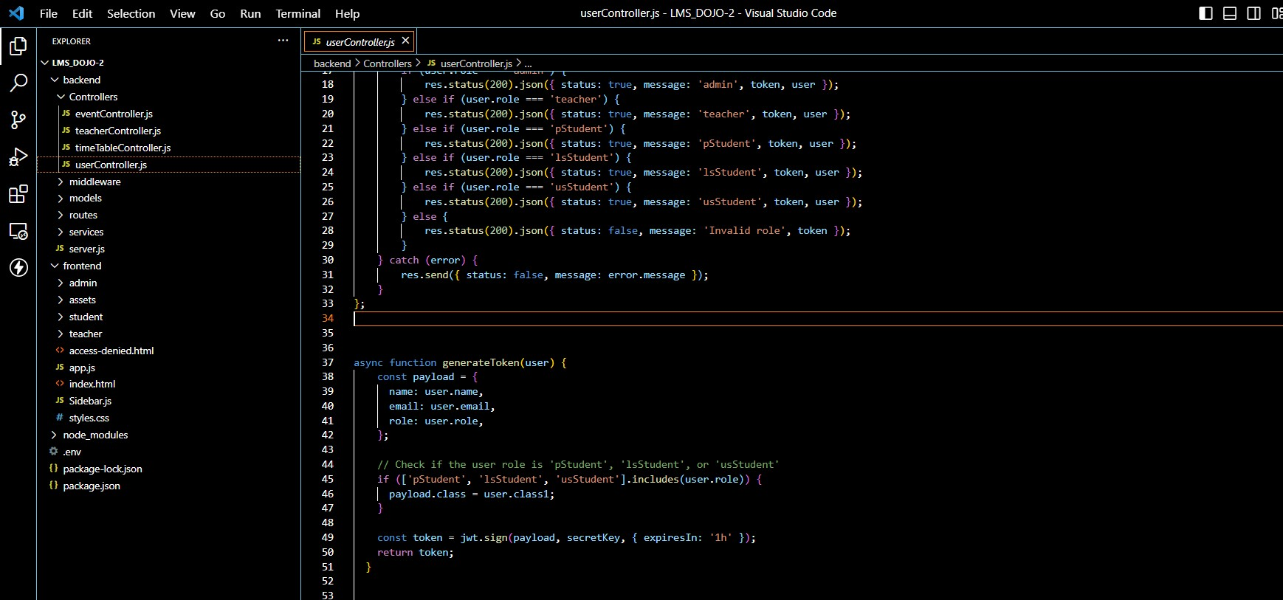

Figure 88 code Implementations sprint 1

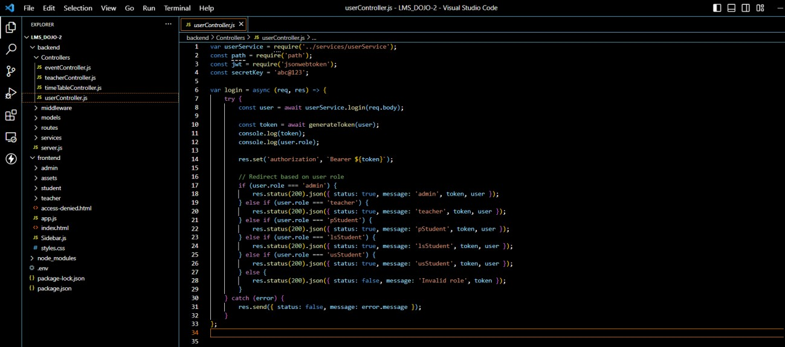

Figure code Implementations sprint 1

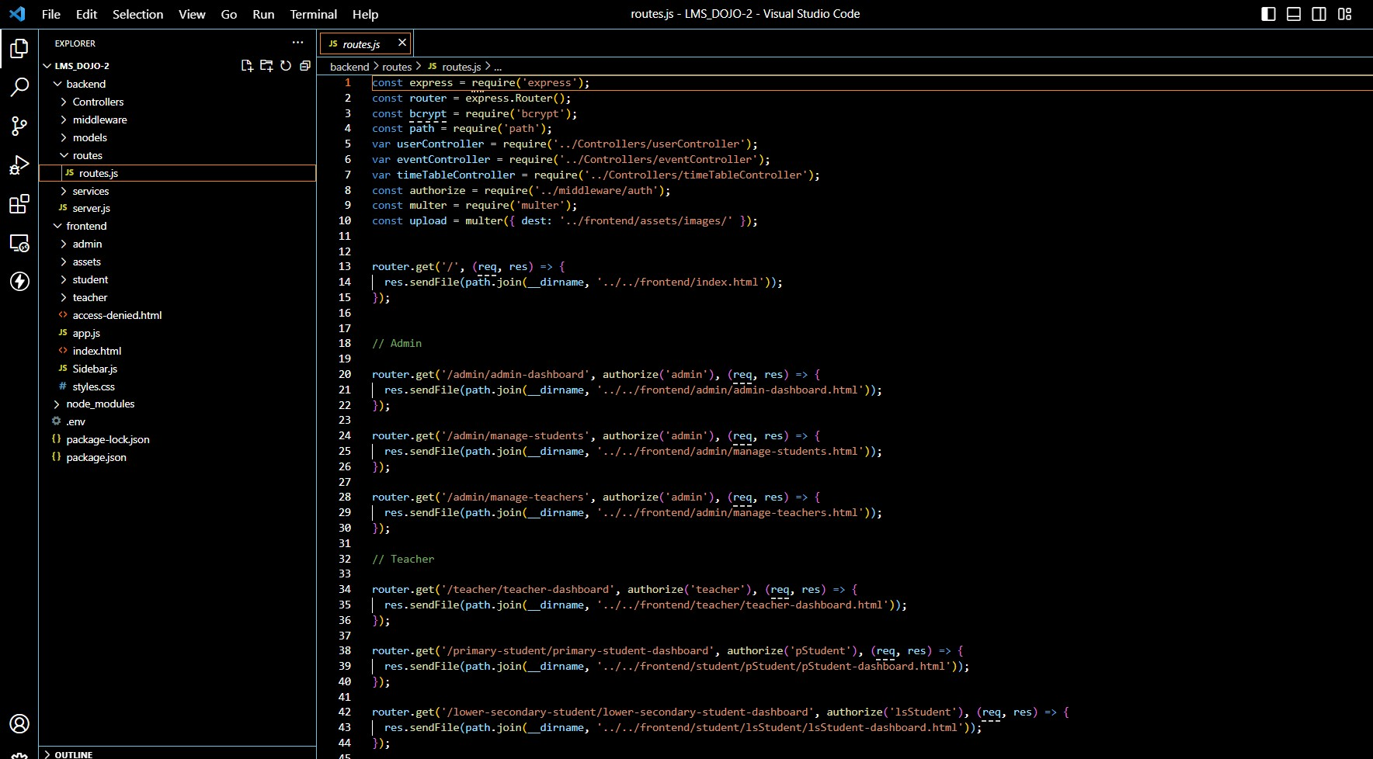

Figure 90 code Implementations sprint 1

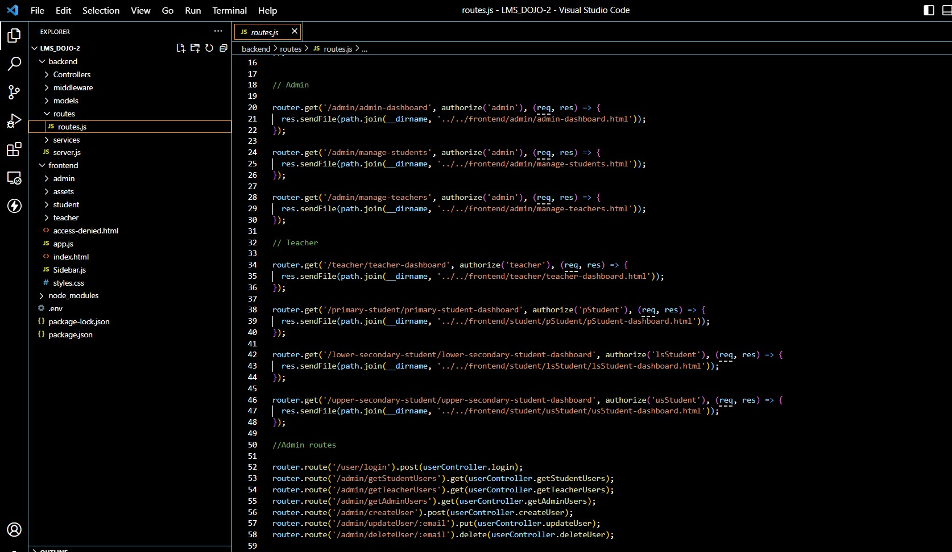

Figure code Implementations sprint 1

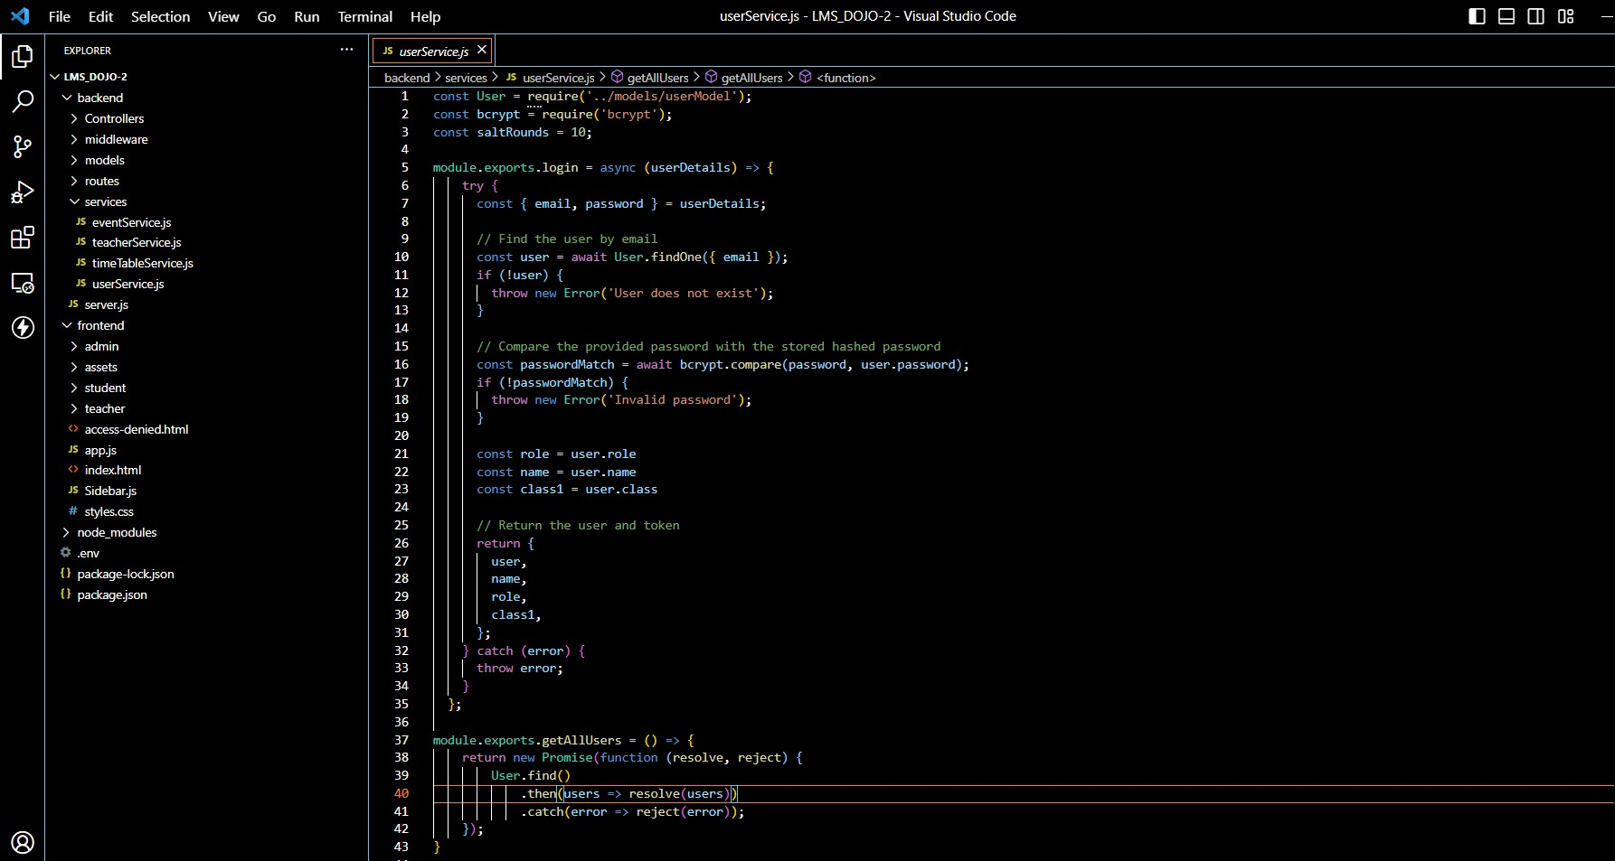

Figure 92 code Implementations sprint 1

## User management

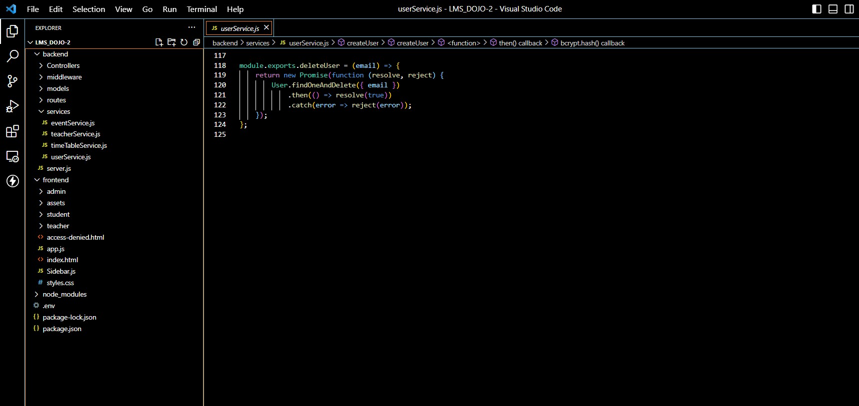

Figure code Implementations sprint 1

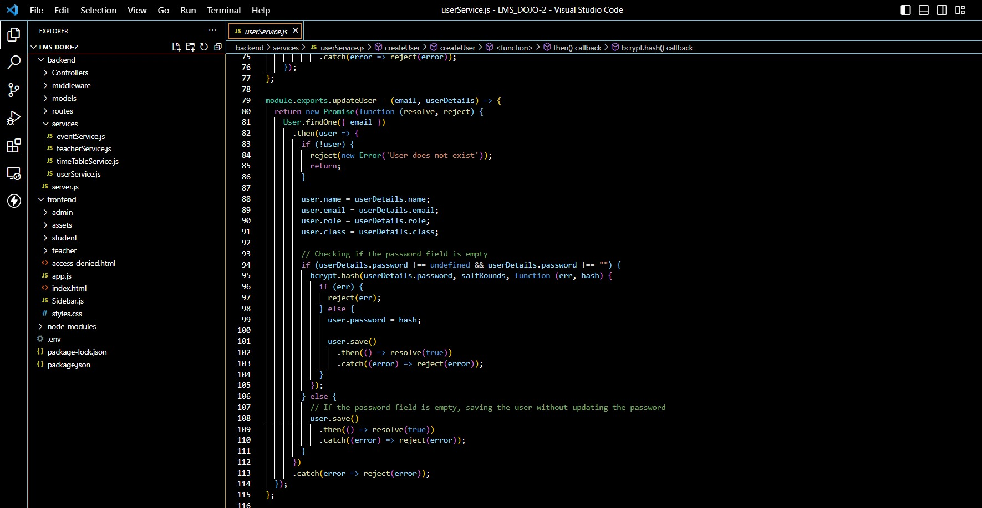

Figure 94 code Implementations sprint 1

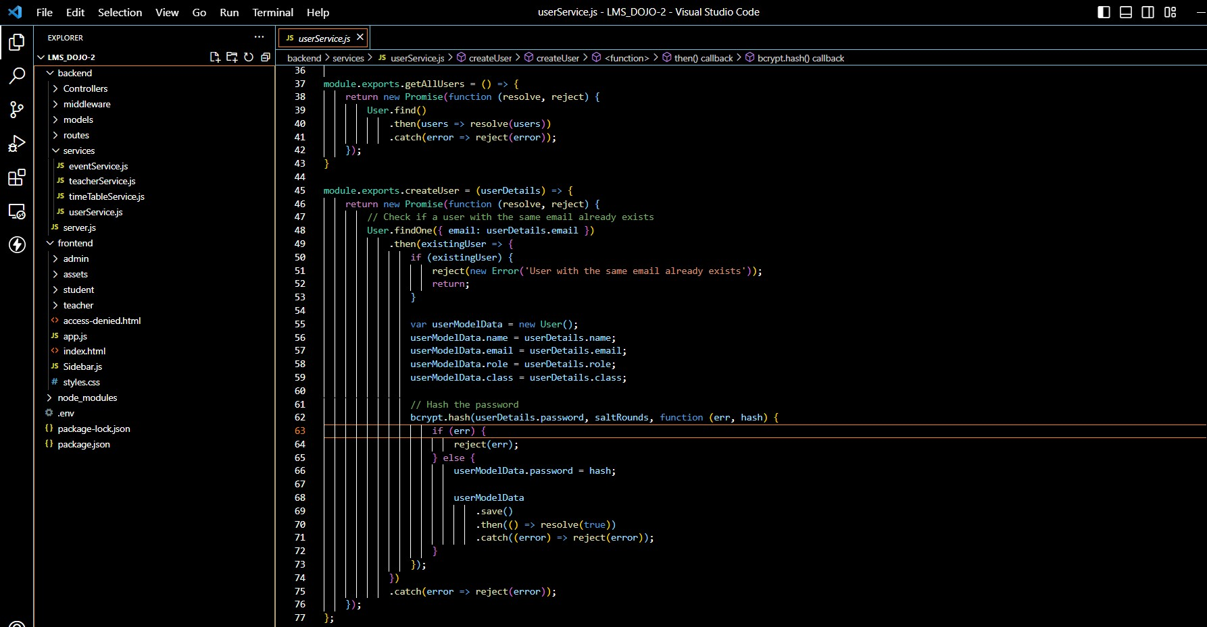

Figure code Implementations sprint 1

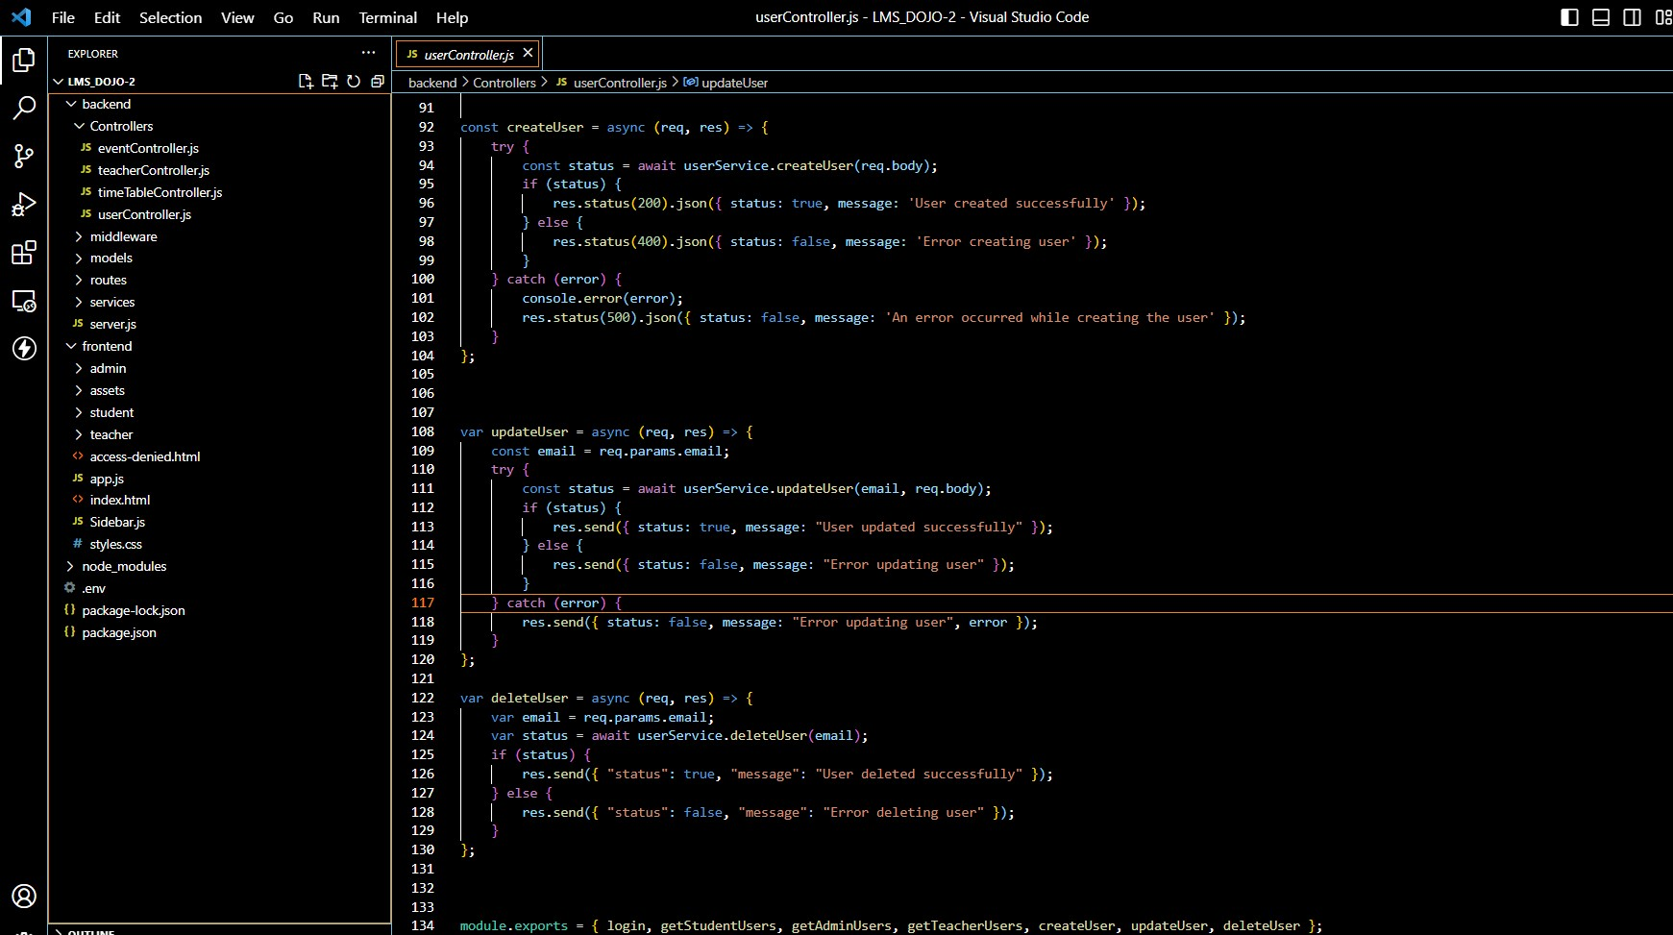

Figure 96 code Implementations sprint 1

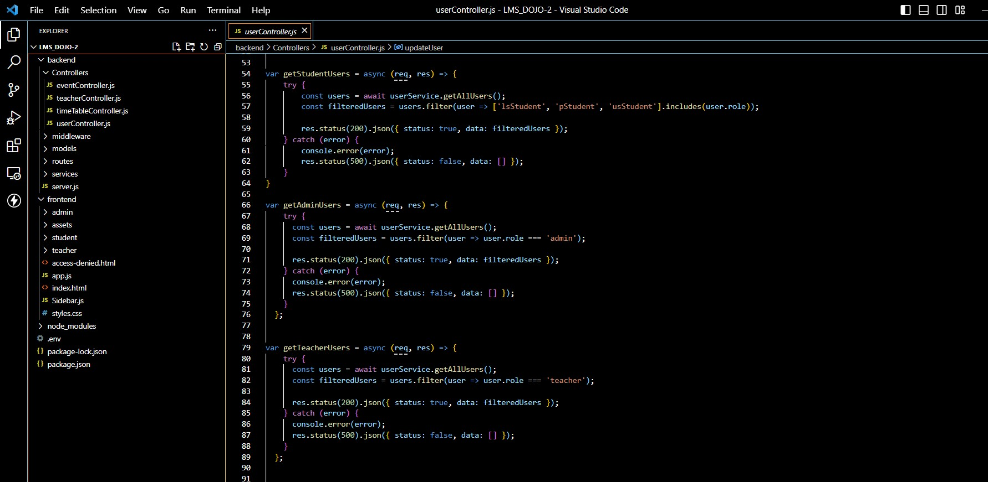

Figure code Implementations sprint 1

## Event management

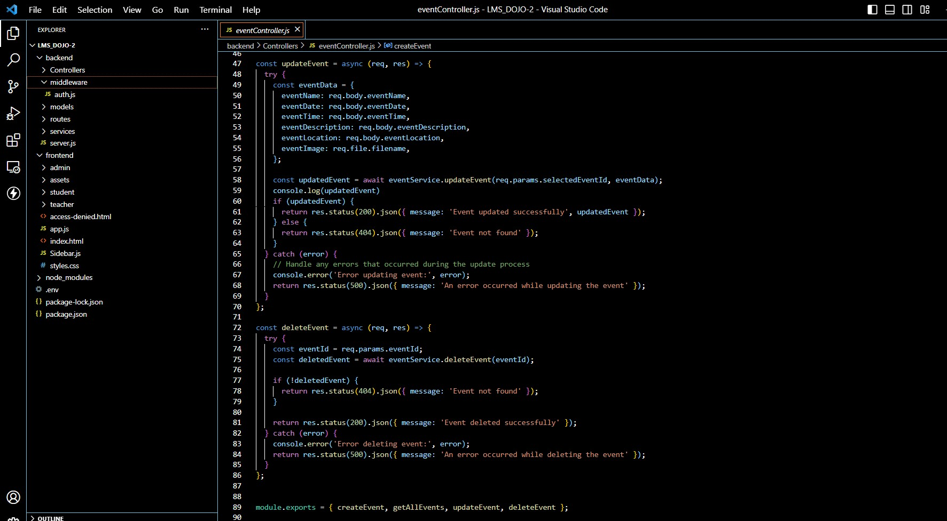

Figure code Implementations sprint 1

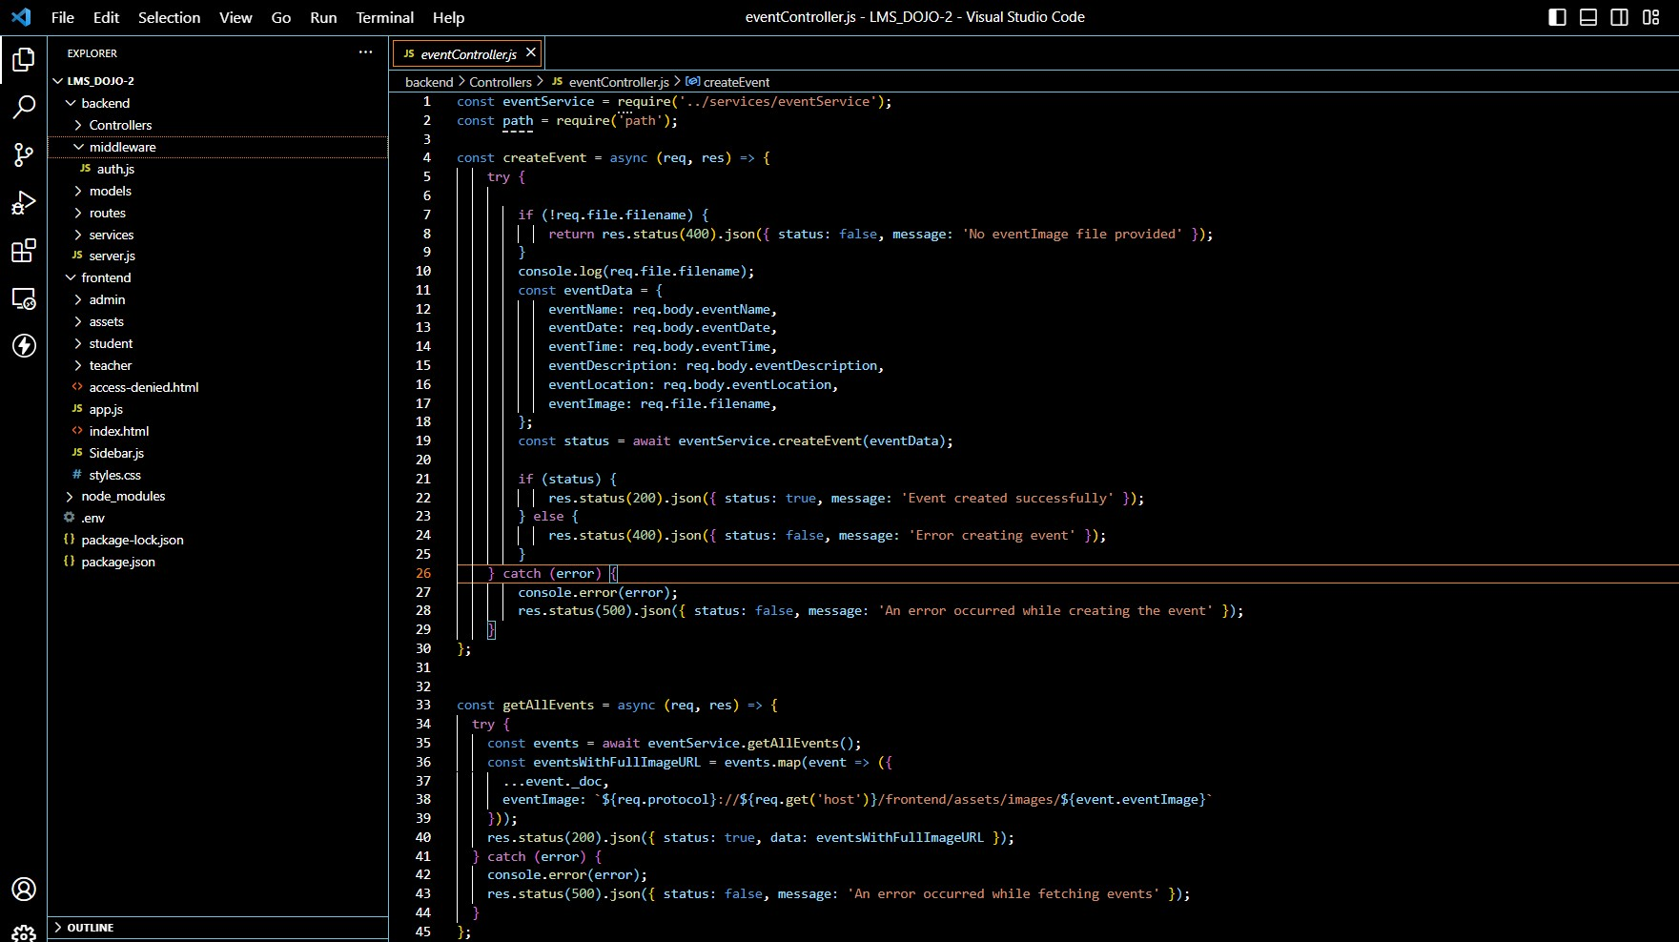

Figure 99 code Implementations sprint 1

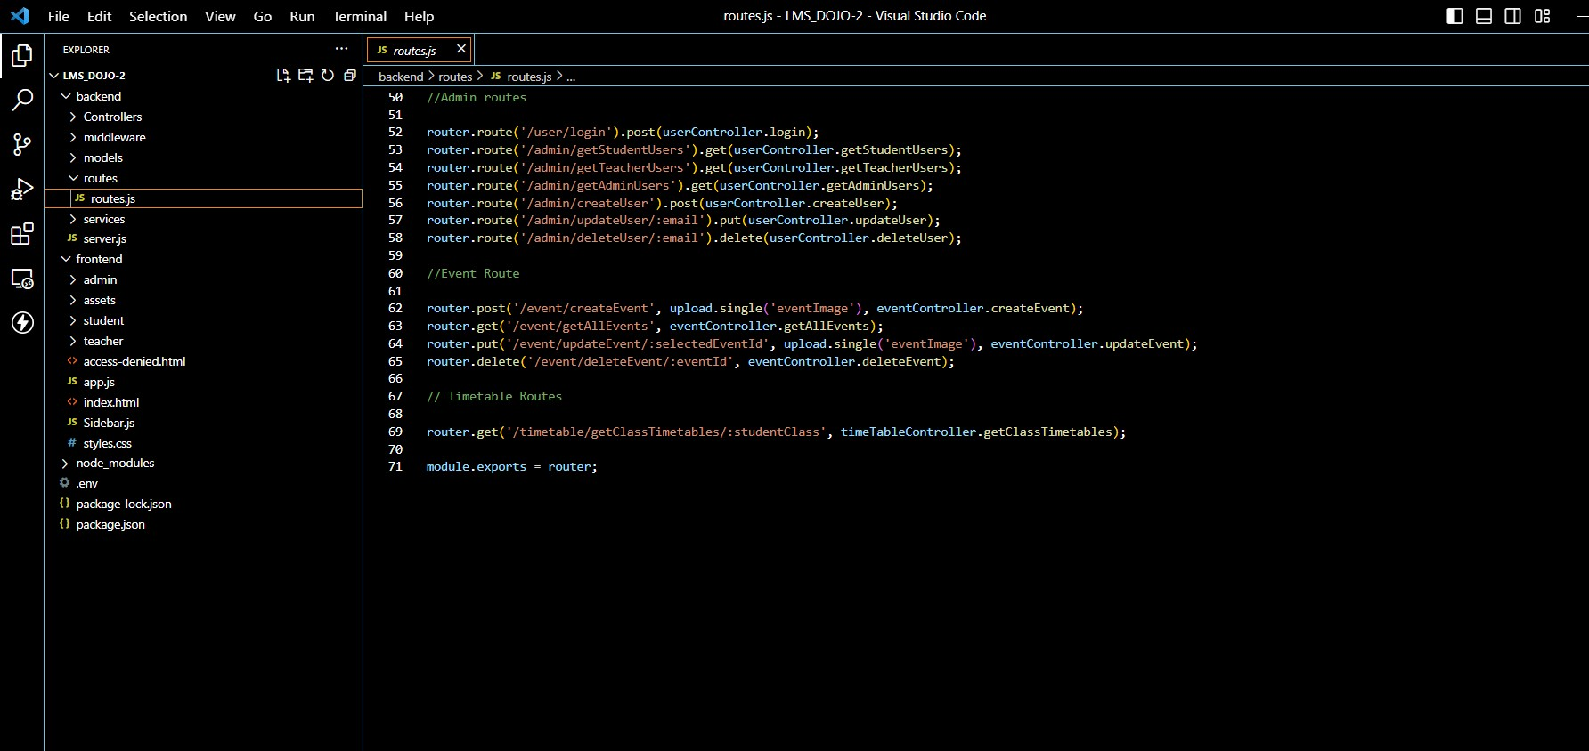

Figure code Implementations sprint 1

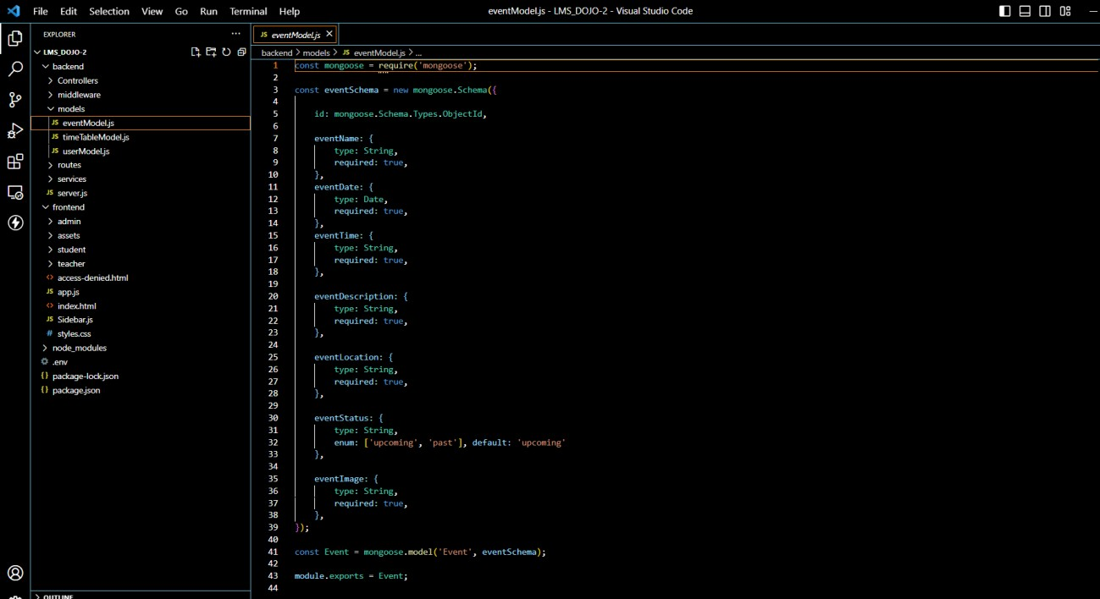

Figure 101 code Implementations sprint 1

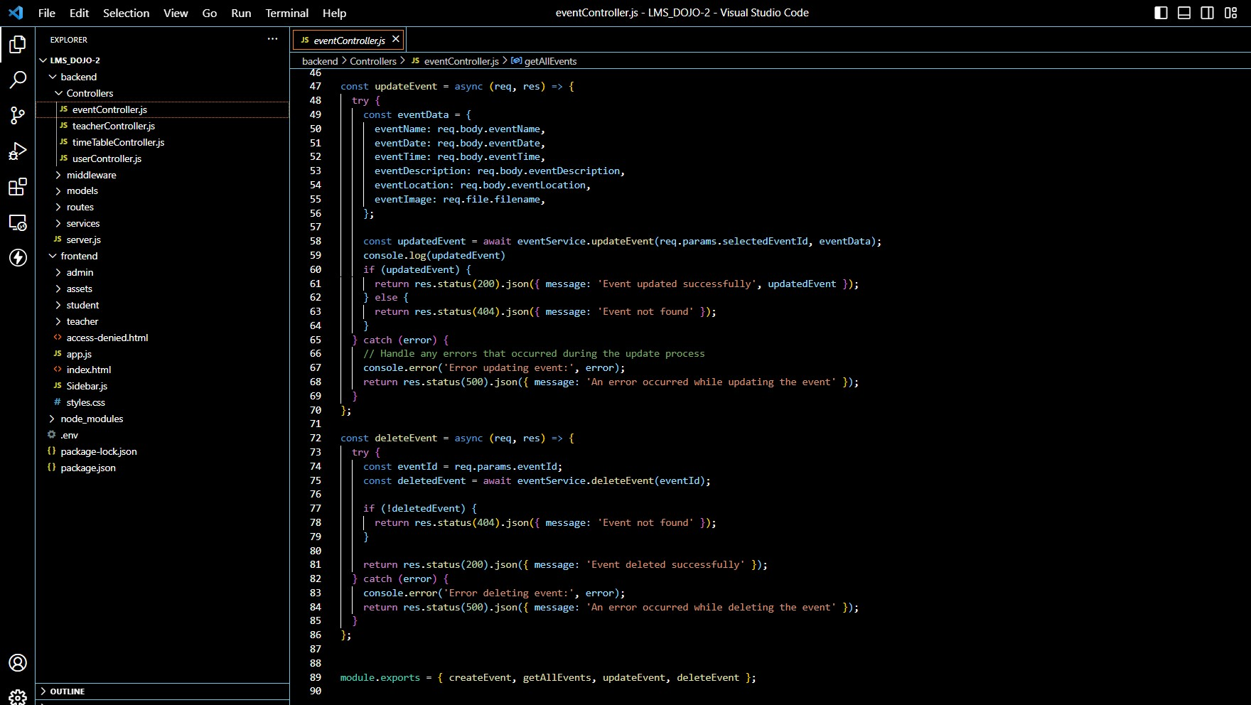

Figure code Implementations sprint 1

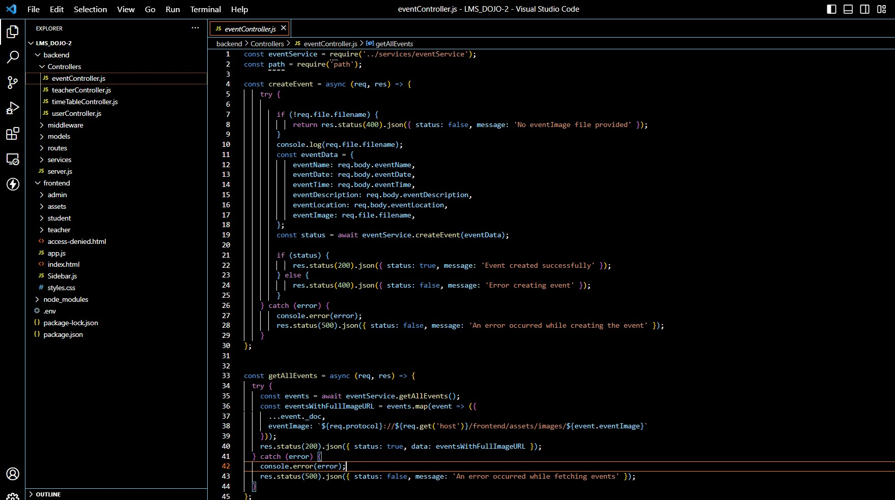

Figure 103 code Implementations sprint 1

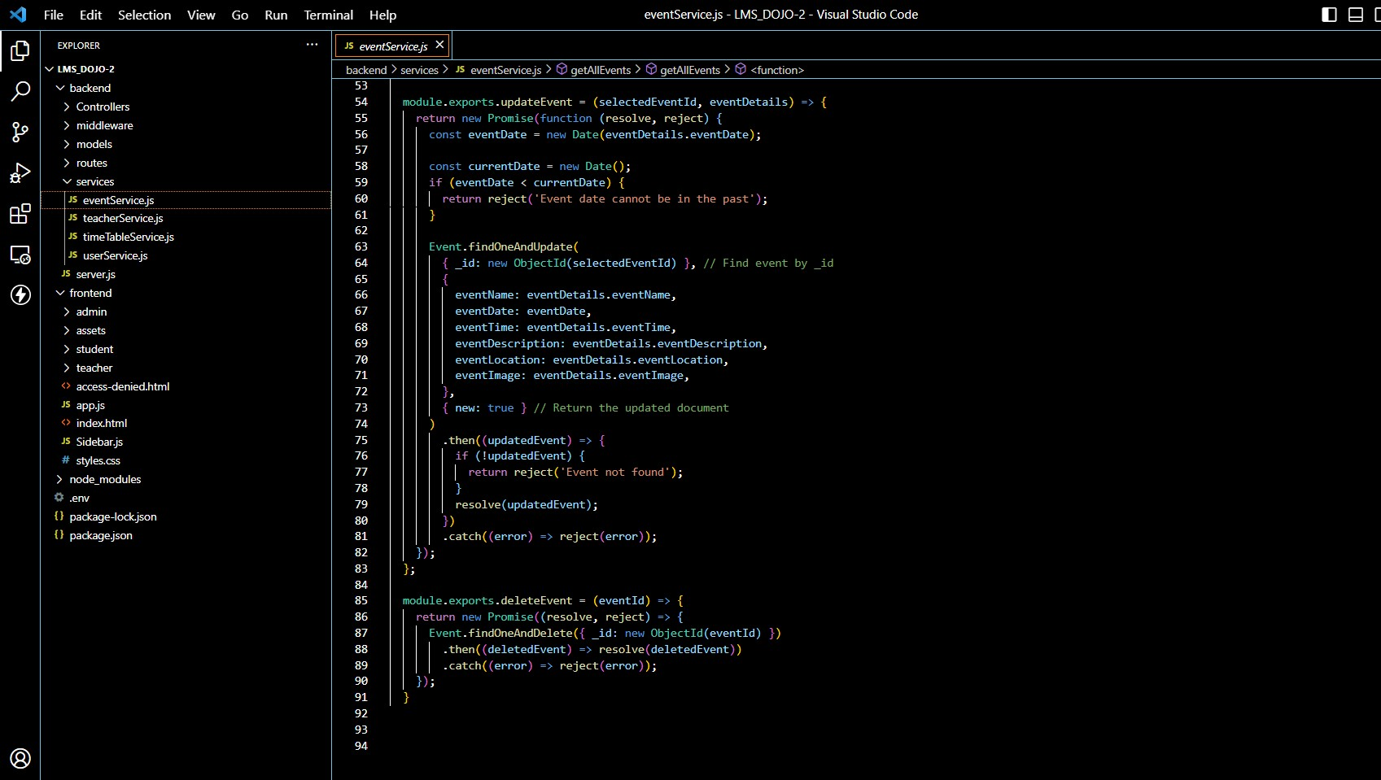

Figure code Implementations sprint 1

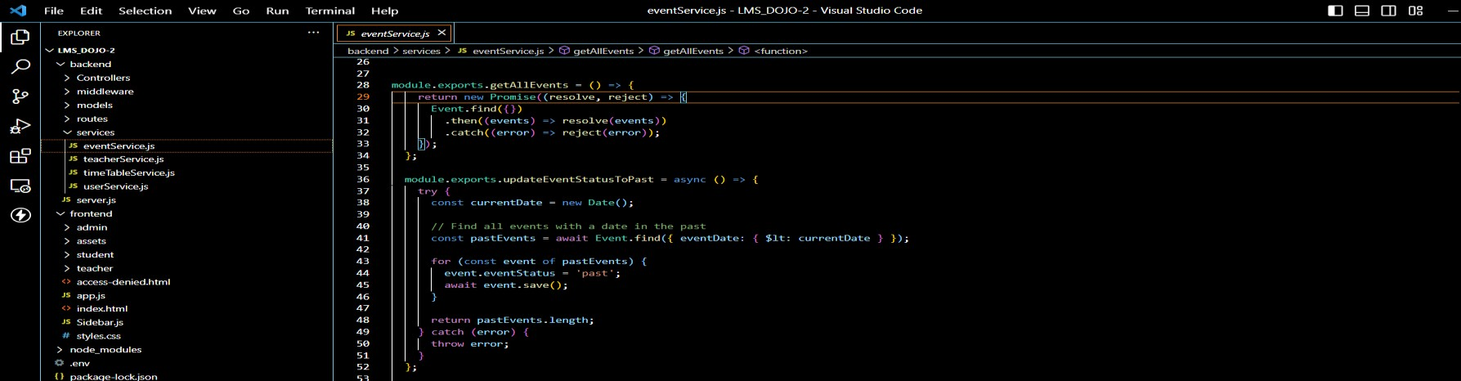

Figure 105 code Implementations sprint 1

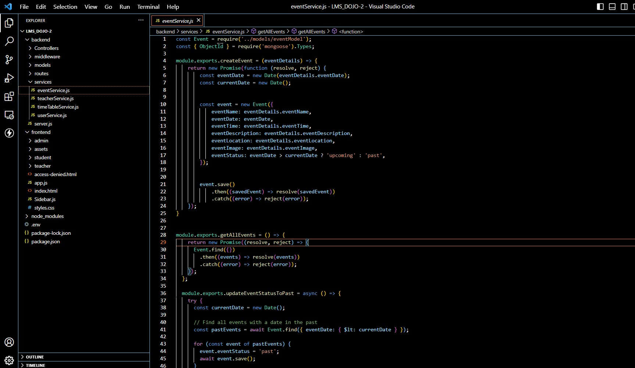

Figure code Implementations sprint 1

## Timetable feature for primary students

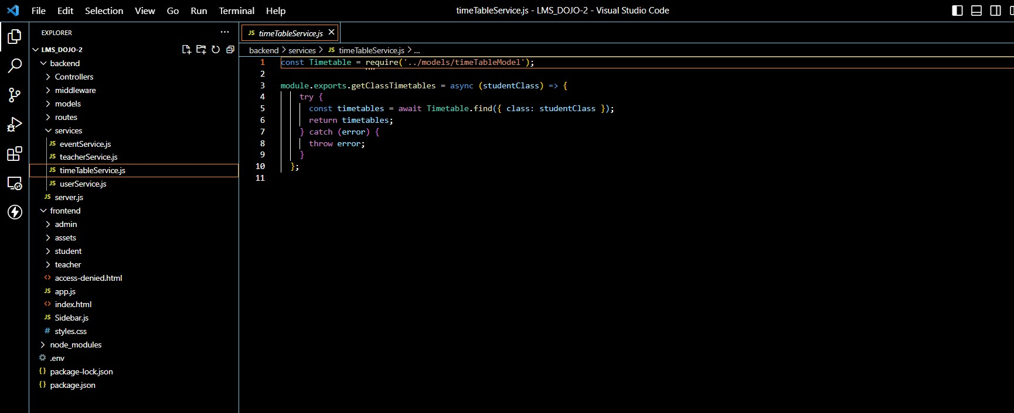

Figure 107 code Implementations sprint 1

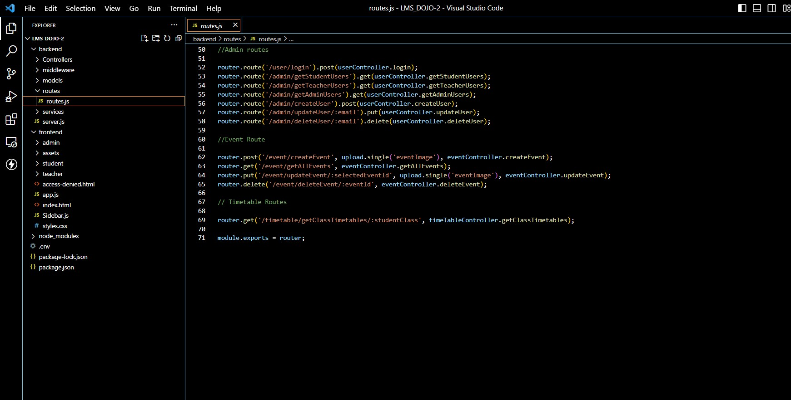

Figure code Implementations sprint 1

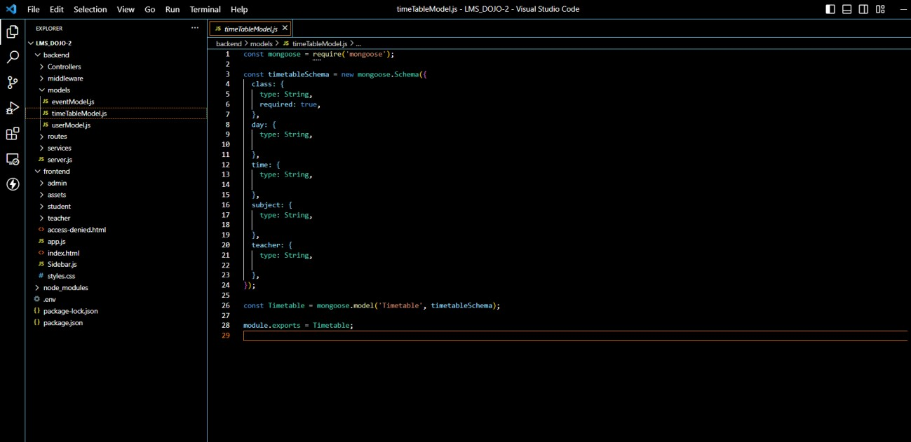

Figure 109 code Implementations sprint 1

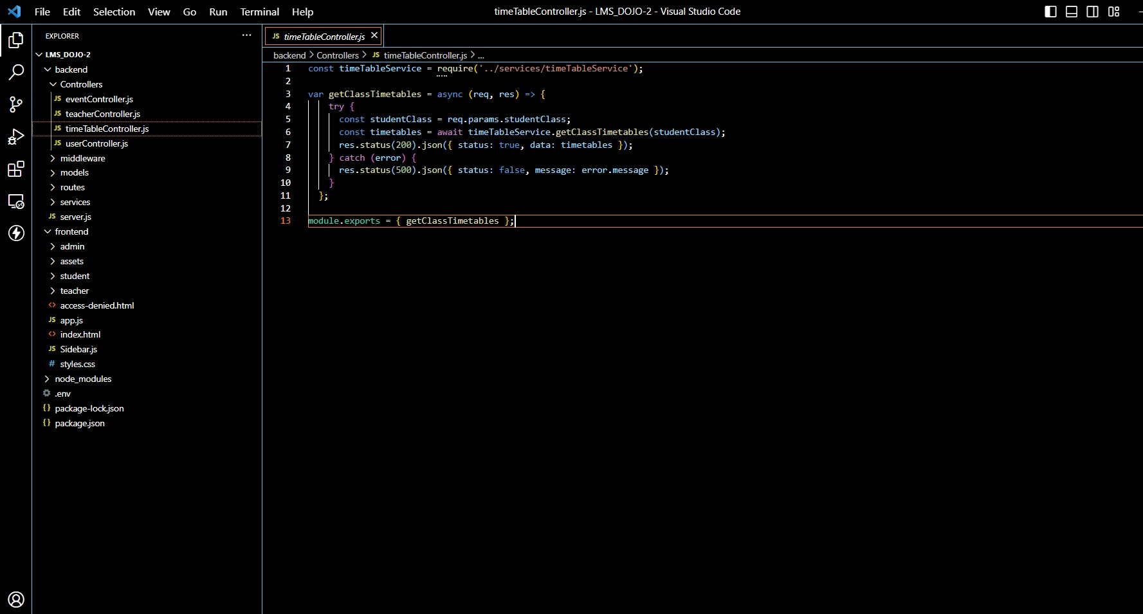

Figure code Implementations sprint 1

Cost management sprint 1

The following cost analysis has been conducted assuming there are 6 working hours per day. The cost per hour has been decided based on the average salary of the respective job role in Sri Lanka. Sources used to determine the average salary per hour have been referenced in the document accordingly.

|  |  |  |  |  |
| --- | --- | --- | --- | --- |
| Responsibility | Role played in the team | Time  invested | Cost per hour | Total cost |
| Sprint 1 | * Scrum master Pasindu lankanath pinidiya bandara   (CB009454) | 24 hours | Rs. 2400 | Rs. 57, 600 |
| * Developer Mohamed ithhaf Mohamed dhanish (CB009562) | 150 hours | Rs 1509.45 | Rs. 226,417.5 |
| * Business analyst Arachchi appuhamillage done dulangi karunasekara (CB010550) | 42 hours | Rs 779.00 | Rs.32,718 |
| * Quality assurance   assurance Pooja selvaraj (CB010098) | 6 hours | Rs 148.00 | Rs.888.000 |

Scrum master:

|  |  |  |
| --- | --- | --- |
| Task | Hours worked | Total cost |
| Task delegation | 1 * 6 | : 4 * 6 * Rs. 2400 =  Rs.32,718 = Rs. 57, 600 |
| Set up project management | 1*6 |
| Preparing a communication plan | 1*6 |
| Meeting arrangements | 1*6 |

Developer:

* Initiate new GitHub repository – 1 day.
* Set up database –2 days.
* Create admin function to register students, teachers, and administrators -2 days.
* Create the frontend of students and teachers' homepage and dashboard – 4 days.
* Create frontend of login for students’, teachers and admins – 2 days
* Create login function with multiuser authentication – 2 days.
* Create admin functions for edit, and delete users – 4 days.
* Create event management functions with add event, edit event, and delete event features

– 5 days.

* Prepare backend of Primary students' dashboard to fetch and display timetable. - 3 days

|  |  |  |
| --- | --- | --- |
| Task | Hours worked | Total cost |
| Initiate new GitHub repository | 1 day *6 hours | 25 * 6 * Rs 1509.45 = Rs.  226,417.5 |
| Set up database | 2 days * 6 hours |
| Create admin function to register students, teachers,  and administrators | 2 days * 6 hours |
| Create the frontend of students and teachers' homepage and dashboard | 4 days * 6 |
| Create frontend of login for students’, teachers and  admins | 2 days * 6 hours |
| Create login function with multiuser authentication | 2 days * 6 hours |

|  |  |  |
| --- | --- | --- |
| Create admin functions for edit, and delete users | 4 days * 6 hours |  |
| Create event management functions with add event, edit event, and delete event features | 5 days * 6 hours |
| Prepare backend of Primary students' dashboard to fetch  and display timetable | 3 days * 6 hours |

Business analyst:

* Prepare Use case diagrams - 1 day.
* Prepare activity diagrams - 1 day.
* Prepare sequence diagrams - 1 day.
* Prepare Figma for interface design - 2 day.
* Sprint review - 1 day

|  |  |  |
| --- | --- | --- |
| Task | Hours worked | Total cost |
| Prepare Use case diagrams | 1 day*6 hours | 7 * 6 * Rs. 779.00 = Rs.32,718 |
| Prepare activity diagrams | 1 day*6 hours |
| Prepare sequence diagrams | 1 day*6 hours |
| Prepare Figma for interface design | 2 days*6 hours |
| Sprint review | 1 day*6 hours |

Quality assurance:

* Testing the system – 1 day

|  |  |  |
| --- | --- | --- |
| Task | Hours worked | Total cost |
| Testing the system | I day * 6 hours | 1 * 6 * Rs.500.00 = Rs.3000.000 |

Sprint retrospective Sprint 1

The purpose of this retrospective is to look back at the sprint we just completed and gauge the positives and negatives of the team’s performance during the sprint. Through this evaluation it is expected to improve ourselves in the next sprint if there were any shortcomings and how to maintain any good practices we displayed during the sprint.

What we achieved

The goals we set forth upon entering sprint were duly completed by meeting the required deadlines and starting the sprint on the set date itself. By adhering to our deadlines and keenly working on the project tasks we were able to achieve all our sprint goals.

We successfully created the login and registration functions for the LMS users with multi-user authentication. Furthermore, we created user management and event management features and set up the frontend of the user dashboards (Primary students, lower secondary students, upper secondary students, teachers and administrators' dashboards).

* We were able to prepare use cases, activity diagrams and sequence diagrams to understand and structure how the system works.
* We created a Figma design which we will be using to refine our user interface in the relevant sprints.
* We were able to successfully achieve our sprint goals for sprint 1.
* We completed the tasks set under sprint 1 in the work breakdown structure.
* We were able to enhance our knowledge of new programming languages being used in the industry.
* Our knowledge on how real-world coding projects is conducted has improved.
* Our knowledge of the preliminary activities that preceded real-world coding projects such UML diagramming, cost planning has vastly improved.

Challenges

Following were some of the challenges we faced during sprint 1.

* It was a challenge to organize meetings at a time that suited all the team members –

As the members all have their own personal schedule it was difficult to organize meetings on the predetermined sprint review dates.

* It was a challenge to keep the team constantly updated – There were instances when the members failed to update the Trello board to let the rest of the team know once a task has been completed.
* It was a challenge to agree on the Figma design – As every individual has different tastes and ideas, agreeing on design components took quite time. However, we were able to make a final design that the entire team was satisfied with.

What we can improve

To ascertain the smooth running of our future sprints here’s what we can improve and fix in our team’s performance.

* Be more flexible to spend more time on team tasks – Once a task has been taken over it is vital to see that it’s handled responsibly and completed on time.
* Start researching the different processes such as UML diagramming, cost analysis sooner so that the sprint deadlines are not affected negatively – As some of the requirements of this document such as preparing a pert analysis was relatively new to the team, it is important to start our research sooner.
* We can communicate more effectively and keep each other more up to date on the sprint progress – Communicating with the team the challenges faced during task completion and keeping the team updated will help the members assist each other more and contribute to the team’s success further.

Action plan

Below is our action plan to improve our team’s efforts in the upcoming sprints:

* Having more frequent meetings – by conducting meetings twice a week will help prevent communication gaps.
* Ensure the participation of all team members in the meetings – The strum master will make sure the team reaches an agreement on a proper time and date and the entire team attends the meeting without fail.
* Update the Trello board in a timely manner – Having reminders on our mobile devices to update our Trello boards will further prevent communication gaps.

Communication plan Sprint 1

|  |  |  |  |  |
| --- | --- | --- | --- | --- |
| Meeting title | Mode | Date | Attendees | Purpose |
| Sprint initialization meeting | Physical | 4th July | * Scrum master * Developer * Business analyst * Quality assurance | * We decided the goals of the sprint and the tasks of each member according to their roles. * We decided the functions we need to complete according to the WBS. |
| 1st review | Physical | End of week one of sprint 1 - 11TH July | * Scrum master * Developer * Business analyst * Quality assurance | * We reviewed the use cases and activity diagrams. * We were able to review our Figma design and make any suitable changes. |
| 2nd review | Physical | End of week two of sprint 1 – 18th July | * Scrum master * Developer * Business analyst * Quality assurance | We reviewed the code progress and the tasks left to be completed. |
| 3rd review | Physical |  | * Scrum master * Developer * Business analyst * Quality assurance | * We reviewed the code progress and the tasks left to be completed. * We attempted to get an understanding of how to test our system. |

|  |  |  |  |  |
| --- | --- | --- | --- | --- |
| Final review | Physical | End of week four of sprint 1 – 1st August | * Scrum master * Developer * Business analyst * Quality assurance | We tested our system and made sure all the intended features of sprint 1 were functional and usable.  Hence, we were able to test the following:  **Register and login with multiuser authentication.**   * User registration function of admin by registering students, teachers and administrators based on their roles. * We tested the login system and made sure the users are redirected to the correct dashboard based on their role.   **User Management:**   * We tested the * Create student, edit student, and delete student functions of administrators. * We tested the create teacher, edit teacher, and delete teacher functions of admin. * We tested the create administrator, edit administrator, and delete administrator functions of admin.   **Event calendar:** |

|  |  |  |  |  |
| --- | --- | --- | --- | --- |
|  |  |  |  | We tested the create events, edit events and delete events functions of admin. |

Test logs Sprint 1

|  |  |  |  |  |  |  |  |
| --- | --- | --- | --- | --- | --- | --- | --- |
| testca se ID | Descripti on | Pre-condition | Test procedure | test inputs | Expected output | Actual output | Result |
| TC00 1 | Register Primary students to the  LMS | The admin must be logged in to the system. Database must be up  and running | Admin: 1) click on “create user”  2) Add in user details 3) click "create user "  button | Student name: Primary student.  2) Email: [PrimaryStudent @gmail.com](mailto:PrimaryStudent@gmail.com) 3) password:1234 5678   1. Role: Primary student 2. Class: 1A | Student is added to the database. Student is displayed in the admin's students list. Student is able to log into  the LMS. | Student is added to the Database.  Student is displayed in the admin's students list. Student is able to log into  the LMS. | PASS |
| TC00 2 | Register Lower secondar y students to the  LMS | The admin must be logged in to the system. Database must be up  and running | Admin: 1) click on “create user”  2) Add in student details of the lower secondary student 3) click "create user "  button | Student name: Lower secondary student. 2) Email: [LoweSecondar](mailto:LoweSecondaryStudent@gmail.com) [yStudent@gma](mailto:LoweSecondaryStudent@gmail.com) [il.com](mailto:LoweSecondaryStudent@gmail.com) 3)password: 12345678   1. Role: lower secondary student 2. class: 6A | Lower secondary level student is added to the Database. Student is displayed in the admin's students list. Student is able to log into  the LMS. | Student is added to the Database.  Student is displayed in the admin's students list. Student is able to log into  the LMS. | PASS |
| TC00 3 | Register upper secondar y students (Collegia te level) to the  LMS | The admin must be logged in to the system. Database must be up  and running | Admin: 1) click on “create user”  2) Add in student details of the upper secondary student 3) click "create user "  button | Student name: upper secondary student. 2) Email: [UpperSecondar](mailto:UpperSecondaryStudent@gmail.com) [yStudent@gma](mailto:UpperSecondaryStudent@gmail.com) [il.com](mailto:UpperSecondaryStudent@gmail.com) 3) password: 12345678 4)  Role: Upper secondary student  Class:11A | Upper secondary level student is added to the Database.  Student is displayed in the admin's students list. Student is able to log into  the LMS. | Student is added to the Database.  Student is displayed in the admin's students list. Student is able to log into  the LMS. | PASS |

|  |  |  |  |  |  |  |  |
| --- | --- | --- | --- | --- | --- | --- | --- |
| TC00 4 | Register teachers to the LMS | The admin must be logged in to the system. Database must be up  and running | Admin: 1) click on "Manage teachers " 2) Click on " Create User" 3) Add in details of the teacher 3) click "create  user " button | 1)Student name: Teacher. 2) Email: [Teacher@gmai l.com](mailto:Teacher@gmail.com) 3)password: 12345678 4)  Role : teacher | Teacher is added to the Database. Teacher is displayed in the admin's teachers list. Teacher is able to log into  the LMS. | Teacher is added to the Database.  Teacher is displayed in the admin's teachers list. Teacher is able to log into  the LMS. | PASS |
| TC00 5 | Register administ rators to the LMS | The admin must be logged in to the system. Database must be up  and running | Admin: 1) click on "Manage administrators"2  ) Click on " Create User" 3) Add in details of the administrator 3) click "create  user " button | 1. Student name: Administrator. 2. Email: [administrator@ gmail.com](mailto:administrator@gmail.com) 3)password 12345678   4) Role: admin | Admin is added to the Database. Admin is displayed in the admin's admins list. Admin is able to log into  the LMS. | Admin is added to the Database  . Admin is displayed in the admin's admins list. Admin is able to log into  the LMS. | PASS |
| TC00 6 | Primary  student login | The database must be up and running. The student must be registered in  the system | primary student:   1. Enter email address and password. 2. Click "sign   in "button | 1) Email: [PrimaryStudent @gmail.com](mailto:PrimaryStudent@gmail.com) 1) password:1234  5678 | Student is redirected to the primary students'  dashboard | Student is redirected to the primary students'  dashboard | PASS |
| TC00 7 | Lower secondar y student  login | The database must be up and running. The student must be registered in  the system | Lower secondary student: 1) Enter email address and password.  2) Click "sign in  "button | 1. Email: [LowerSecondar yStudent@gma il.com](mailto:LowerSecondaryStudent@gmail.com) . 2. password:   12345678 | Student is redirected to the Lower secondary students'  dashboard | Student is redirected to the Lower secondary students'  dashboard | PASS |
| TC00 8 | Upper secondar y student  login | The database must be up and running. The student must be registered in  the system | Upper secondary student: 1) Enter email address and password 2  ) Click "sign in  "button | 1) Email: Upper [SecondaryStud ent@gmail.co m](mailto:SecondaryStudent@gmail.com) .2) password:  12345678 | Student is redirected to the Upper secondary students'  dashboard | Student is redirected to the Upper secondary students'  dashboard | PASS |
| TC00 9 | Teacher login | The database must be up and running. The teacher  must be | Teacher: 1) Enter email address and password 2) Click "sign in  "button | 1) Email: [teacher@gmail. com](mailto:teacher@gmail.com) .2) password:  12345678 | Teacher is redirected to the Teacher's  dashboard | Teacher is redirected to the Teachers'  dashboard | PASS |

|  |  |  |  |  |  |  |  |
| --- | --- | --- | --- | --- | --- | --- | --- |
|  |  | registered in the system |  |  |  |  |  |
| TC01 0 | Admin login | The database must be up and running. The admin must be registered in  the system | Admin: 1) Enter email address and password .  2) Click "sign in "button | 1. Email : [admin@gmail. com](mailto:admin@gmail.com) . 2. password: 12345678 | Admin is redirected to the admins'  dashboard | Admin is redirected to the admins'  dashboard | PASS |
| TC01 1 | Edit Primary student  details | The database must be up and running. The admin must be registered in  the system | Admin: 1) Click on "Mange students” option in admin side panel. 2) Click the “Edit" button next to the primary student's name in the admins' students list. 3) Change the student's details in the pop form as required.  4)click on “save  changes” button. | User: old email is "[PrimaryStude](mailto:PrimaryStudent@gmail.com) [nt@gmail.com](mailto:PrimaryStudent@gmail.com) " .  New email :  [PStudent@gma](mailto:PStudent@gmail.com) | 1)New email of the student is displayed in the database and the admin's students list. 2) The email is now  [PStudent@gmai](mailto:PStudent@gmail.com) | 1)New email of the student is displayed in the database and the admin's students list. 2) The email is now [PStudent@gmai](mailto:PStudent@gmail.com)  [l.com](mailto:PStudent@gmail.com) | PASS |
| [il.com](mailto:PStudent@gmail.com) | [l.com](mailto:PStudent@gmail.com) |
| TC01 2 | Edit Lower secondar y student  details | The database must be up and running. The admin must be registered in  the system | Admin: 1) Click on "Mange students” option in admin side panel. 2) Click the “Edit" button next to the Lower secondary name in the admins' students list.  3) Change the student's details in the pop form as required. 4)click on “save changes” button. | User: old email is [LowerSecondar](mailto:LowerSecondaryStudent@gmail.com) [yStudent@gma](mailto:LowerSecondaryStudent@gmail.com) [il.com](mailto:LowerSecondaryStudent@gmail.com).  New email: [LSStudent@g](mailto:LSStudent@gmail.com)  [mail.com](mailto:LSStudent@gmail.com) | 1)New email of the student is displayed in the database and the admin's students list. 2) The email is now [LSStudent@gm](mailto:LSStudent@gmail.com)  [ail.com](mailto:LSStudent@gmail.com) | 1)New email of the student is displayed in the database and the admin's students list. 2) The email is now [LSStudent@gm](mailto:LSStudent@gmail.com)  [ail.com](mailto:LSStudent@gmail.com) | PASS |

|  |  |  |  |  |  |  |  |
| --- | --- | --- | --- | --- | --- | --- | --- |
| TC01 3 | Edit upper secondar y student  details | The database must be up and running. The admin must be registered in  the system | Admin: 1) Click on "Mange students" option in admin side panel. 2) Click the “Edit" button next to the upper secondary name in the admins' students list. 3) Change the student's details in the pop form as required.  4)click on “save changes” button. | User: old email is "[UpperSeconda](mailto:UpperSecondaryStudent@gmail.com) [ryStudent@gm](mailto:UpperSecondaryStudent@gmail.com) [ail.com](mailto:UpperSecondaryStudent@gmail.com)". New email: [USStudent@g](mailto:USStudent@gmail.com)  [mail.com](mailto:USStudent@gmail.com) | 1)New email of the student is displayed in the database and the admin's students list. 2) The email is now [USStudent@gm](mailto:USStudent@gmail.com)  [ail.com](mailto:USStudent@gmail.com) | 1)New email of the student is displayed in the database and the admin's students list. 2) The email is now [USStudent@gm](mailto:USStudent@gmail.com)  [ail.com](mailto:USStudent@gmail.com) | PASS |
| TC01 4 | Delete primary student  details | The database must be up and running. The admin must be registered in  the system | Admin: 1) Click on "Mange students” option in admin side panel.  2) Click the “Delete" button next to the primary student's name in the admins'  students list. | Click "Delete" button | Primary student is deleted from the database and unable to login  to the LMS | Primary student is deleted from the database and unable to login to the  LMS | PASS |
| TC01 5 | Delete lower secondar y student  details | The database must be up and running. The admin must be registered in  the system | Admin: 1) Click on "Mange students" option in admin side panel.  2) Click the "Delete" button next to the lower secondary student's name in the admins'  students list. | Click "Delete" button | lower secondary student is deleted from the database and unable to login  to the LMS | lower secondary student is deleted from the database and unable to login  to the LMS | PASS |

|  |  |  |  |  |  |  |  |
| --- | --- | --- | --- | --- | --- | --- | --- |
| TC01 6 | Delete upper secondar y student  details | The database must be up and running. The admin must be registered in  the system | Admin: 1) Click on "Mange students” option in admin side panel. 2) Click the “Delete" button next to the upper secondary student’s name in the admins'  students list. | Click "Delete" button | upper secondary student is deleted from the database and unable to login  to the LMS | upper secondary student is deleted from the database and unable to login  to the LMS | PASS |
| TC01 7 | Delete teacher details | The database must be up and running. The admin must be registered in  the system | Admin: 1) Click on "Mange teachers” option in admin side panel. 2) Click the “Delete" button next to the teacher’s name in the admins' teacher  list. | Click "Delete" button | teacher is deleted from the database and unable to login  to the LMS | teacher is deleted from the database and unable to login  to the LMS | PASS |
| TC01 8 | Delete admin  details | The database must be up and running. The admin must be registered in  the system | Admin: 1) Click on "Mange admins “option in admin side panel. 2) Click the “Delete" button next to the administrator’s name in the admins' admins  list. | Click "Delete" button | admin is deleted from the database and unable to login  to the LMS | admin is deleted from the database and unable to login  to the LMS | PASS |
| TC01 9 | Edit teacher details | The database must be up and running. The admin must be registered in  the system | Admin: 1) Click on "Mange teachers” option in admin side panel. 2) Click the “Edit" button next to the teacher’s name in the admins' teachers  list. 3) Change | User: old email is " teacher @gmail.com". New email: [teacherT@gma](mailto:teacherT@gmail.com)  [il.com](mailto:teacherT@gmail.com) | 1. New email of the teacher is displayed in the database and the admin's teachers list. 2. The email is now   [teacherT@gmail](mailto:teacherT@gmail.com) | 1. New email of the teacher is displayed in the database and the admin's teachers list. 2. The email is now   [teacherT@gmai](mailto:teacherT@gmail.com) | PASS |
| [.com](mailto:teacherT@gmail.com) | [l.com](mailto:teacherT@gmail.com) |

|  |  |  |  |  |  |  |  |
| --- | --- | --- | --- | --- | --- | --- | --- |
|  |  |  | the teacher's details in the pop form as required.  4)click on “save changes” button. |  |  |  |  |
| TC02 0 | Edit admin  details | The database must be up and running. The admin must be registered in  the system | Admin: 1) Click on "Mange admins” option in admin side panel. 2) Click the “Edit" button next to the admin name in the admins' admins list. 3) Change the admin's details in the pop form as required.  4)click on “save changes” button. | User: old email is " [admin@gmail.](mailto:admin@gmail.com) [com](mailto:admin@gmail.com)" . New email: [adminA@gmai](mailto:adminA@gmail.com)  [l.com](mailto:adminA@gmail.com) | 1. New email of the admin is displayed in the database and the admin's admins list. 2. The email is now [adminA@gmail.](mailto:adminA@gmail.com)   [com](mailto:adminA@gmail.com) | 1. New email of the admin is displayed in the database and the admin's admins list. 2. The email is now [adminA@gmail](mailto:adminA@gmail.com)   [.com](mailto:adminA@gmail.com) | PASS |
| TC02 1 | Edit event details | The database must be up and running. The admin must be registered in  the system | Admin: 1) Click on "Mange events” option in admin side panel. 2) Click the “Edit" button next to the event name in the admins' admins list.  3) Change the event 's details in the pop form as required. 4)click on “save changes” button. | User: event name is " Event1”. New event name:  Event12 | Event name is changed from "Event1" to "Event12" | Event name is changed from "Event1" to "Event12" | PASS |

|  |  |  |  |  |  |  |  |
| --- | --- | --- | --- | --- | --- | --- | --- |
| TC02 2 | Delete event details | The database must be up and running. The admin must be registered in  the system | Admin: 1) Click on "Mange events “option in admin side panel. 2) Click the “Delete" button next to the event name in the admins'  events list. | Click "Delete" button | event is deleted from the database and not displayed | event is deleted from the database and not displayed | PASS |
| TC02 3 | Register events to the LMS | The admin must be logged in to the system. Database must be up  and running | Admin: 1) click on "Manage events"2) Click on " Create event" 3) Add in details of the event such as event name, date, location, time, description and upload an image 3) click "create event "  button | 1)Event name: Event1 2) Event date: 10/2/2024  Event time : 13:00 Event location : APIIT Event description: "This is event 1 " .  Event image: upload an image, | 1. The event is added to the Database. Event is displayed in the admin's events list. 2. The event’s name, time, date, location, description, status and image is displayed. | 1. The event is added to the Database. Event is displayed in the admin's events list. 2. The event’s name, time, date, location, description, status and image is displayed. | PASS |
| TC02 4 | Primary student can view their  timetable | The student must be registered as a primary student in the  database | primary student:   1. Login by entering the correct email address and password. 2. Click " View timetable " in the homepage /   dashboard | Click "View timetable" button | Primary student is redirected to their timetable page which displays their  timetable | Primary student is redirected to their timetable page which displays their  timetable | PASS |

Sprint 2

# Work Breakdown Structure sprint 2.

|  |  |  |  |  |
| --- | --- | --- | --- | --- |
| Task | **Business Analyst** Pasindu Lankanath Pinidiya Bandara (CB009454) | **Quality Assurance** Mohamed Ithhaf Mohamed Dhanish (CB009562) | **Developer** Arachchi Appuhamillage done Dulangi Karunasekara (CB010550) | **Scrum Master** Pooja selvaraj (CB010098) |
| Creating Tasks and Setting up Trello |  |  |  | 100% |
| UML  diagramming Use case diagrams, use case specification.  , activity diagrams, sequence diagrams) | 100% |  |  |  |
| Updating project management platform |  |  |  | 100% |
| Communication plan |  |  |  | 100% |
| Time management (Pert analysis) | 100% |  |  |  |

|  |  |  |  |  |
| --- | --- | --- | --- | --- |
| Creating Branches in GitHub Repository |  |  | 100% |  |
| Add CRUD for Admins |  |  | 100% |  |
| Add CRUD for Manage Subjects |  |  | 100% |  |
| Add CRUD for Primary |  |  | 100% |  |
| Add CRUD for Secondary |  |  | 100% |  |
| Add CRUD for Collegiate |  |  | 100% |  |
| Assign Subject to Students |  |  | 100% |  |
| Create Quiz Functionality for Teacher |  |  | 100% |  |
| Add Submission for Students |  |  | 100% |  |
| Download and Delete Submission for Teachers |  |  | 100% |  |
| Activity CRUD Functionality for Teachers |  |  | 100% |  |
| Costing calculations (Cost analysis) |  |  |  | 100% |
| Manual Testing |  | 100% |  |  |
| Selenium Testing |  | 100% |  |  |
| Sprint review | 100% |  |  |  |

# Sprint goals sprint 2.

The goals of the 2nd sprint were to complete the following functionalities of the system.

1. Subject creation, edit and delete.
2. Student Functionality to view activities and submit assignments.
3. Teacher functionality to view submissions per activity.

# Gantt Chart sprint 2.

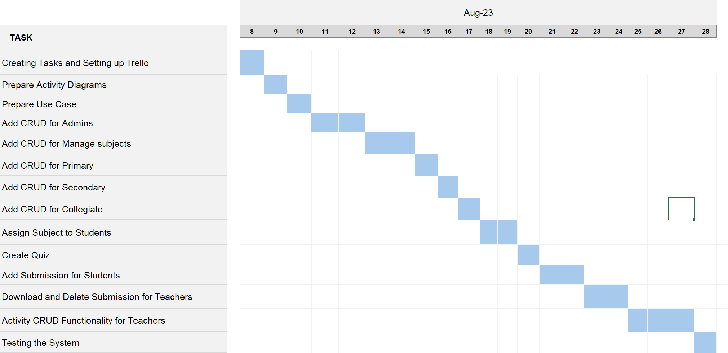

Figure Gantt chart sprint 2.

# Use case diagrams sprint 2.

Admin subject management

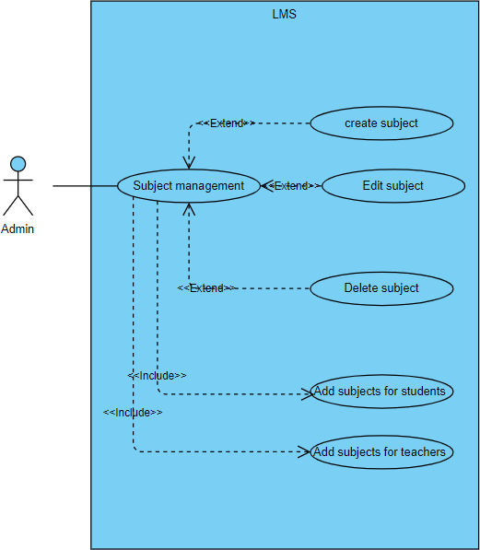

Figure Use case diagram sprint 2 Teacher Create activity for students

Teacher function to create activities for students and manage them.

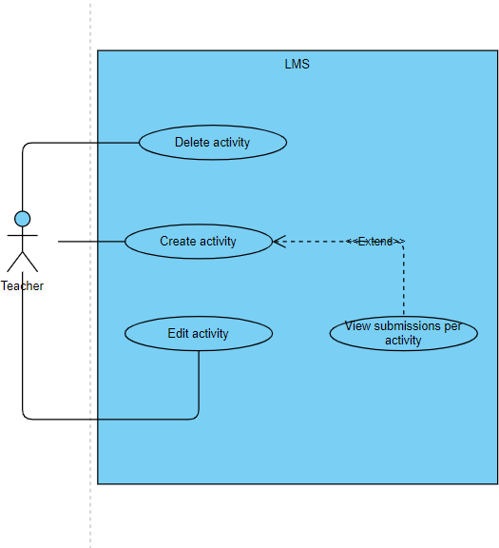

Figure Use case diagram sprint 2 view submission

Teacher function to view submissions per activity and download the submission files.

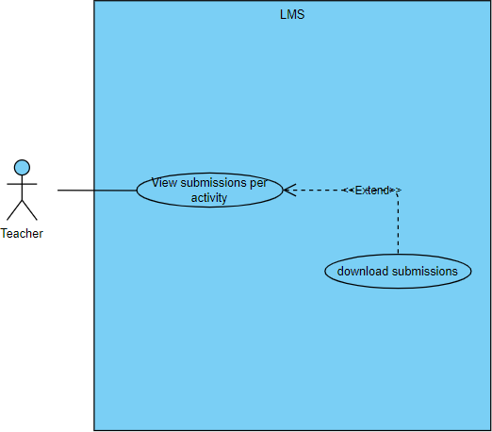

Figure Use case diagram sprint 2 view activites

Student function to view activities and add submissions per activity.

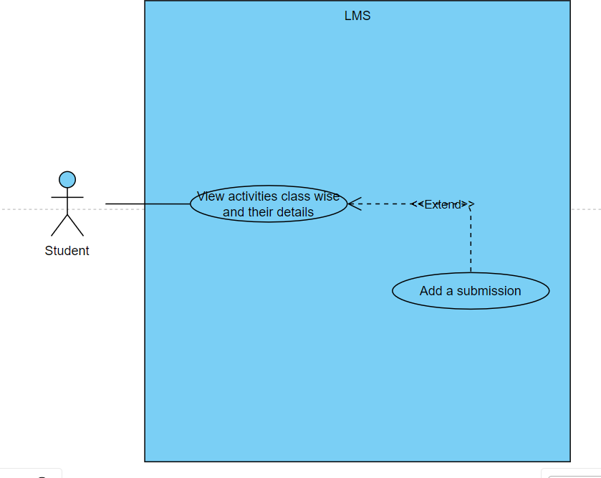

Figure Use case diagram sprint 2 for create subject

### Create subject.

|  |  |
| --- | --- |
| Use Case Name | Admin create new subject |
| Description | Allows the administrator to create a subject with a unique code with edit and delete privileges. Allows the admin to assign a subject to students and teachers during their registration. |
| Primary Actor | Administrator |
| Pre-Conditions | The database must be functional. The admin must be logged in to the system. |
| Basic Flow | 1. Use Case begins when the administrator clicks on the “Manage subjects” button from the admin sidebar. 2. The system retrieve the data of subjects already created and, in the system, 3. Admin clicks on the “create subject “button. 4. Admin adds the subject name and subject code. 5. Admin clicks on “add subject “ 6.Subject is created and the use case ends. |
| Extensions | If the subject name is not unique   1. System display message “Error creating activity 2. Use case ends   If the subject code is not unique   1. System display message “Error creating activity 2. Use case ends |
| Post Conditions | The subject is created and can be assigned to students and teachers. |
| Optional Information |  |

### Edit subject.

|  |  |
| --- | --- |
| Use Case Name | Admin Edit subject details. |
| Description | Allows the administrator to edit a subject’s details such as change the subject name and code. |
| Primary Actor | Administrator |
| Pre-Conditions | The database must be functional. The admin must be logged in to the system. |
| Basic Flow | 1. Use Case begins when the administrator clicks on the “Manage subjects” button from the admin sidebar. 2. The system retrieve the data of subjects already created and, in the system, 3. Admin clicks on the “Edit “button next to the specific subject that needs to be edited. 4. Admin makes the required changes to the subject name and subject code. 5. Admin clicks on “save changes “button. 6.Subject details are updated and the use case ends. |
| Extensions | If the subject name is not unique   1. System display message “Error updating activity 2. Use case ends   If the subject code is not unique   1. System display message “Error updating activity 2. Use case ends |
| Post Conditions | The subject is updated and displayed. |
| Optional Information |  |

### Delete subject.

|  |  |
| --- | --- |
| Use Case Name | Admin delete subject details. |
| Description | Allows the administrator to delete a subject from the database |
| Primary Actor | Administrator |
| Pre-Conditions | The database must be functional. The admin must be logged in to the system. |
| Basic Flow | 1. Use Case begins when the administrator clicks on the “Manage subjects” button from the admin sidebar. 2. The system retrieve the data of subjects already created and, in the system, 3. Admin clicks on the “Delete “button next to the specific subject that needs to be deleted. 4. Admin clicks on “delete “button. 5.Admin clicks “ok” on the prompt to confirm deletion.   6.Subject details are removed and the use case ends. |
| Extensions |  |
| Post Conditions | The subject is deleted and no longer displayed. |
| Optional Information |  |

### Teacher’s function to create an activity.

|  |  |
| --- | --- |
| Use Case Name | Teacher function to create activities. |
| Description | Allows a teacher to create an activity and make it visible for the relevant class students. |
| Primary Actor | Teacher |
| Pre-Conditions | System is up and running, teacher must be logged into the system |
| Basic Flow | 1. Use Case begins when the teacher clicks on the “create activity” button from the teacher side bar 2. The create activity form appears. The teacher adds the activity name, due date, submission time, Activity description, subjects the activity is form, classes the activity is for and the activity ID. 3. Teacher clicks on “create activity “button. 4. Activity is created and the use case ends. |
| Extensions | If the required form fields are not filled   1. System display message “required message.” 2. Use case ends |
| Post Conditions | Students of the selected classes can view the activity |
| Optional Information | - |

**Teacher function to edit activities.**

|  |  |
| --- | --- |
| Use Case Name | Teacher function to edit activities. |
| Description | Allows a teacher to edit an activity and update it. |
| Primary Actor | Teacher |
| Pre-Conditions | System is up and running, teacher must be logged into the system |
| Basic Flow | 1. Use Case begins when the teacher clicks on the “Manage activities” button from the teacher side bar 2. A list of activities and their details appear with the activity name, due date, submission time, Activity description, subjects the activity is form, classes the activity is for and the activity ID. 3. Teacher clicks on “edit “button next to the activity. 4. Teacher makes any necessary changes to the activity name, due date, submission time, Activity description, subjects the activity is form, classes the activity is for and the activity ID. 5. Teacher clicks on “save changes” button 6. Activity is updated and use case ends |
| Extensions |  |
| Post Conditions | Activity details are updated and can be viewed by the students. |
| Optional Information | - |

**Teacher function to delete an activity.**

|  |  |
| --- | --- |
| Use Case Name | Teacher function to delete activities. |
| Description | Allows a teacher to delete an activity and remove it from the database |
| Primary Actor | Teacher |
| Pre-Conditions | System is up and running, teacher must be logged into the system |
| Basic Flow | 1. Use Case begins when the teacher clicks on the “Manage activities” button from the teacher side bar 2. A list of activities and their details appear with the activity name, due date, submission time, Activity description, subjects the activity is form, classes the activity is for and the activity ID. 3. Teacher clicks on “delete “button next to the specific activity.   4 Activity is deleted and use case ends |
| Extensions |  |
| Post Conditions | Activity details are deleted and can no longer be viewed by students and teachers. |
| Optional Information | - |

**Teacher function to view submissions.**

|  |  |
| --- | --- |
| Use Case Name | Teacher function to view submissions per activity and download the submission files. |
| Description | Allows teachers to see the submissions made by students for the activities created. |
| Primary Actor | Teacher |
| Pre-Conditions | System is up and running, teacher must be logged into the system |
| Basic Flow | 1. Use Case begins when the teacher clicks on the “Manage activities” button from the teacher side bar. 2. The system retrieve the activity list and details from the database for the logged in user. 3. Teacher clicks on the “view submissions “button 4. Use Case ends after the system will display the submissions received for the selected activity along with the submission name, file and email of the student who made the submission. |
| Extensions |  |
| Post Conditions | Teacher can view submissions made students per activity |
| Optional Information | - |

**Student can view his or her activities.**

|  |  |
| --- | --- |
| Use Case Name | Student function to view activities |
| Description | Allows students to view the activities created by the teacher. |
| Primary Actor | Primary, upper, and lower secondary student. |
| Pre-Conditions | Database is functional and student must be  logged in. |
| Basic Flow | 1. Use Case begins when the student clicks on the “View my activities” button from the navigation bar. 2. The system retrieves the activity information from the database for the logged in user. 3. Use Case ends after the system will display the activity information for the user on the “View my activities” page. |
| Extensions |  |
| Post Conditions | The user can view their assigned activities |
| Optional Information | - |

**Teacher function to download submitted files.**

|  |  |
| --- | --- |
| Use Case Name | Teacher function to view submissions per activity. |
| Description | Allows teachers to see the submissions made by students for the activities created. |
| Primary Actor | Teacher |
| Pre-Conditions | System is up and running, teacher must be logged into the system |
| Basic Flow | 1. Use Case begins when the teacher clicks on the “Manage activities” button from the teacher side bar. 2. The system retrieve the activity list and details from the database for the logged in user. 3. Teacher clicks on the “view submissions “button 4. Use Case ends after the system will display the submissions received for the selected activity along with the submission name, file and email of the student who made the submission. |
| Extensions |  |
| Post Conditions | Teacher can view submissions made students per activity |
| Optional Information | - |

**Teacher function to download submission files.**

|  |  |
| --- | --- |
| Use Case Name | Teacher function to download submission files. |
| Description | Allows teachers to download submission files |
| Primary Actor | Teacher |
| Pre-Conditions | System is up and running, teacher must be logged into the system |
| Basic Flow | 1. Use Case begins when the teacher clicks on the “Manage activities” button from the teacher side bar. 2. The system retrieve the activity list and details from the database for the logged in user. 3. Teacher clicks on the “view submissions “button 4. The system will display the submissions received for the selected activity along with the submission name, file and email of the student who made the submission. 5.Teacher clicks on the “download “button next to the file name.   6. File is downloaded and the use case ends. |
| Extensions |  |
| Post Conditions |  |
| Optional Information | - |

**Teacher function to create a quiz.**

|  |  |
| --- | --- |
| Use Case Name | Teacher function to create a quiz. |
| Description | Allows teachers to create a quiz and make it available for students. |
| Primary Actor | Teacher |
| Pre-Conditions | System is up and running, teacher must be logged into the system |
| Basic Flow | 1. Use Case begins when the teacher clicks on the “create quiz” button from the teacher dashboard. 2. The create quiz form appears. 3. Teacher fills in the form fields such as quiz questions, answer, and options 4.Teacher clicks on the “create quiz “button next to the file name.   6. Quiz is created, and the use case ends |
| Extensions | If the form fields are not filled   1. An error message is displayed. 2. Quiz is not created. 3. Use case ends. |
| Post Conditions |  |
| Optional Information | - |

# Activity diagrams sprint 2

**Create subject for admin.**

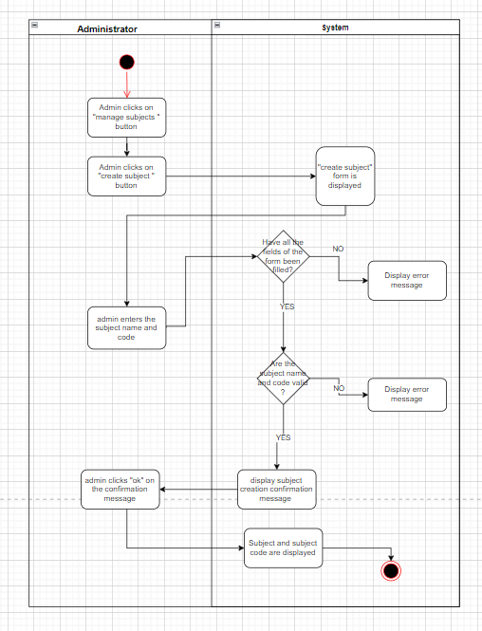

Figure Activity Diagram sprint 2 Create subject for admin

**Edit subject for admin.**

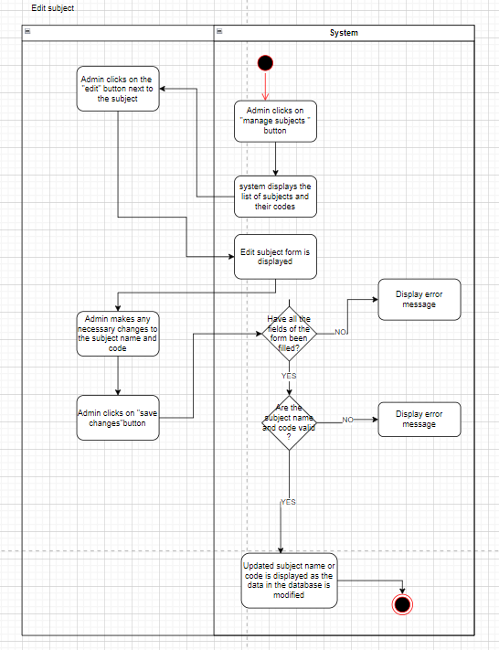

Figure 117 Acitvity diagram sprint 2 Edit subject for admin

**Delete subject for admin.**

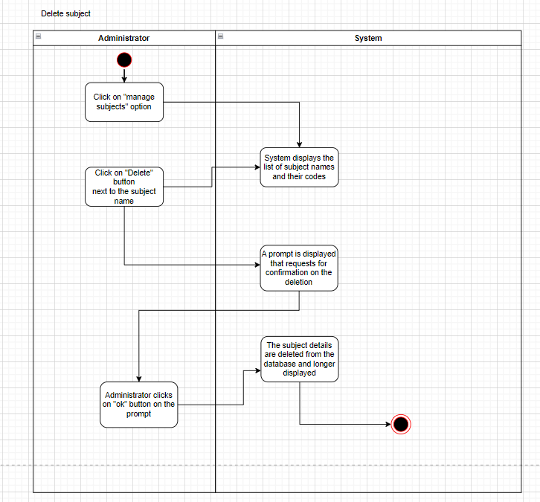

Figure Acitivty diagram sprint 2 Delete subject for admin

**Create activity**.

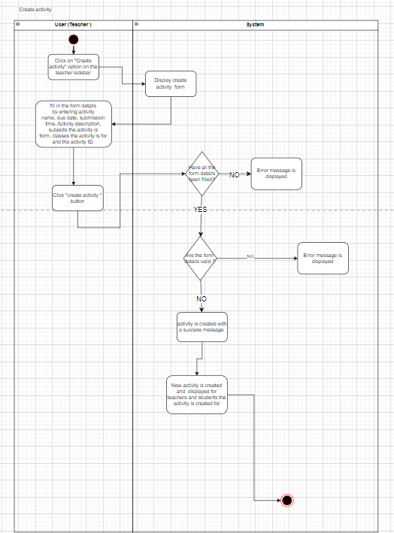

Figure Activity diagram sprint 2 Create Activity

**Edit activity.**

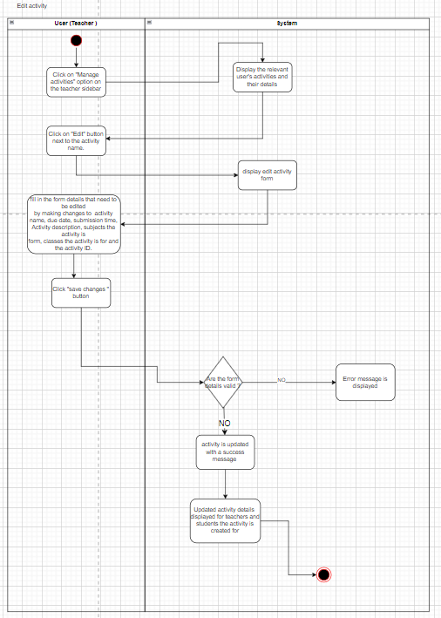

Figure Acitivty diagram sprint 2 Edit Acitivity

**Delete activity.**

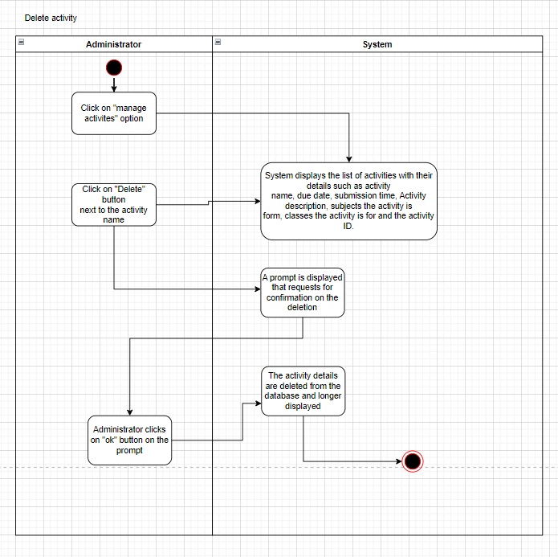

Figure Acitivty diagram sprint 2 Delete Acitivtiy

**View activities by students**

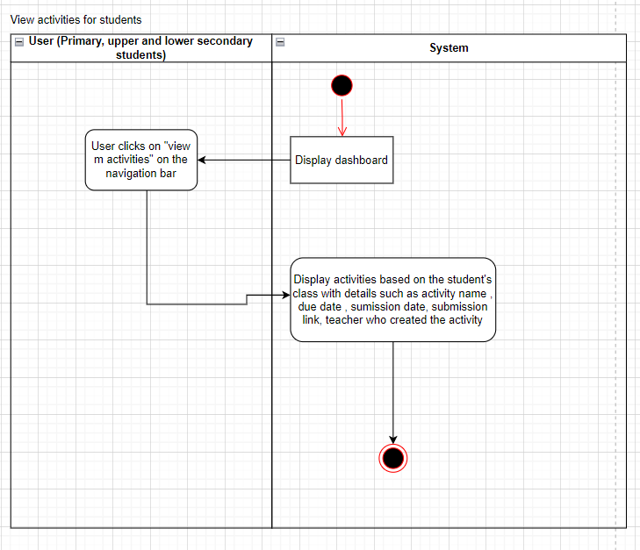

Figure Acitivty diagram sprint 2 View acitivty for students

**Sequence diagrams**

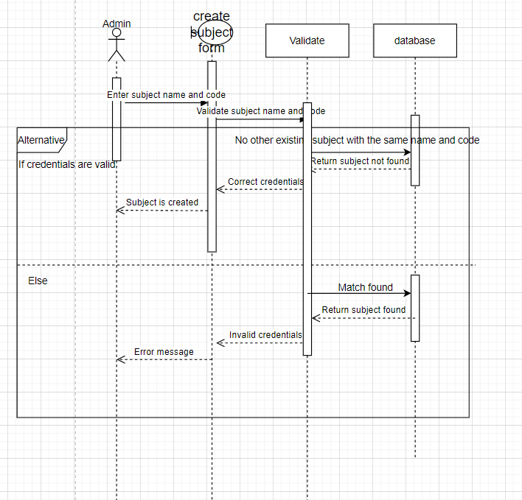

Figure sequence diagram sprint 2

# Time management Sprint 2

|  |  |  |  |
| --- | --- | --- | --- |
| **Activity ID** | **Activity Description** | **Predecessors** | **Duration (Days)** |
| A | Creating Tasks and Setting up Trello | None | 1 |
| B | Prepare Use Case Diagrams | A | 1 |
| C | Prepare Activity Diagrams | A, B | 1 |
| D | Creating Branches in GitHub Repository | A | 1 |
| E | Add CRUD for Admins | B, D | 3 |
| F | Add CRUD for Manage Subjects | E | 3 |
| G | Add CRUD for Primary | E | 3 |
| H | Add CRUD for Secondary | G | 2 |
| I | Add CRUD for Collegiate | G | 2 |
| J | Assign Subject to Students | F, H, I | 3 |
| K | Create Quiz Functionality for Teacher | J | 1 |
| L | Add Submission for Students | J | 2 |
| M | Download and Delete Submission for Teachers | L | 3 |

|  |  |  |  |
| --- | --- | --- | --- |
| N | Activity CRUD Functionality for Teachers | M | 3 |
| O | Testing the System | E, F, G, H, I, K, L, M, N | 1 |
| P | Sprint Review | O | 1 |

## AOA Diagram Sprint 2

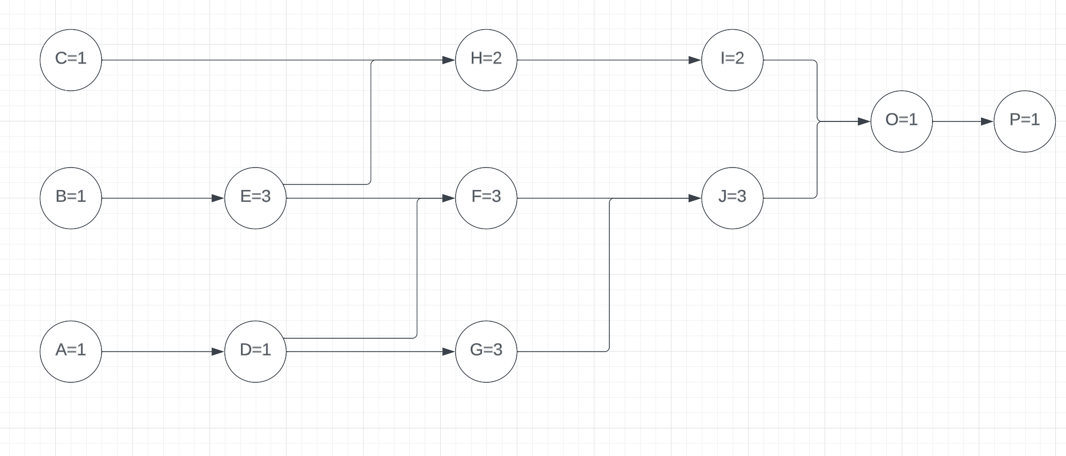

Figure AOA Diagram Sprint 2

## AON Diagram Sprint 2

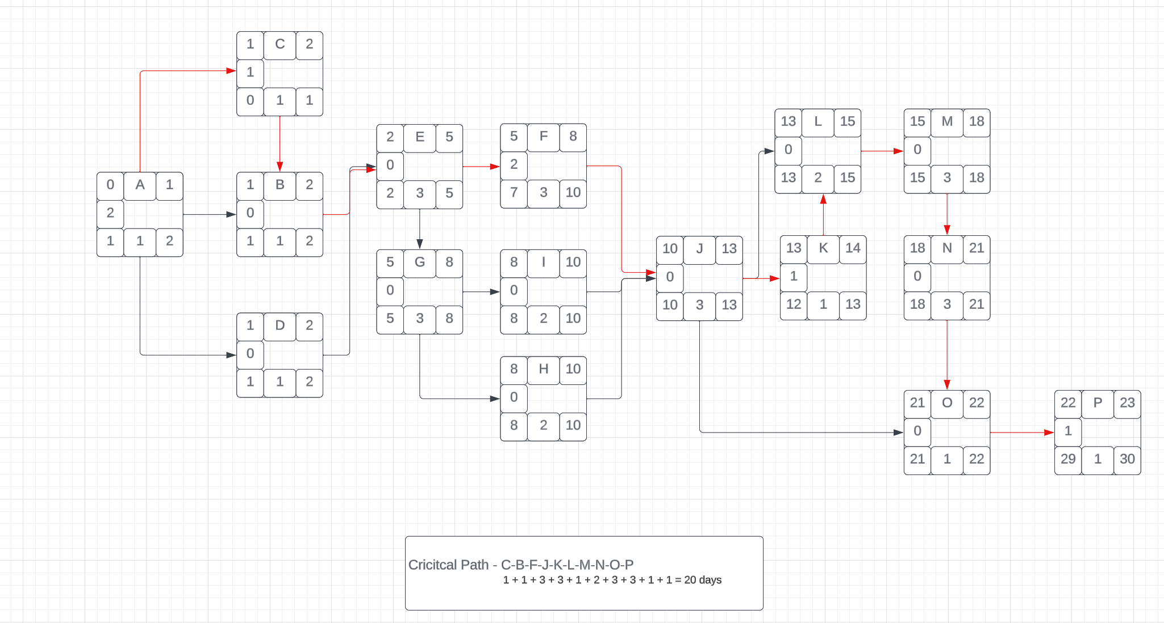

Figure AON Diagram Sprint 2

# 

# Communication plan Sprint 2

|  |  |  |  |  |
| --- | --- | --- | --- | --- |
| Meeting ID | Frequency | Participants | Points of discussion | Mode |
| 1st week review | Met twice a week.  8th august 11th august | Scrum master Developer Business analyst Quality assurance | Discussed and decided the sprint goals and the responsibilities of each member | Physical |
| 2nd week review | Met twice a week. | Scrum master Developer | Review code progress and the | Physical |

|  |  |  |  |  |
| --- | --- | --- | --- | --- |
|  | 14th august 18th august | Business analyst Quality assurance | UML diagram creation process |  |
| 3rd week review | Met twice a week.  8th august 12th august | Scrum master Developer Business analyst Quality assurance | Review code progress and the UML diagram creation process | Physical |
| 4th week review | Met twice a week.  21st august 25th august | Scrum master Developer Business analyst Quality  assurance | Did code refactoring and tested the developed  functionalities | Physical |

# Code images sprint 2

## Submission file download

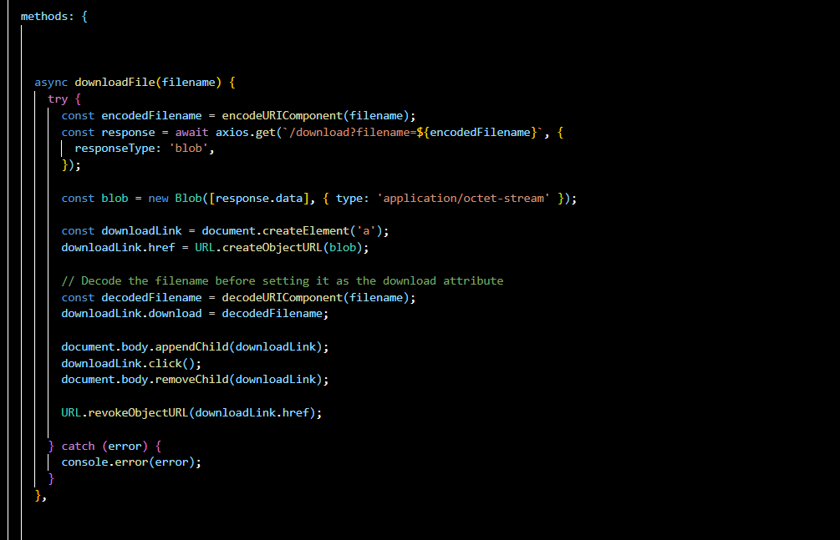

Figure code sprint 2 submission file download

## Create activity.

Figure sprint 2 Code Create activity

## Edit activity.

Figure sprint 2 Code Edit actiivity

## Add submissions.

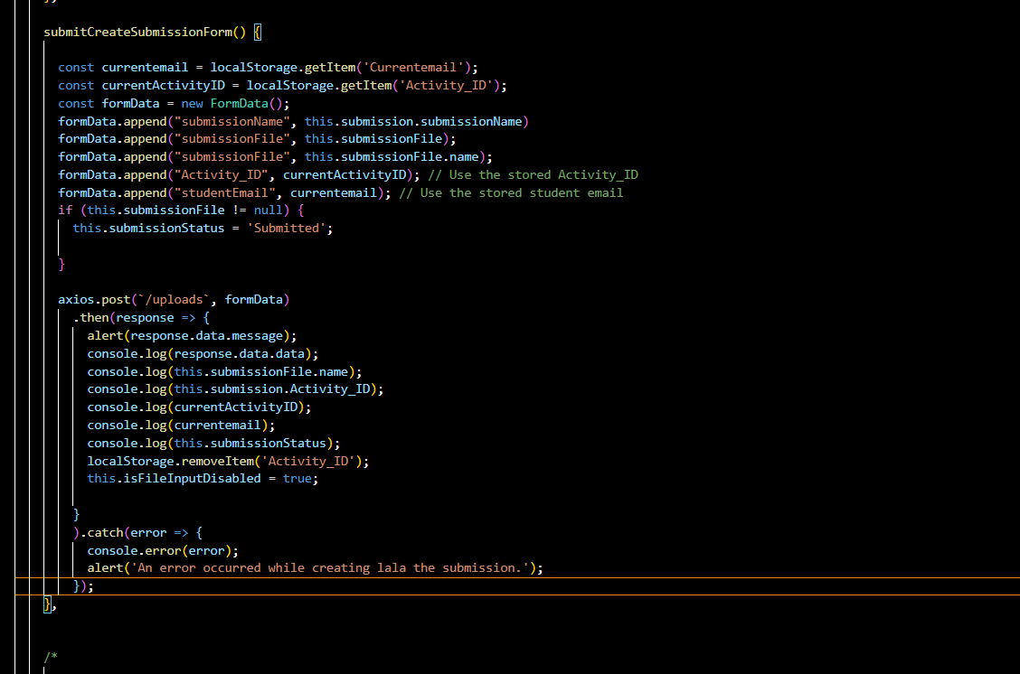

Figure sprint 2 Code Add submissions

## Create subject.

Figure sprint 2 Code Create subject

## Edit subject.

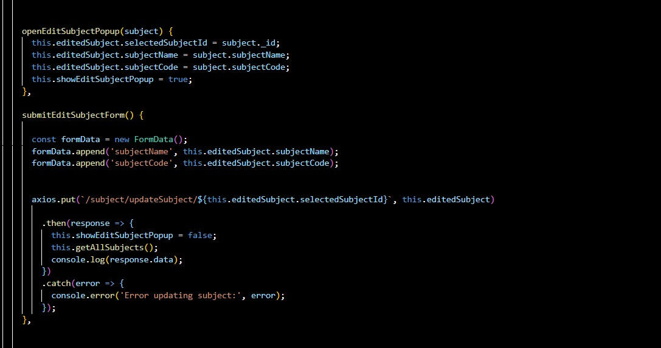

Figure 131 sprint 2 Code Edit subject

## Delete subject.

Figure sprint 2 Code Delete subject

# Product backlog sprint 2

Figure product backlog sprint 2 part 1

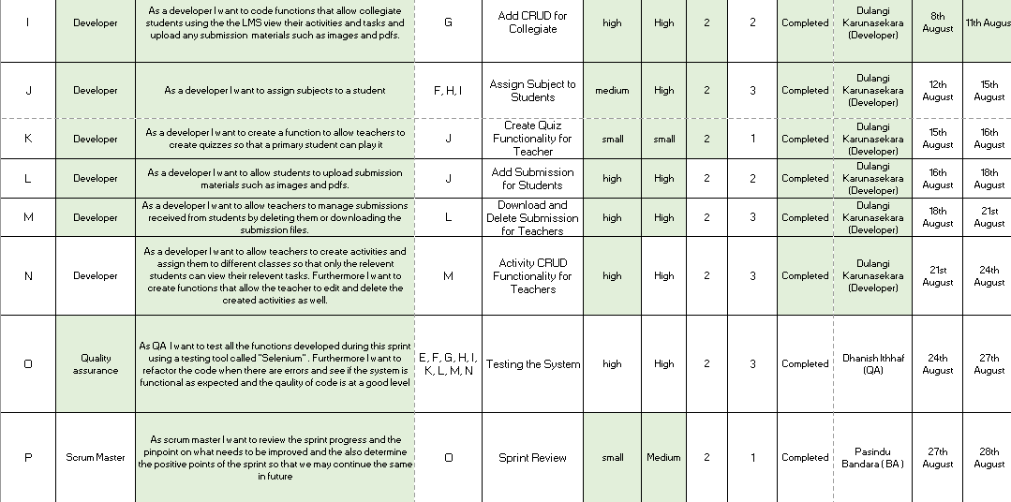

Figure product backlog sprint 2 part 2

# Project management sprint 2

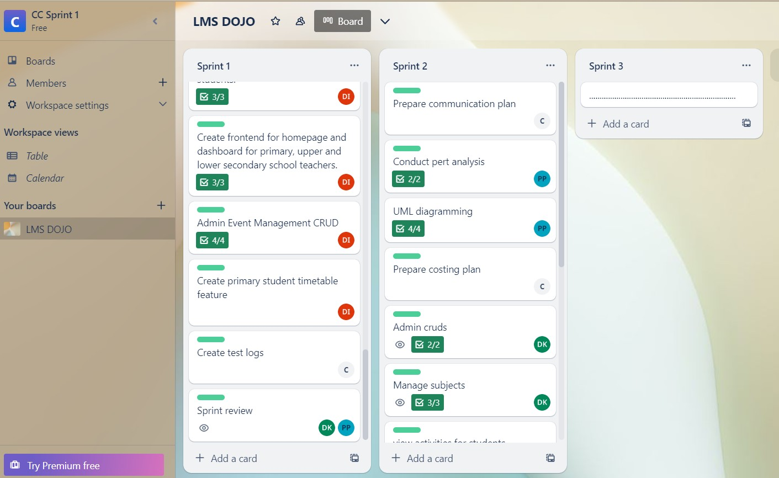

Figure Trello board sprint 2 part 1

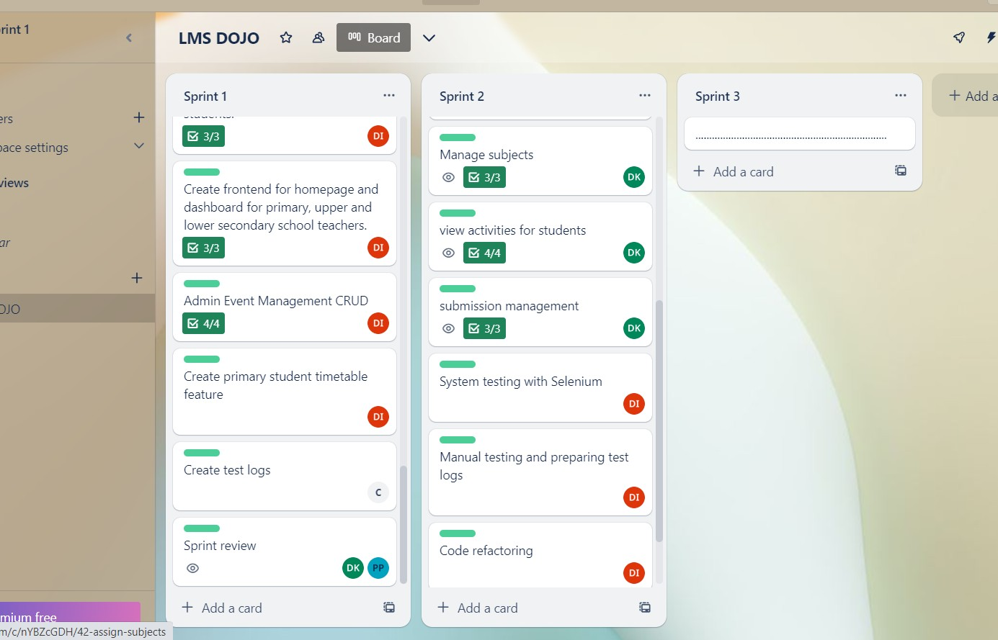

Figure 136 Trello board sprint 2 part 2

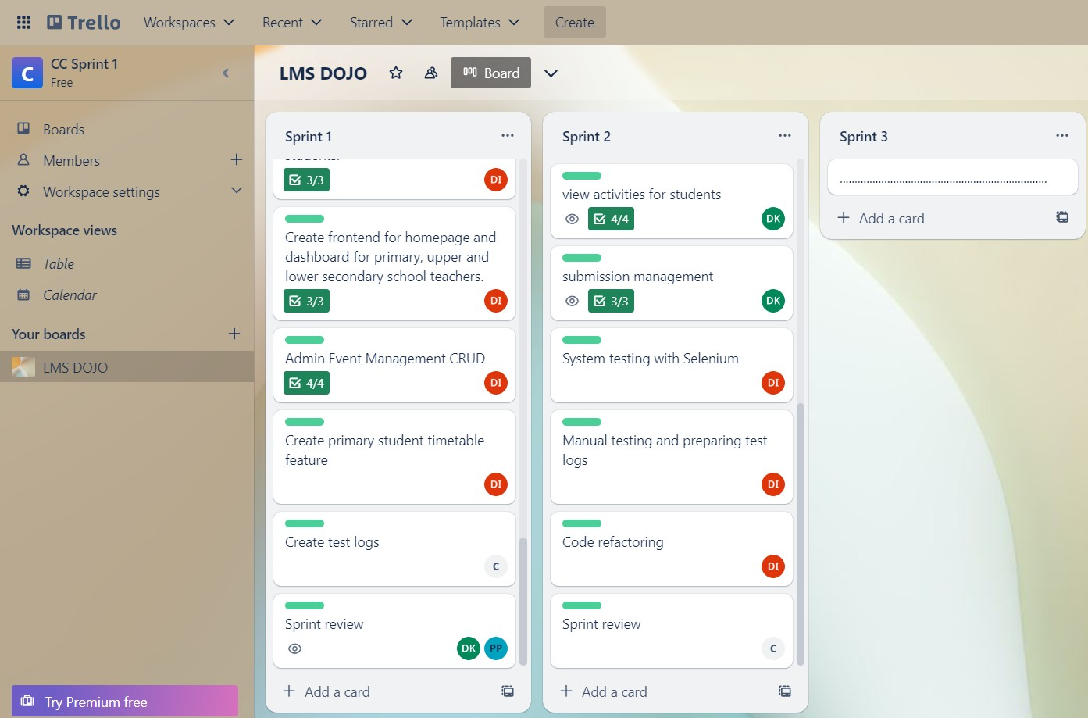

Figure 137 Trello board sprint 2 part 3

# Test Logs Sprint 2

|  |  |  |  |  |  |  |  |
| --- | --- | --- | --- | --- | --- | --- | --- |
| **Testca se ID** | **Descripti on** | **Pre- conditi on** | **Test**  **Procedure** | **Test Inputs** | **Expected Output** | **Actual Output** | **Resul t** |
| 1 | Test creation of a subject | User is logged in | The admin must be logged in to the system. Database  must be up and running | Subject name  – Chemistry Subject Code  - CH2023 | Success message displayed | [Success message] | Pass |
| 2 | Test editing a subject | User is logged in | The admin must be logged in to the system. Database must be up  and running | Subject name  –  Chemistry123 Subject Code  - CH2023123 | Success message displayed | [Success message] | Pass |
| 3 | Test deleting a subject | User is logged in | The admin must be logged in to the system. Database must be up and running | Subject ID, Click and confirm | Success message displayed | [Success message] | Pass |
| 4 | Test creating a quiz | User is logged in | Go to 'Quizzes' section | Quiz details | Quiz created successfull  y | [Success message] | Pass |
| 5 | Test adding classes/s ubjects | User is logged in | The admin must be logged in to the system. Database must be up and running. | Class – 4B Subject - Chemistry | Success message displayed | [Success message] | Pass |

|  |  |  |  |  |  |  |  |
| --- | --- | --- | --- | --- | --- | --- | --- |
| 6 | Test creating an activity | User is logged in | Go to 'Activities' section | Activity details | Success message displayed | [Success message] | Pass |
| 7 | Test editing an activity | User is logged in | Go to 'Activities' section | Activity details | Success message displayed | [Success message] | Pass |
| 8 | Test deleting an activity | User is logged in | Go to 'Activities' section | Activity ID, Click and confirm | Success message displayed | [Success message] | Pass |
| 9 | Test adding submissi ons | User is logged in | Go to 'Submissions' section | Submission details | Success message displayed | [Success message] | Pass |
| 10 | Test downloa ding submissi on | User is logged in | Go to 'Submissions' section | Submission ID | Submission downloade d | [Downlo aded file] | Pass |
| 11 | Test deleting submissi  on | User is logged in | Go to 'Submissions' section | Submission ID, Click and confirm | Success message displayed | [Success message] | Pass |

Selenium Testing Sprint 2

## A screenshot of a computer Description automatically generated Create, edit and delete subjects.

Figure sprint 2 Selenium Testing CRUD for subjects

## Create quiz

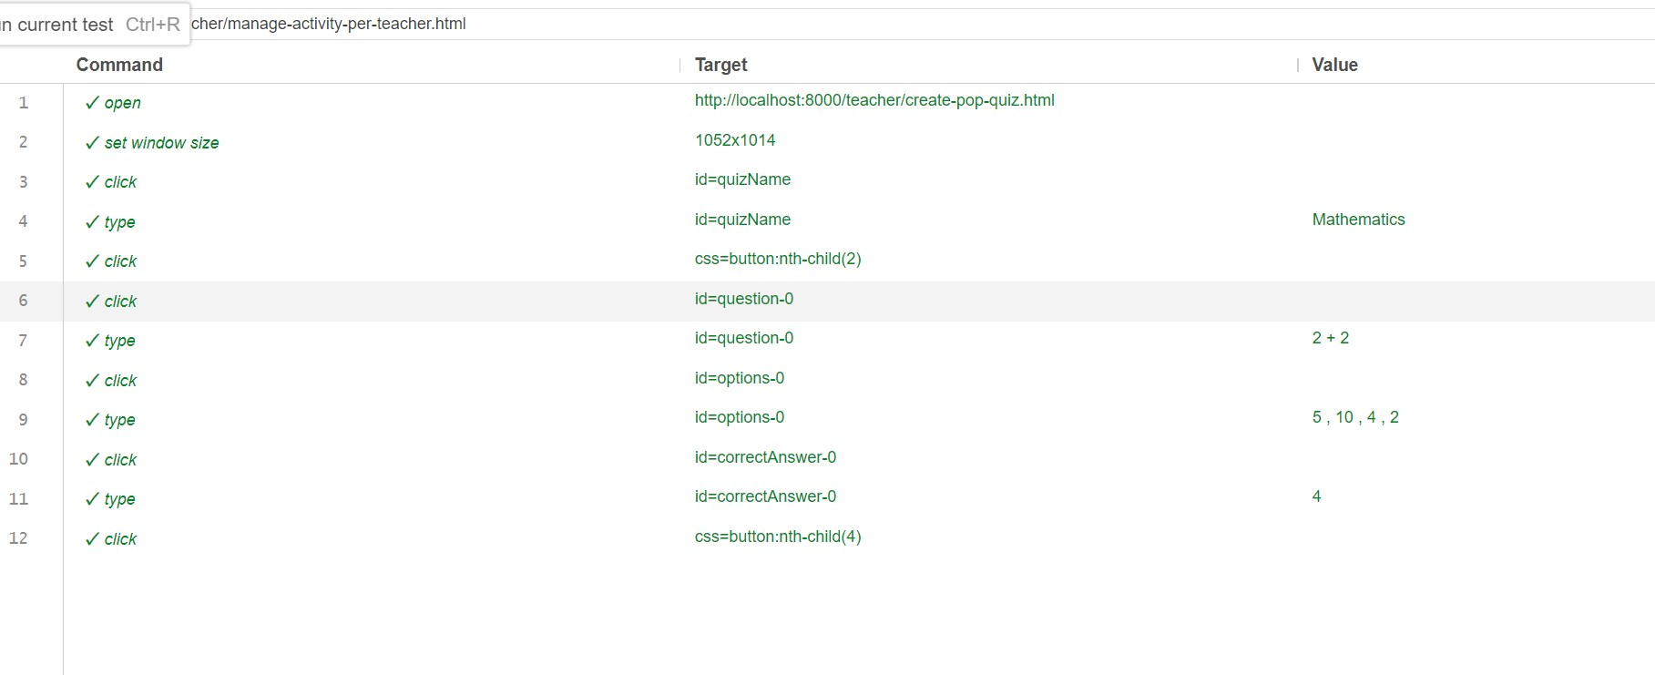

Figure sprint 2 Selenium Testing Create Quiz

## Add classes and subjects to students

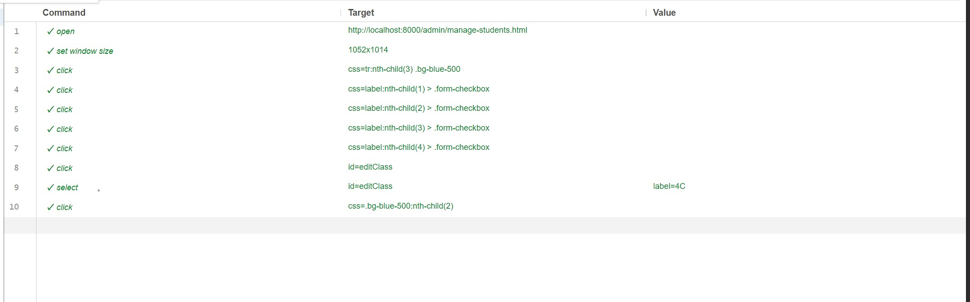

Figure sprint 2 Selenium Testing Add classes and subject to students

## Create activity

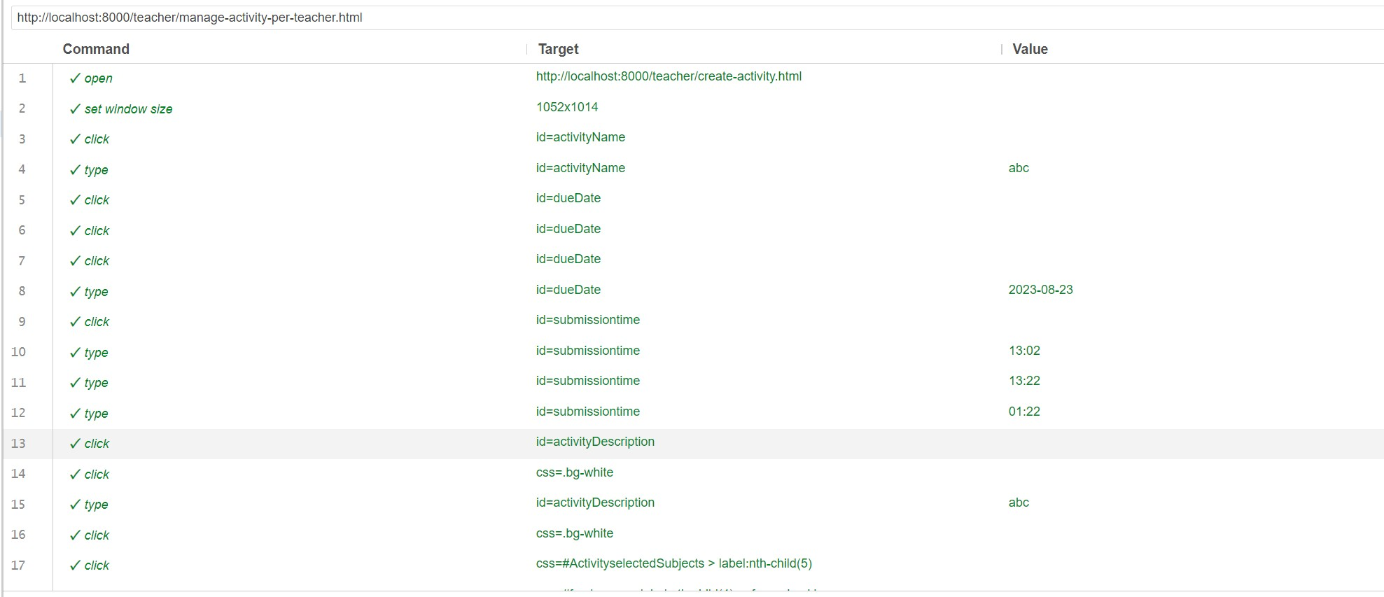

Figure sprint 2 Selenium Testing Create acitivity

## edit and delete activity.

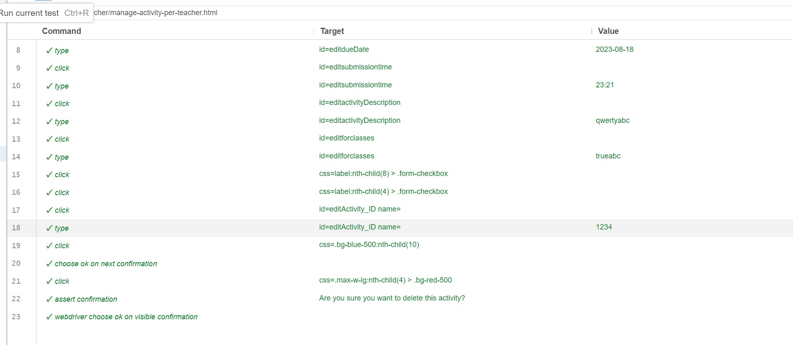

Figure sprint 2 Selenium Testing Edit and delete acitivity

## Add submissions.

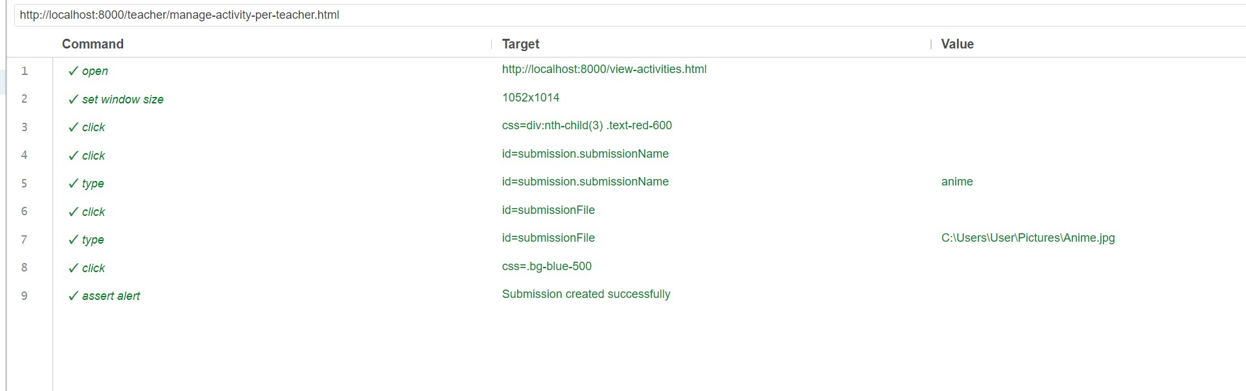

Figure sprint 2 Selenium Testing Add submissions

## Download and Delete submission.

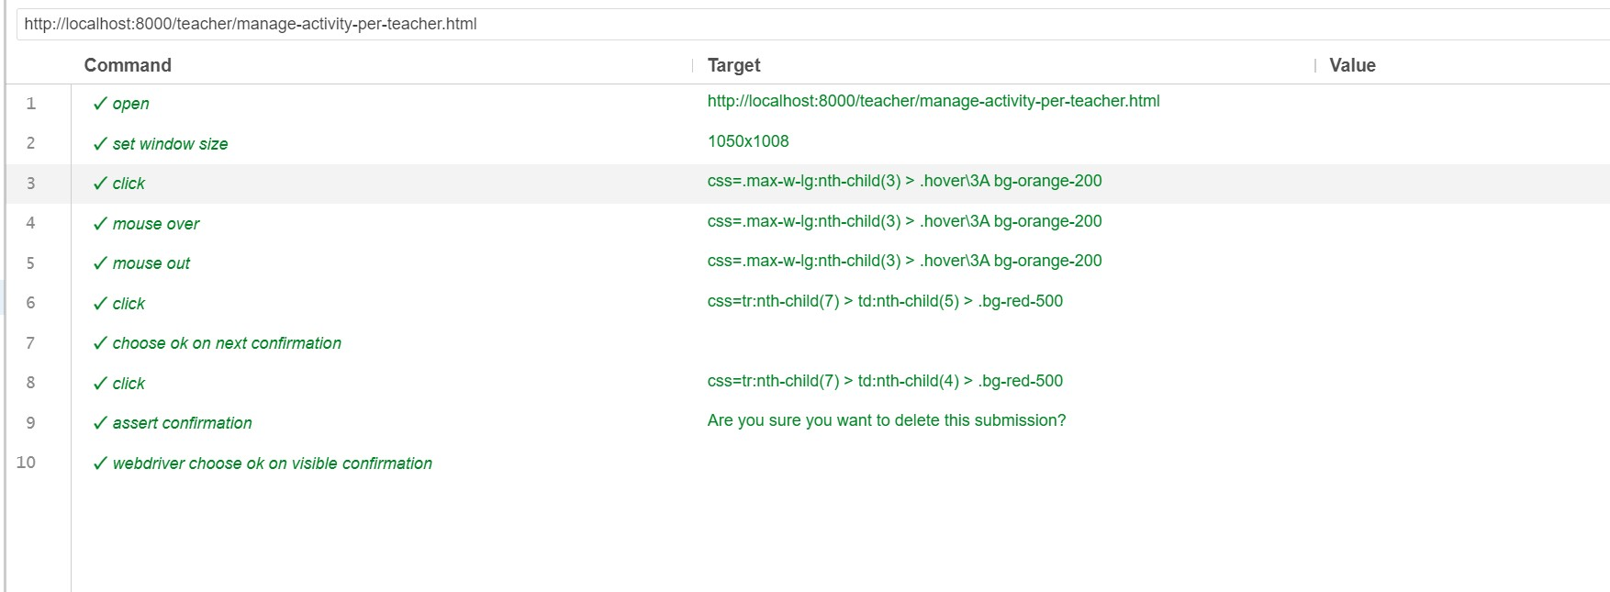

Figure sprint 2 Selenium Testing Download and delete submissions

# Cost management sprint 2

The following cost analysis has been conducted assuming there are 6 working hours per day. The cost per hour has been decided based on the average salary of the respective job role in Sri.

Lanka. Sources used to determine the average salary per hour have been referenced in the document accordingly.

|  |  |  |  |  |
| --- | --- | --- | --- | --- |
| Responsibility | Role played in the team | Time invested | Cost per hour | Total cost |
|  | Business Analyst | 35 hours | Rs 779.00 | Rs 27,300 |
|  | Pasindu lankanath |  |  |  |
|  | pinidiya bandara |  |  |  |
|  | (CB009454) |  |  |  |
|  | Quality assurance | 6 hours | Rs 500.00 | Rs 3000 |
|  | Mohamed Ithhaf |  |  |  |
|  | Mohamed |  |  |  |
|  | Dhanish |  |  |  |
|  | (CB009562) |  |  |  |
| Sprint 2 |  |  |  |  |
| Developer | 120 hours | Rs 1509.45 | Rs 181,134 |
|  | Arachchi |  |  |  |
|  | appuhamillage |  |  |  |
|  | done dulangi |  |  |  |
|  | karunasekara (CB010550) |  |  |  |
|  | Scrum Master | 12 hours | Rs - 2400 | Rs - 28,800 |
|  | Pooja selvaraj |  |  |  |
|  | (CB010098) |  |  |  |

Scrum master:

|  |  |  |
| --- | --- | --- |
| Task | Hours worked | Total cost |
| Task delegation | 3 hours | 12 hours * 2400 = 28,800 |
| Set up project management | 3 hours |
| Preparing a communication plan | 3 hours |
| Meeting arrangements | 3 hours |
| **Total Scrum Master Cost** | **12 hours** | **Rs - 28,800** |

Developer:

|  |  |  |
| --- | --- | --- |
| Task Description | Hours Worked | Total Cost (Rs.) |
| Setting up branches in GitHub Repository | 3 hours | 120 * 2400 = 181,134 |
| CRUD for Admins | 15 hours |
| CRUD for Manage Subjects | 12 hours |
| Add CRUD for Primary | 10 hours |
| Add CRUD for Secondary | 12 hours |
| Add CRUD for Collegiate | 8 hours |

|  |  |  |
| --- | --- | --- |
| Assign Subject to Students | 12 hours |  |
| Create Quiz Functionality for Teacher | 12 hours |
| Add Submission for Students | 12 hours |
| Download and Delete Submission for Teachers | 12 hours |
| Activity CRUD Functionality for Teachers | 12 hours |
| **Total Developer Cost** | **120 hours** | Rs 181,134 |

Business Analyst:

|  |  |  |
| --- | --- | --- |
| Task | Hours worked | Total cost |
| Prepare Use case diagrams | 10 hours | 35 * 779.00 = 27,300 |
| Prepare activity diagrams | 10 hours |
| Prepare sequence diagrams | 10 hours |
| Sprint review | 5 hours |
| **Total BA Cost** | **35 hours** | **Rs 27,300** |

Quality Assurance:

|  |  |  |
| --- | --- | --- |
| Task Description | Hours Worked | Total Cost (Rs.) |
| Testing the system | 6 hours | 6 * 500 = 3000 |
| **Total QA Cost** | **6 hours** | **Rs 3000** |

# 

# Sprint retrospective Sprint 2

The purpose of the sprint retrospective is to highlight the positives and the negatives of the sprint we just completed. What we were able to accomplish are as follows:

* We successfully completed the sprint goals decided at the beginning of the sprint in our first sprint review meeting. We were able to add the following functions to our system.
* Admin can assign subjects to students.
* Admin can assign classes to students and teachers.
* Teachers can create activities for different classes.
* Teachers can receive, view, and download submissions uploaded by students for specific activities.
* Primary, secondary, and collegiate students can view due tasks and upload pdfs, images, and word documents.
* Admin can create, edit, and delete subjects.

**Further accomplishments**

We were able to complete our sprint in a timely manner and complete our goals. We communicated well as a team using Trello as our project management tool. We held bi-weekly meetings to stay up to date on each other’s progress.

By being open to learning and growing we were able to successfully implement further features in our system.

We successfully tested our LMS using Selenium as our testing tool.

Sprint 3

# Work Breakdown Structure Sprint 3

|  |  |  |  |  |
| --- | --- | --- | --- | --- |
| Task | **Developer** Pasindu lankanath pinidiya bandara (CB009454) | **Scrum Master** Mohamed ithhaf Mohamed dhanish (CB009562) | **Quality Assurance** Arachchi appuhamillage done dulangi karunasekara (CB010550) | **Business Analyst** Pooja selvaraj (CB010098) |
| Setting up a trello board |  | 100% |  |  |
| Prepare a communication plan |  | 100% |  |  |
| Prepare use case diagrams |  |  |  | 100% |
| Prepare activity diagrams |  |  |  | 100% |

|  |  |  |  |  |
| --- | --- | --- | --- | --- |
| Prepare sequence diagrams |  |  |  | 100% |
| Create the frontend for attendance marking feature | 100% |  |  |  |
| Create teacher functionality to mark attendance  for students | 100% |  |  |  |
| Create the frontend for  viewing attendance | 100% |  |  |  |
| Create student functionality to view attendance for subjects | 100% |  |  |  |
| Create frontend to display system analytics to administrator | 100% |  |  |  |
| Create backend to provide the administrator with analytics regarding the Learning  management system | 100% |  |  |  |
| Make design changes to the user interface for students | 100% |  |  |  |
| Admin Analytics | 100% |  |  |  |
| Manual Testing |  |  | 100% |  |
| Selenium Testing |  |  | 100% |  |

|  |  |  |  |  |
| --- | --- | --- | --- | --- |
| Test Cases |  |  | 100% |  |
| Sprint Review |  | 100% |  |  |

# Sprint goals sprint 3

The goals of the 3rd sprint were to complete the following functionalities of the system.

1. Remaining Student CRUDS
2. Attendance Marking for teachers.
3. Attendance Viewing for students.
4. Displaying their respective classes in the student dashboards
5. Analytics for Admin

# Communication Plan sprint 3

|  |  |  |  |  |
| --- | --- | --- | --- | --- |
| Meeting ID | Frequency | Participants | Points of discussion | Mode |
| 1st week review | Met twice a week.  25th august 27th august | Scrum master Developer Business analystQuality assurance | Discussed and decided the sprint goals and the responsibilities of each member | Physical |
| 2nd week review | 1st September 4th September | Business analystQuality assurance | UML diagram and other diagrams creation process | Physical |
| 3rd week review | Met twice a week.  10th September 15th September | Scrum master Developer Business analystQuality assurance | Review code progress and the other necessary documents | Physical |
| 4th week review | Met twice a week.  21st September 25th September | Scrum master Developer Business analyst Quality  assurance | Did code refactoring and tested the developed functionalities | Physical |

# Code Images sprint 3

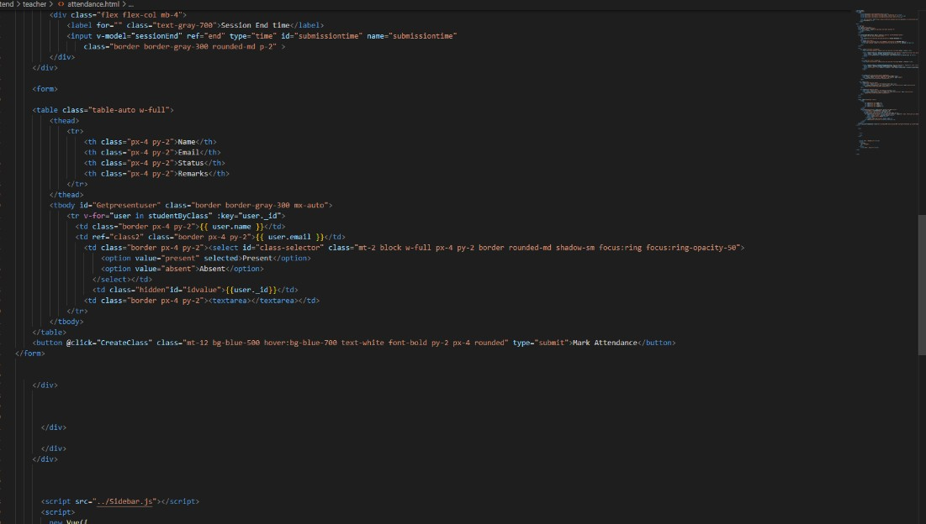

Figure sprint 3 Code Teacher attendance marking view.

## Show chosen subjects for each upper secondary student.

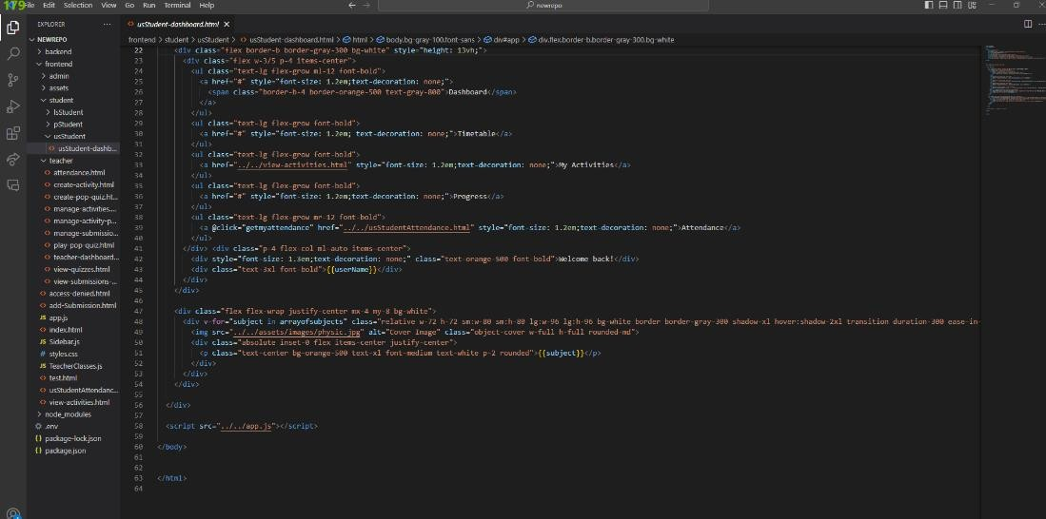

Figure sprint 3 Code Show chosen subjects for each upper secondary student.

## Analytics for the LMS

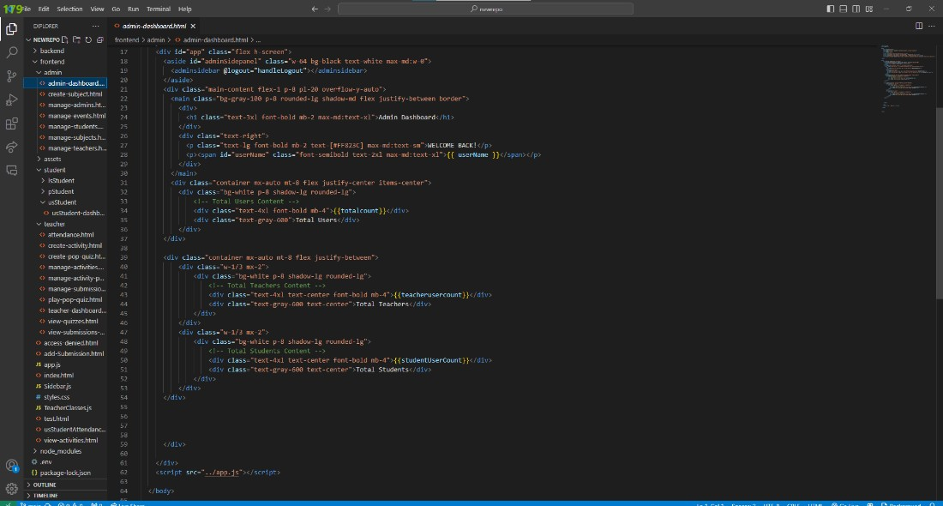

Figure sprint 3 Code Analytics

## Attendance view for each subject for each Upper secondary student

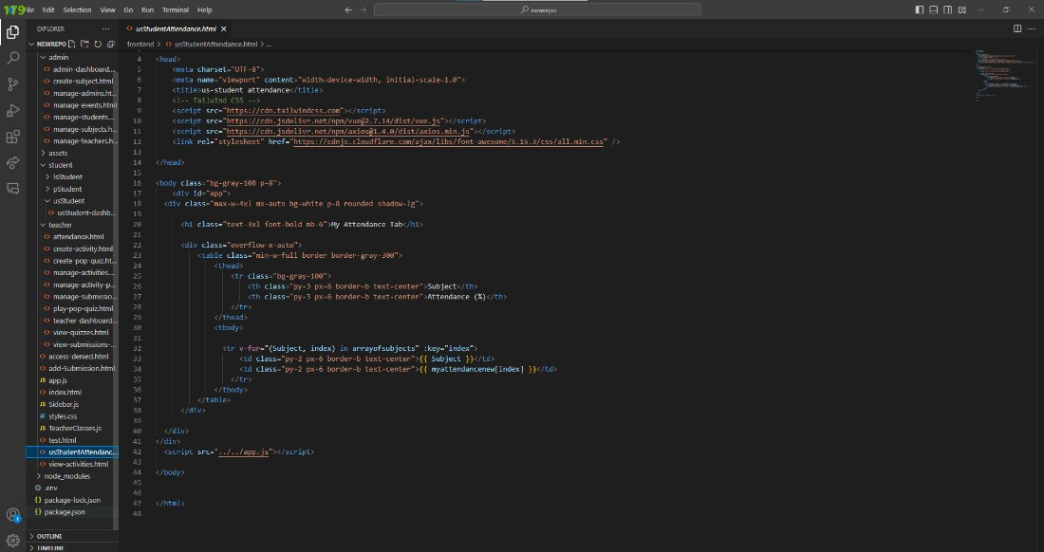

Figure 148 sprint 3 Code Attendance view for each subject for each Upper secondary student

# Product backlog sprint 3

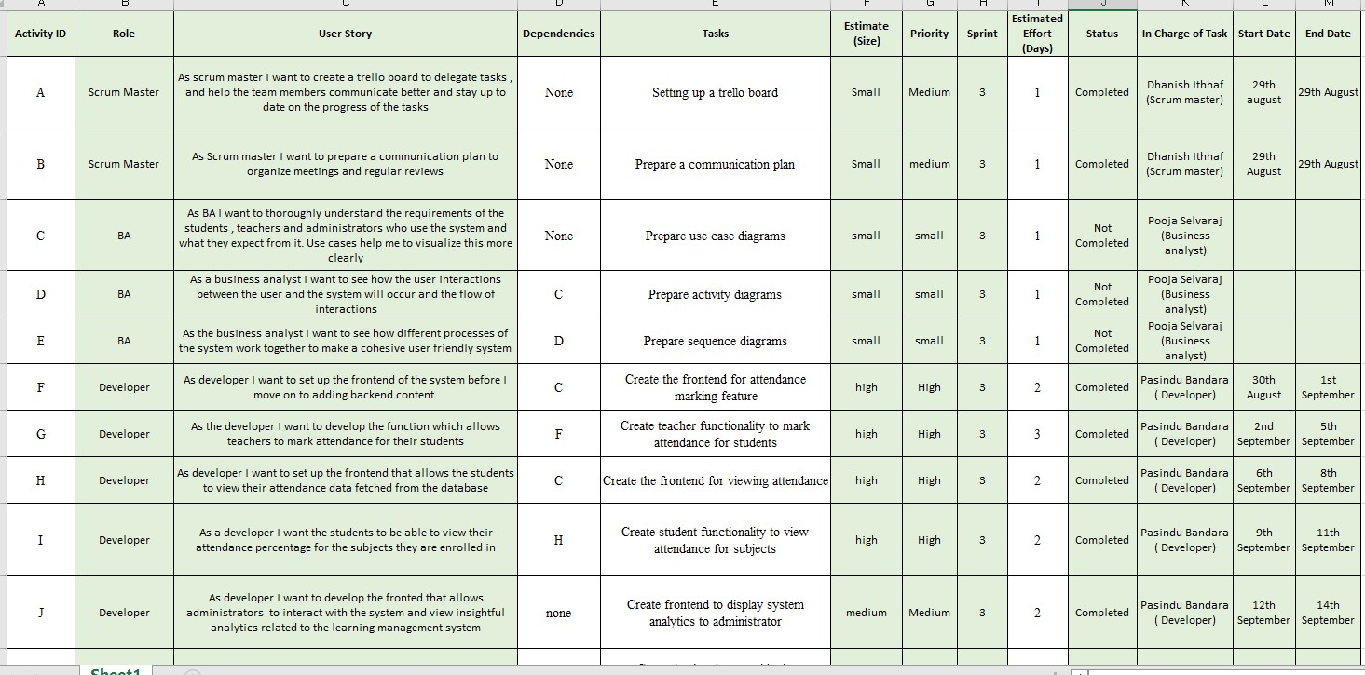

Figure sprint 3 backlog part 1

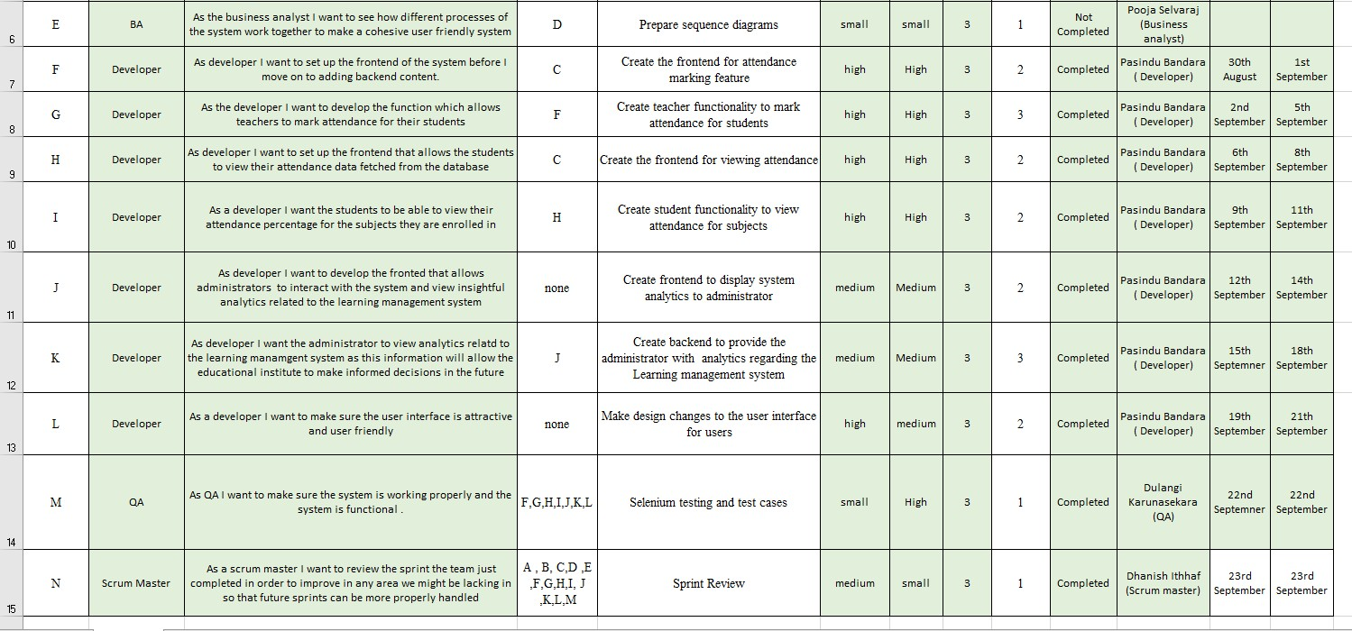

Figure sprint 3 backlog part 2

# Project Management sprint 3

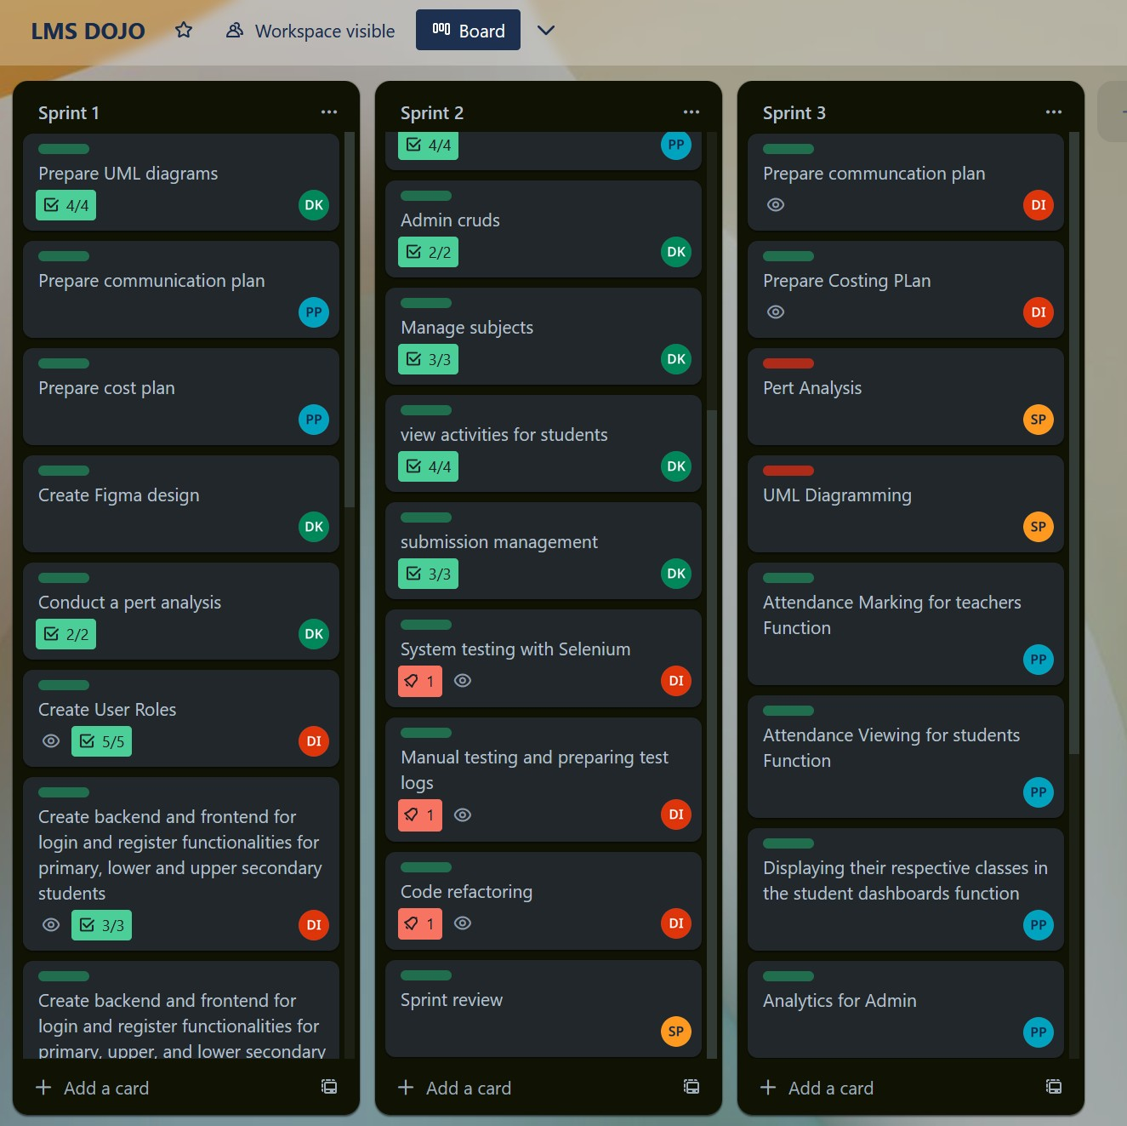

Figure Trello board sprint 3 part 1

*Figure 14 Trello board snapshot*

Figure Trello board sprint 3 part 2

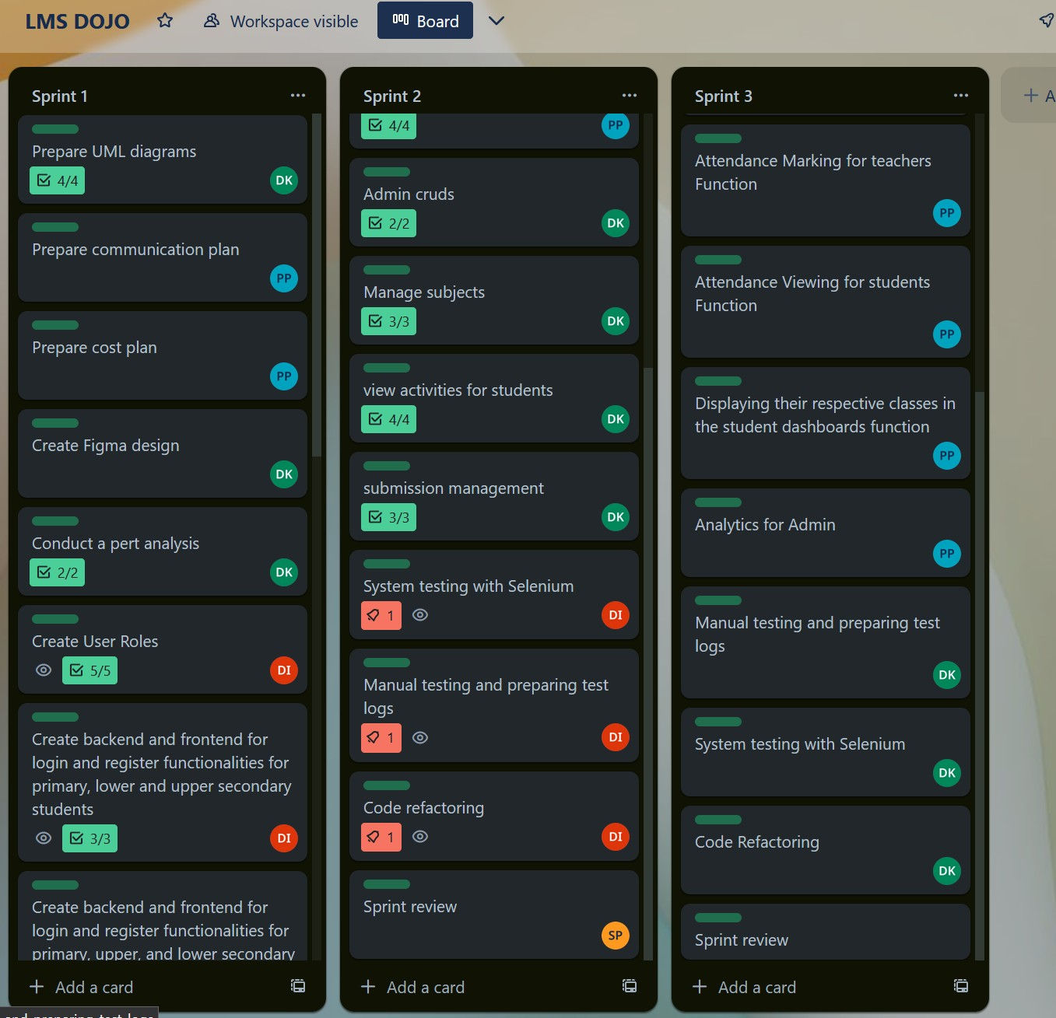

*Figure 15: Trello Board SnapShot 2*

# Test Cases sprint 3

|  |  |  |  |  |
| --- | --- | --- | --- | --- |
| Test case ID | Test | Expected output | Actual Output | Pass/Fail |
| TC1 | Mark attendance function for teacher | Teacher can record whether a student is absent or present for a class | Teacher can record whether a student is absent or present for a class | Pass |
| TC2 | Student ability to view their attendance per  subject | Students can view their attendance for  subjects | Students can view their attendance for  subjects | Pass |
| TC3 | Teacher can mark a student as present | Teacher is able to pick a choice between ‘absent’ and ‘fail’ and mark attendance | Teacher is able to pick a choice between ‘absent’ and ‘fail’ and mark attendance | Pass |
| TC4 | Teacher can mark a student as absent | Teacher is able to pick a choice between ‘absent’ and ‘fail’ and mark attendance | Teacher is able to pick a choice between ‘absent’ and ‘fail’ and mark attendance | Pass |
| TC5 | Are buttons clickable ? | The navigation bar button for attendance should directly take teacher to  the attendance marking page | The navigation bar button for attendance directly takes teacher to the  attendance marking page | Pass |
| TC6 | Analytics visible for administrator | The administrator can see analytics related to the LMS such as the number of students ,  teachers and total users | The administrator can see analytics related to the LMS such as the number of students ,  teachers and total users | Pass |

|  |  |  |  |  |
| --- | --- | --- | --- | --- |
| TC7 | Student’s ability to view the subjects they are enrolled in | When the student logs into the LMS the students can view their subject names on their dashboard | When the student logs into the LMS the students can view their subject names on their dashboard | Pass |

# Selenium Testing sprint 4

### Teacher mark attendance

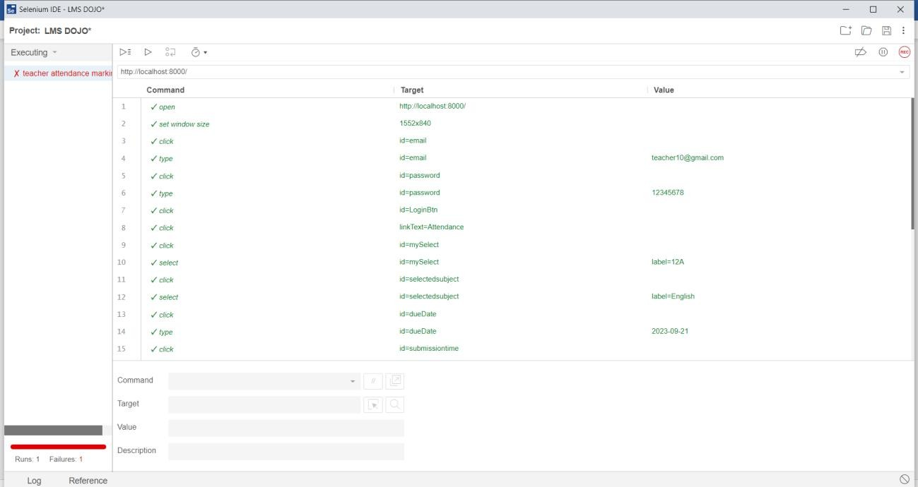

Figure sprint 3 selenium testing part 1

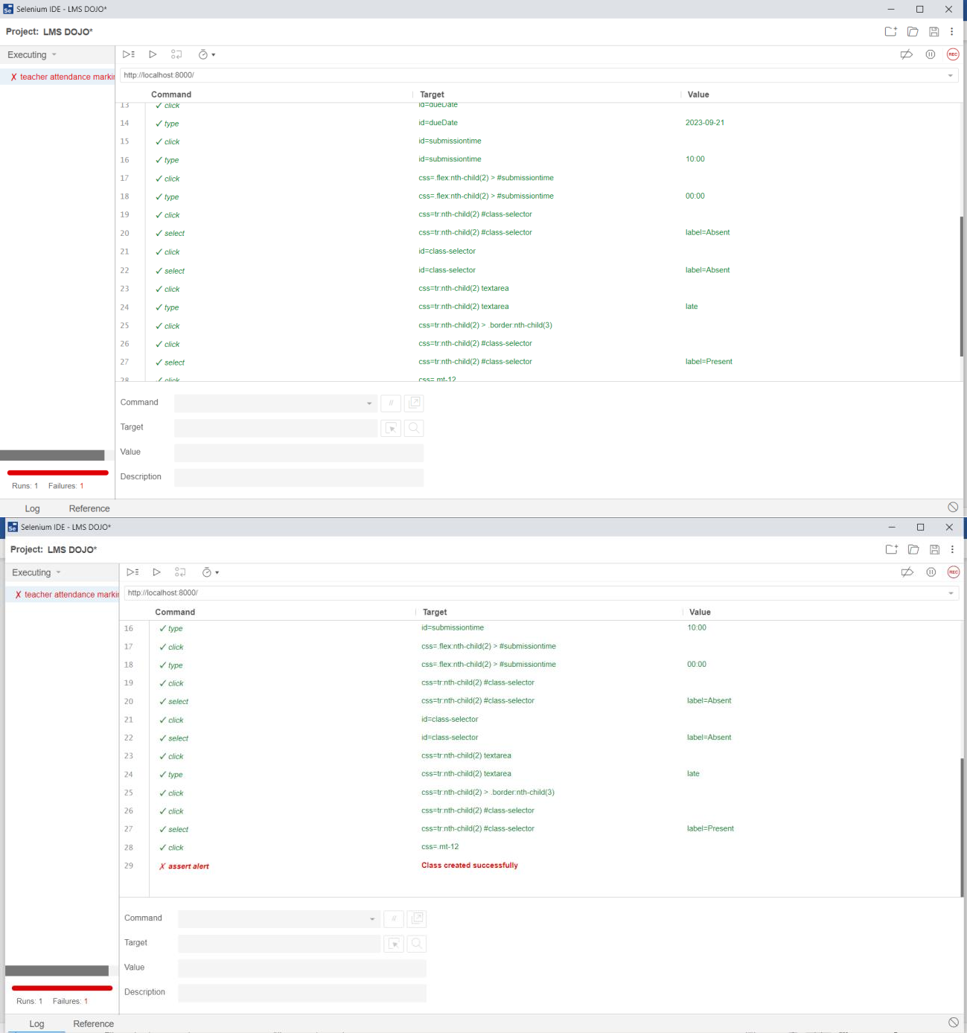

Figure 154 sprint 3 selenium testing part 2

# Cost Management sprint 3

The cost estimate that follows has been done with the assumption that each day has six hours of labor. The cost per hour was determined using the average income in Sri Lanka for the given work role. Sources used to calculate the average hourly wage have been cited appropriately in the text.

|  |  |  |  |  |
| --- | --- | --- | --- | --- |
| Responsibility | Role played in the team | Time invested | Cost per hour | Total cost |
| Sprint 3 | **Developer** | 100 hours | Rs 1509.45 | Rs 150,945 |
| Pasindu lankanath |
| pinidiya bandara |
| (CB009454) |
| **Scrum Master** | 12 hours | Rs - 2400 | Rs - 28,800 |
| Mohamed Ithhaf |
| Mohamed |
| Dhanish |
| (CB009562) |
| **Quality Assurance** | 6 hours | Rs 500.00 | Rs 3000 |
| Arachchi |
| appuhamillage |
| done dulangi |
| karunasekara |
| (CB010550) |
| **Business Analyst** | 30 hours | Rs 779.00 | Rs - 23,370 |
| Pooja selvaraj |
| (CB010098) |

Scrum master:

|  |  |  |
| --- | --- | --- |
| Task | Hours worked | Total cost |
| Task delegation | 3 hours | 12 hours * 2400 = 28,800 |
| Set up project management | 3 hours |
| Preparing a communication plan | 3 hours |
| Meeting arrangements | 3 hours |
| **Total Scrum Master Cost** | **12 hours** | **Rs - 28,800** |

Developer:

|  |  |  |
| --- | --- | --- |
| Task Description | Hours Worked | Total Cost (Rs.) |
| Setting up branches in GitHub Repository | 6 hours | 100 * 1509.45 = 150,945 |
| CRUD for Students | 20 hours |
| Attendance Marking for teachers feature | 20 hours |
| Attendance Viewing for students feature | 20 hours |
| Displaying their respective classes in the student dashboard’s feature | 20 hours |
| Analytics for Admin | 6 hours |
| Fixing prompts | 8 hours |

Business Analyst:

|  |  |  |
| --- | --- | --- |
| Task | Hours worked | Total cost |
| Prepare Use case diagrams | 10 hours | 30 * 779.00 = 23,370 |
| Prepare activity diagrams | 10 hours |
| Prepare sequence diagrams | 10 hours |
| Sprint review | 5 hours |
| **Total BA Cost** | **35 hours** | **Rs 27,300** |

Quality Assurance:

|  |  |  |
| --- | --- | --- |
| Task Description | Hours Worked | Total Cost (Rs.) |
| Manual Testing the system | 2 hours | 6 * 500 = 3000 |
| Test Case | 2 hours |
| Selenium Testing | 2 hours |
| **Total QA Cost** | **6 hours** | **Rs 3000** |

# Sprint Retrospective sprint 3

This retrospective's goal is to assess the pros and cons of the team's performance during the last sprint, which we just finished. Through this assessment, it is anticipated that we will be able to fix any flaws and preserve any positive behaviors we shown during the sprint.

‘

### What we achieved

By fulfilling the necessary deadlines and beginning the sprint on the designated day, we successfully accomplished the objectives we set forth when we first entered the sprint. We were able to complete all of our sprint targets by keeping to our deadlines and working diligently on the project chores.

We were successful in developing the remaining CRUD features for students, including the ability to show the relevant classes on the student dashboard. Additionally, we solved all prompting difficulties and included the features of Attendance Marking for instructors and Attendance Viewing for students. By concluding the project and resolving all the concerns, we were able to effectively finish it. What we were able to accomplish:

* + Remaining CRUD functions for students
  + Teachers can mark attendance of their students.
  + Student can view their attendance and the percentage attended.
  + Displaying their respective classes in the student dashboard’s feature.
  + Admin Analytics
  + Fixed all errors and prompting difficulties.

### Further accomplishments

We succeeded in finishing our sprint on schedule and accomplishing our objectives. Trello served as our project management tool, and it helped our team communicate effectively. We met every two weeks to discuss our respective progress.

We were able to effectively add more functionality to our system by being willing to learn and develop. By manually and using Selenium as our testing tool, we tested our LMS.

### What we can improve

Here are several areas where our team's performance may be enhanced and fixed to ensure the seamless operation of our next sprints.

* Work with others more flexibly to spend more time on team projects - Once a work has been assigned, it is crucial to ensure that it is handled professionally and finished on time.
  + - * We can communicate better and keep each other more informed about the sprint's development. The members of the team will be able to support each other more and contribute more to the team's success if they communicate the difficulties they have while completing tasks and keep the team informed.

# Overall system testing

|  |  |  |  |  |  |  |
| --- | --- | --- | --- | --- | --- | --- |
| Test Case ID | Test Case | preconditions | Test inputs | Expected Output | Actual output | Result |
| Test case 1 | Register students to the system | The admin must be an authorized individual logged into the system.  The user cannot already be registered to the system | The admin enters the user’s email , password , name and classes the user wants to take and the subjects the user wants to take on | The student is registered to the system and his or her details appear in the database and the student can login to the LMS | The student is registered to the system and his or her details appear in the database and the student can login to the LMS | PASS |
| Test case 2 | Student can login | Student must be registered by the admin | The user inputs his or her email and password | User can successfully browse the LMS | User can successfully browse the LMS | PASS |
| Test case 3 | Register teacher to the system | The admin must be an authorized individual logged into the system.  The user cannot already be registered to the system | The name ,email and password along with the classes and subjects the teacher will be in charge of will be selected | The student is registered to the system and his or her details appear in the database and the student can login to the LMS | The student is registered to the system and his or her details appear in the database and the student can login to the LMS | PASS |
| Test case 4 | Teacher can login | Teacher must be registered to the system and enter valid email and password credentials | The user inputs his or her email and password | User can successfully browse the LMS | User can successfully browse the LMS | PASS |
| Test case 5 | Create an event in the event calendar | The admin must be logged into the system | The admin must add the event name , location , time and date along with a description and image | The event is created and appears in the admin’s event calendar. |  | PASS |
| Test case 6 | Edit student details | The admin must be logged into the system | The admin must make modification to the relevant data he or she wants to change, | The changes are propagated throughout the system and the modified data is displayed both in the LMS and the database | The changes are propagated throughout the system and the modified data is displayed both in the LMS and the database | PASS |
| Test case 7 | Edit teacher details | The admin must be logged into the system | The admin must make modification to the relevant data he or she wants to change, | The changes are propagated throughout the system and the modified data is displayed both in the LMS and the database | The changes are propagated throughout the system and the modified data is displayed both in the LMS and the database | PASS |
| Test case 8 | Edit event details | The admin must be logged into the system | The admin must make modification to the relevant data he or she wants to change, | The changes are propagated throughout the system and the modified data is displayed both in the LMS and the database | The changes are propagated throughout the system and the modified data is displayed both in the LMS and the database | PASS |
| Test case 9 | Create subject | The admin must be logged into the system.  The subject cannot already exist in the database | Admin must enter a unique subject name and code | The new subject is added to the database and teachers and students can be added to the subjects during user registration. | The new subject is added to the database and teachers and students can be added to the subjects during user registration. | PASS |
| Test case 10 | Edit subject details | The admin must be logged into the system | The admin must make modification to the relevant data he or she wants to change, | The changes are propagated throughout the system and the modified data is displayed both in the LMS and the database | The changes are propagated throughout the system and the modified data is displayed both in the LMS and the database | PASS |
| Test case 11 | View timetable for primary students | Primary student must be logged into the system | The user must click on the  “view my timetable “ button | The primary student is able to view the subjects that must be attended for the day and the time those subject classes will start | The primary student is able to view the subjects that must be attended for the day and the time those subject classes will start | PASS |
| Test case 12 | Teachers can create activities | Teacher must be logged into the system and have created activities | Teacher must add activity details such as the activity name , description , submission link , due date and time | The created task is visible to the teacher and the relevant students | The created task is visible to the teacher and the relevant students | PASS |
| Test case 13 | Teacher can edit details of created activity | User must be logged in | The teacher must make modification to the relevant data he or she wants to change, | The changes are propagated throughout the system and the modified data is displayed both in the LMS and the database | The changes are propagated throughout the system and the modified data is displayed both in the LMS and the database | PASS |
| Test case 14 | Teacher can delete activities created by him or her | User must be logged in | The delete button next to the activity must be clicked | The activity is deleted from the database and no longer viewable by any of the users | The activity is deleted from the database and no longer viewable by any of the users | PASS |
| Test case 15 | Student can view activities of the class her or she belongs in | User must be logged in |  | The student can successfully view the activity specifications and add any submissions if required | The student can successfully view the activity specifications and add any submissions if required | PASS |
| Test case 16 | Student can add submissions to the activities | User must be logged in | User must fill the submission form with the activity name and the submission file | The student is able to successfully add an image , word document or pdf for the teacher to view for grading | The student is able to successfully add an image , word document or pdf for the teacher to view for grading | PASS |
| Test case 17 | Teacher can view submissions made by students | User must be logged in | The teacher must click the ‘view submissions’ button next to the activity | The teacher can see the submission details such the student who made the submission and the submission file | The teacher can see the submission details such the student who made the submission and the submission file | PASS |
| Test case 18 | Teacher can add grades to the submissions | User must be logged in | Teacher must click the ‘add grades ‘ button next to the submission and enter the grades and feedback | The teacher can provide a grade and feedback for submissions which the student can later view | The teacher can provide a grade and feedback for submissions which the student can later view | PASS |
| Test case 19 | Teacher can download the files uploaded by students | User must be logged in | Teacher must click the ‘download’ button next to the submission name | The teacher can successfully download the file submissions to his or her device and peruse them for marking | The teacher can successfully download the file submissions to his or her device and peruse them for marking | PASS |
| Test case 20 | Students can upload pdfs, word documents and images | The file size must not exceed 2GB | Student can click on the ‘upload files’ button and upload a file of their choice | The student can make a submission that does not exceed the 2GB file size capacity and he or she attempts to do so their will an error message and the file is not uploaded | The student can make a submission that does not exceed the 2GB file size capacity and he or she attempts to do so their will an error message and the file is not uploaded | PASS |
| Test case 21 | Student can view the score and feedback received for submissions | User must be logged in |  | When the user goes to the dashboard and sees the activities then if the teacher has uploaded any grades or feedback this will be visible | When the user goes to the dashboard and sees the activities then if the teacher has uploaded any grades or feedback this will be visible | PASS |
| Test case 22 | Teachers can mark attendance | User must be logged in | Teacher must enter the name of the class he or she is marking attendance for and then mark the students as absent or present | Teacher can successfully pick a class and mark the students as absent or present. This will generate a calculation of the students percentage attendance for the subject | Teacher can successfully pick a class and mark the students as absent or present. This will generate a calculation of the students percentage attendance for the subject |  |
| Test case 23 | Student can view their percentage attendance per subject | User must be logged in |  | Students can view their percentage attendance for a subject. This will be updated real-time as the teacher marks attendance each day. | Students can view their percentage attendance for a subject. This will be updated real-time as the teacher marks attendance each day. |  |

# Selenium testing

### Register student

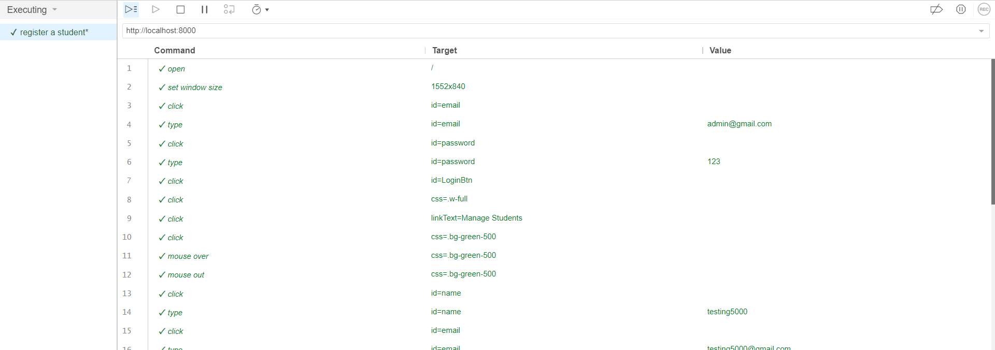

Figure selenium testing

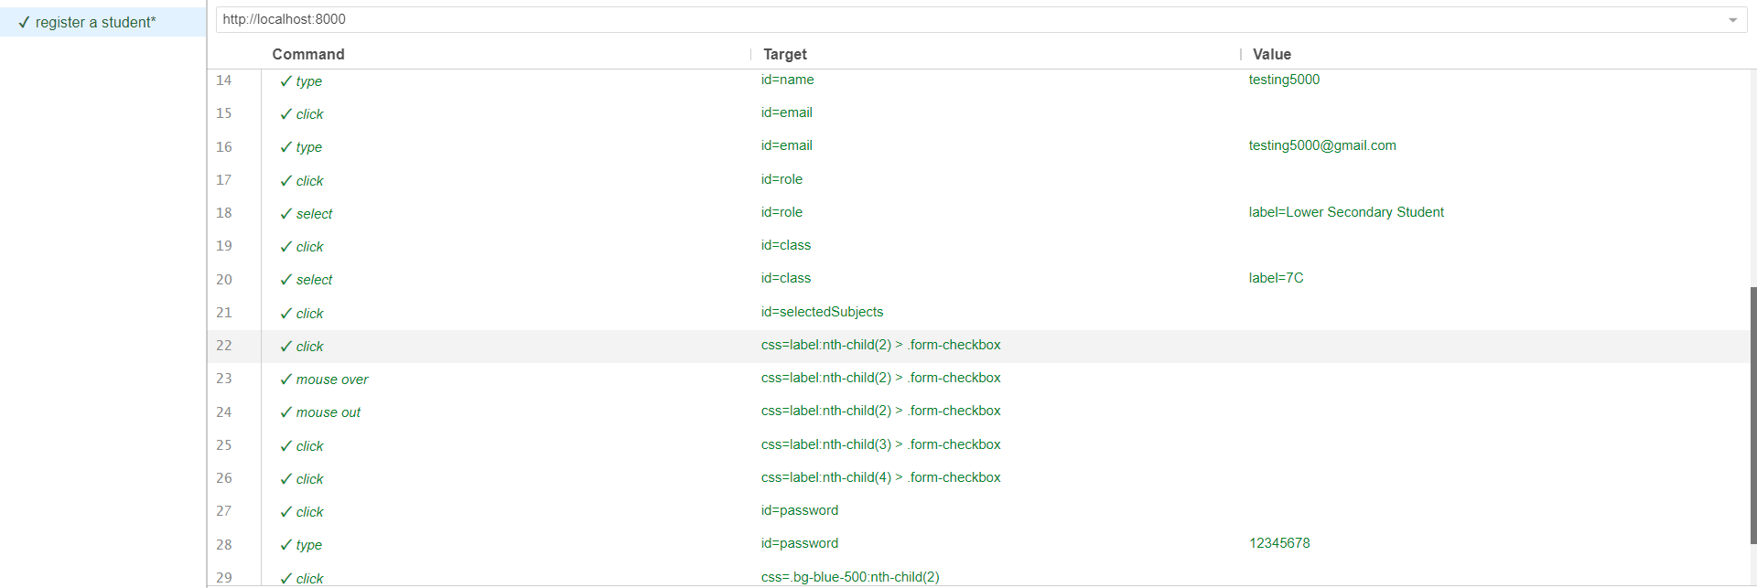

Figure selenium testing

### Register teacher

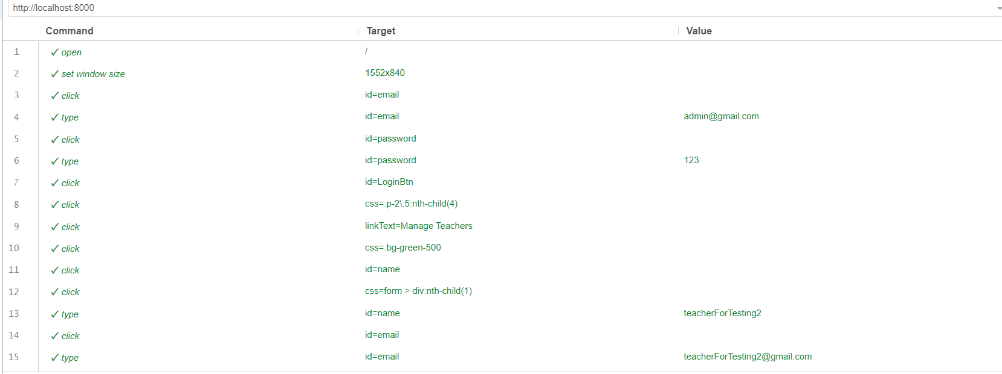

Figure selenium testing



Figure selenium testing

### Register admin

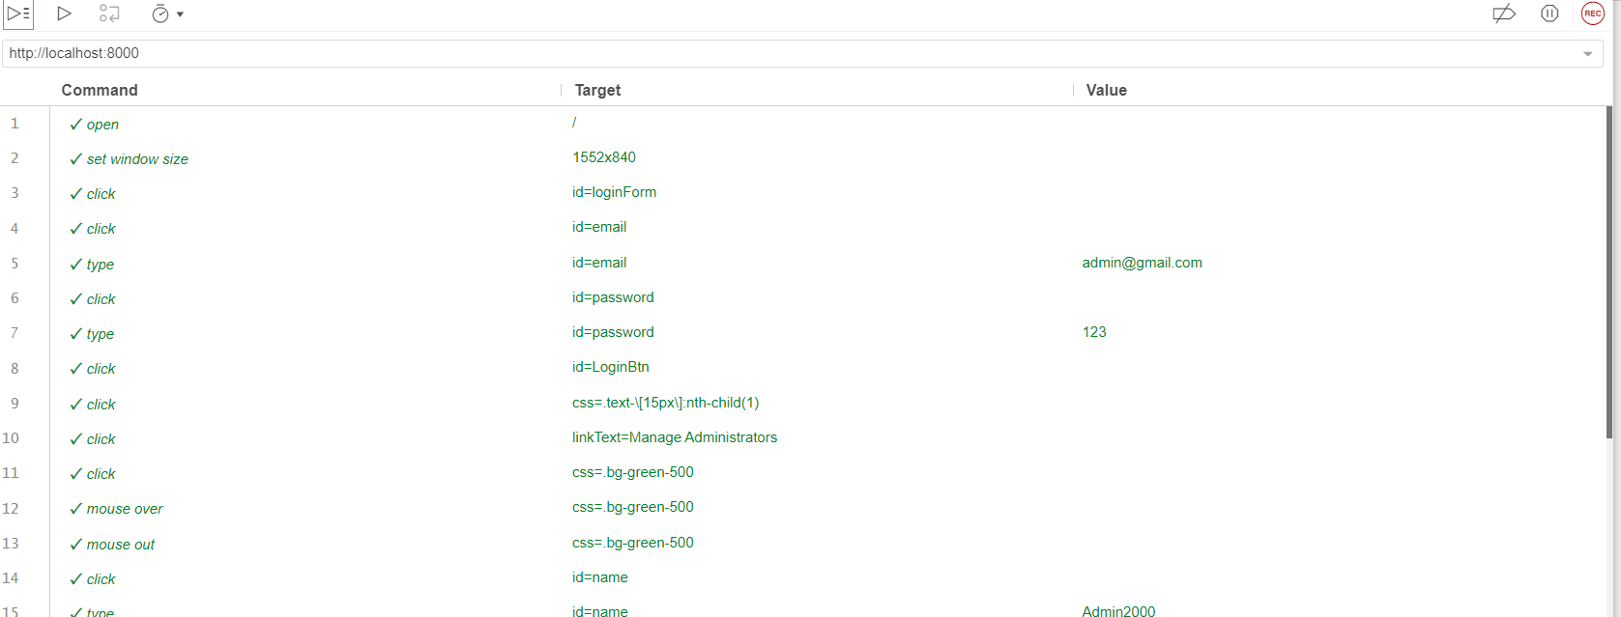

Figure selenium testing

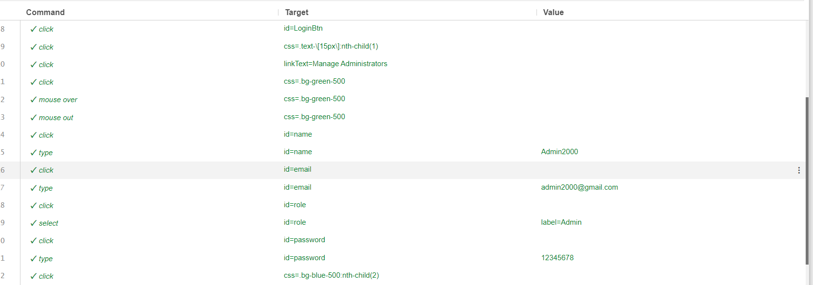

Figure selenium testing

### Create event

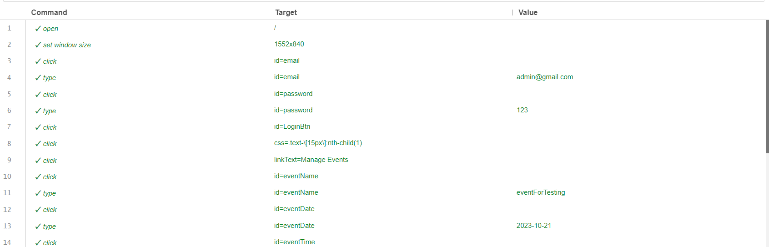

Figure selenium testing

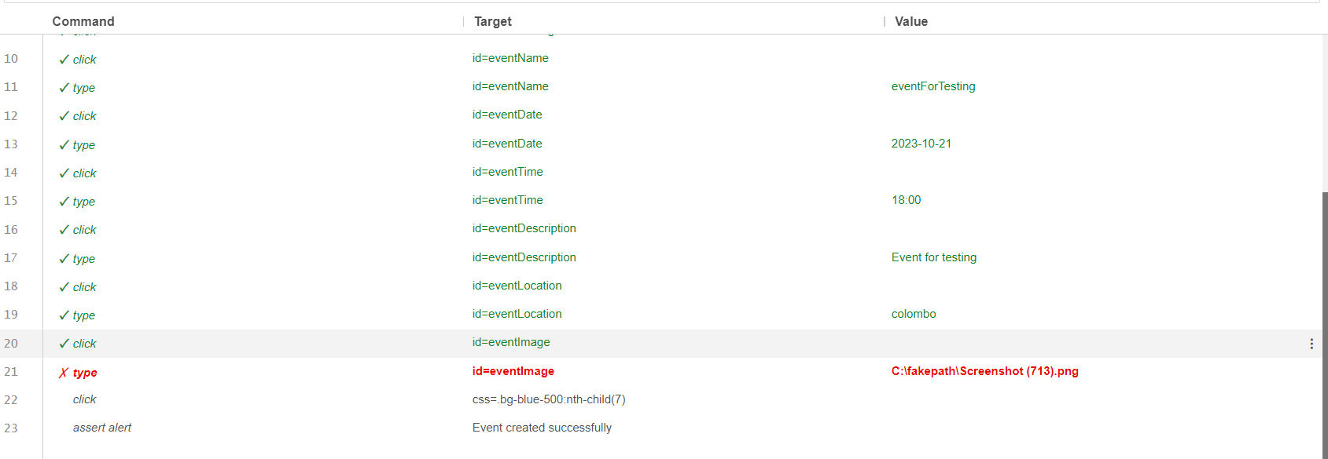

Figure selenium testing

### Edit student

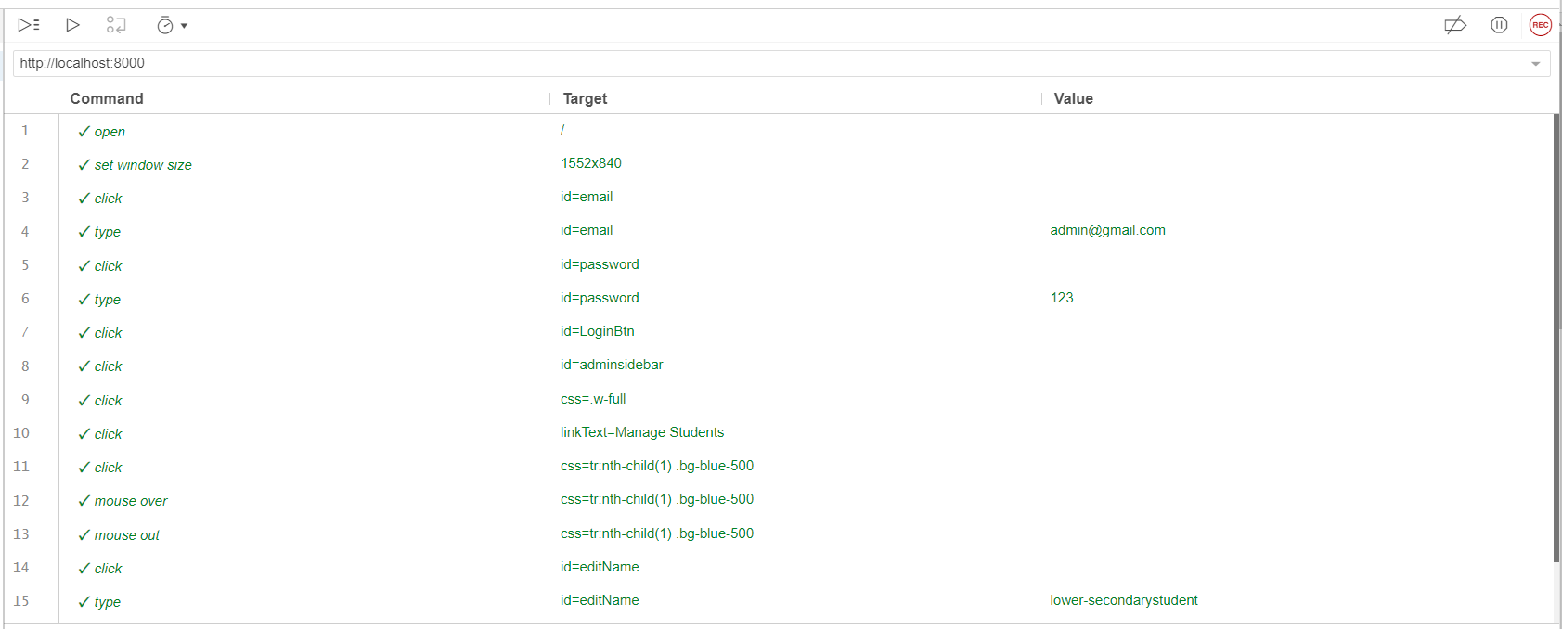

Figure selenium testing

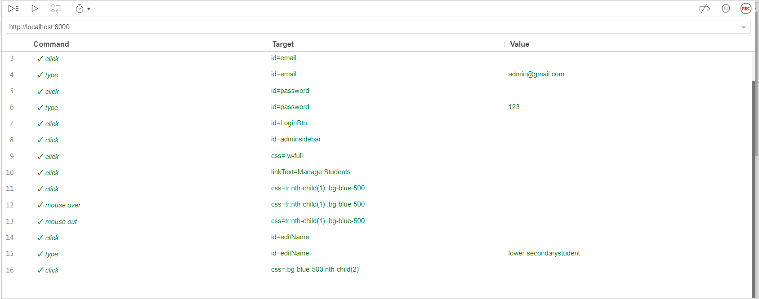

Figure selenium testing

### Edit teacher

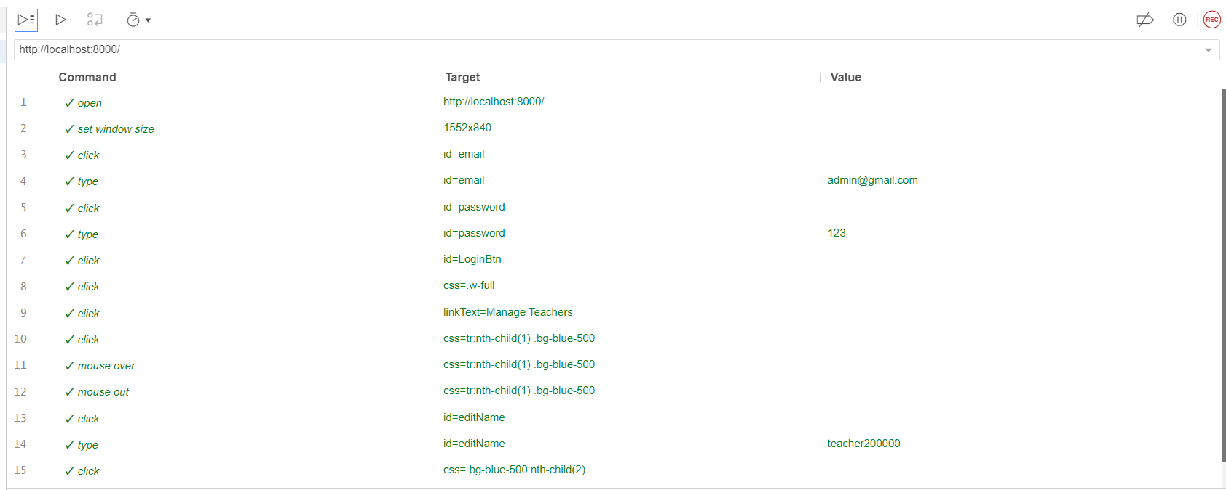

Figure selenium testing

### Edit administrator

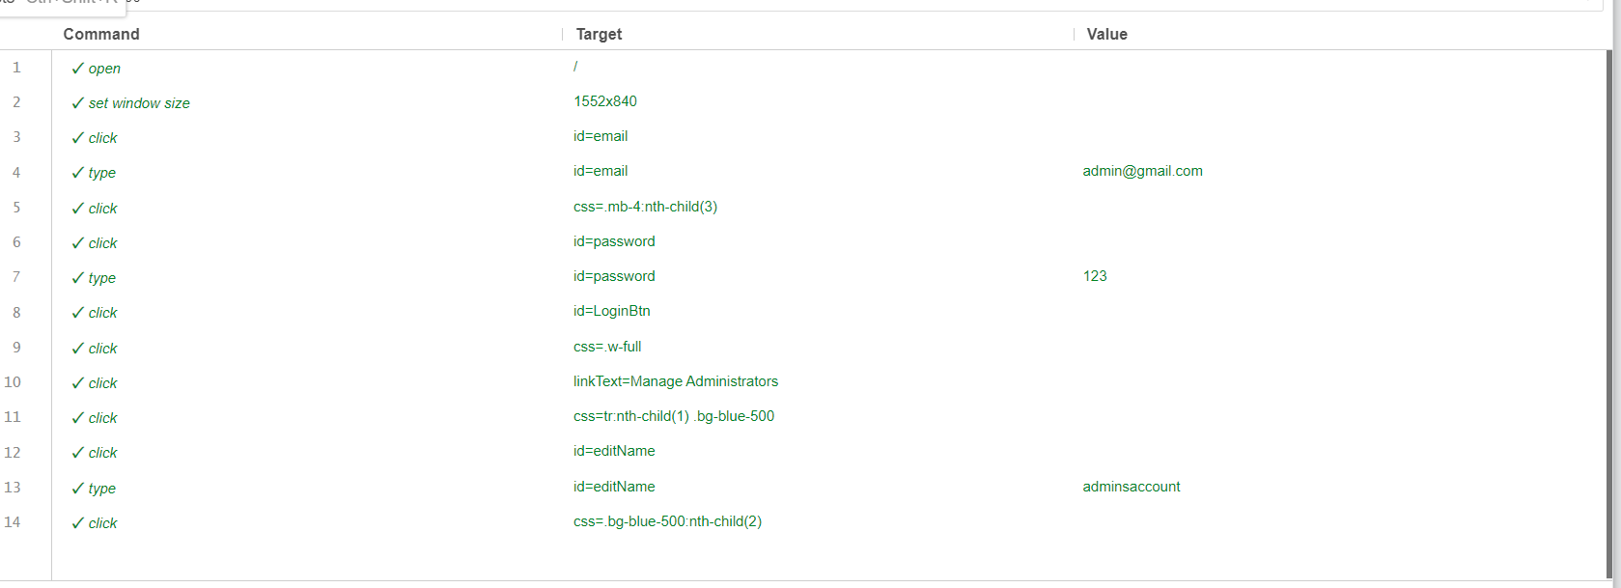

Figure selenium testing

### Add a submission

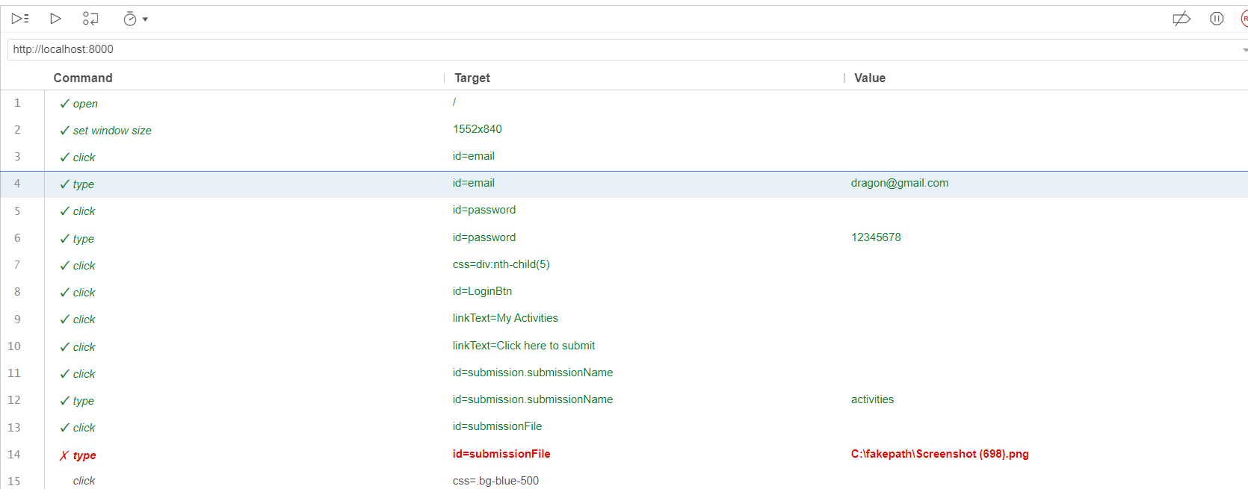

Figure selenium testing

### Add grades and feedback

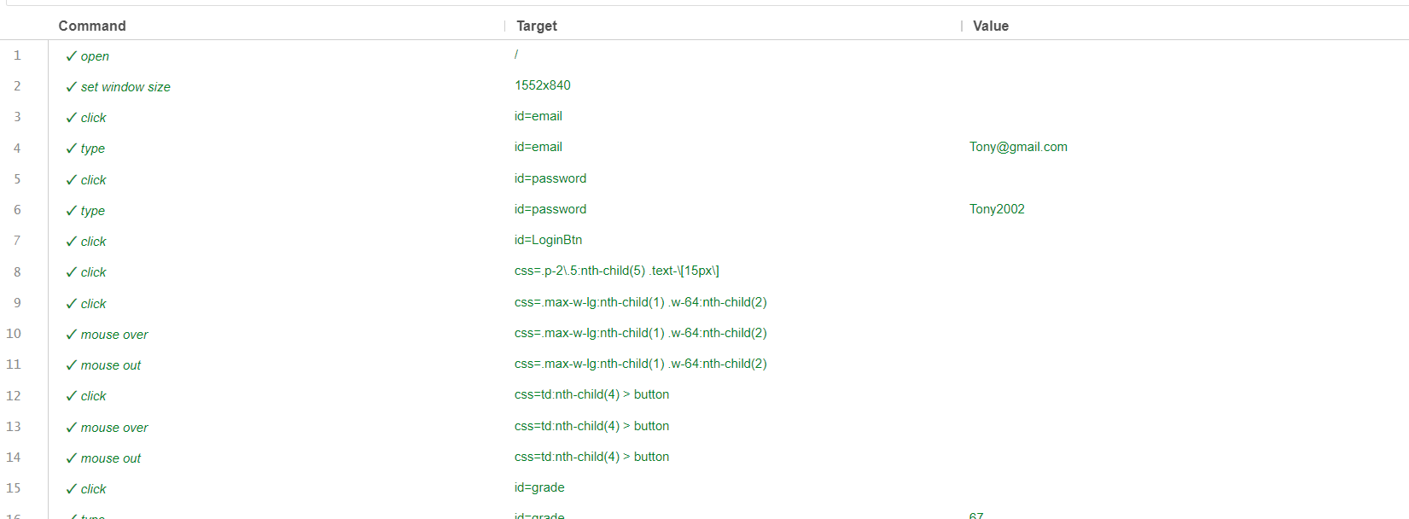

Figure selenium testing

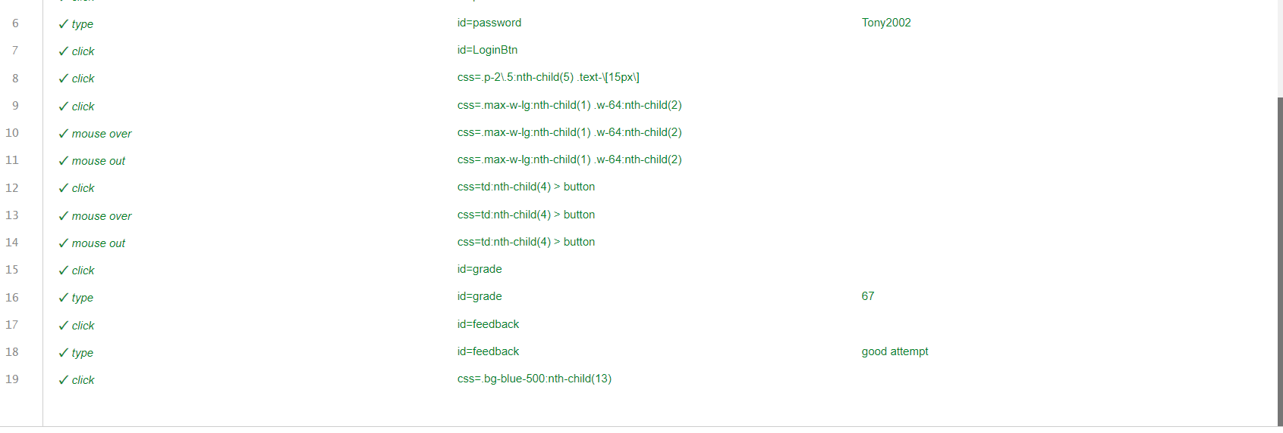

Figure selenium testing

### Attendance Marking

Figure selenium testing

Figure selenium testing

# Conclusion

We performed a thorough set of test cases to evaluate the Learning administration System (LMS), covering a variety of functionality such as user administration, student features, teacher functionalities, event management, and more. The system's capacity to manage student and teacher interactions, conduct event management activities, add, update, and delete users, and ensure smooth data flow and user experience were all tested.

Throughout the testing phase, the system demonstrated reliable operation and performance. The user management module worked well for adding, updating, and removing student and teacher accounts, making sure that only those with the proper permissions could access the system. The student features, including checking schedules, accessing class materials, uploading assignments, and viewing uploaded assignments, operated without a hitch. Activities could be easily added by teachers, edited, and student submissions could be easily viewed. Administrators could effectively create, alter, and delete events thanks to event management features.

In conclusion, the Learning Management System's functions proven to be solid, approachable, and trustworthy. The system is ready for deployment because it successfully completed all test cases and meets the requirements outlined in the initial design. To maintain ongoing optimal performance as the user base and data volume grow over time, it is advised to carry out routine maintenance checks and updates.

References

*Average Business Analyst, it salary in Sri Lanka* (no date) *PayScale*. Available at: [https://www.payscale.com/research/LK/Job=Business_Analyst%2C_IT/Salary](https://www.payscale.com/research/LK/Job%3DBusiness_Analyst%2C_IT/Salary) (Accessed: 05

August 2023).

*Average quality assurance (QA) / Quality Control (QC) inspector salary in Sri Lanka* (no date) *PayScale*.

Available at: [https://www.payscale.com/research/LK/Job=Quality_Assurance_(QA)_%2F_Quality_Control_(Q](https://www.payscale.com/research/LK/Job%3DQuality_Assurance_(QA)_%2F_Quality_Control_(QC)_Inspector/Salary) [C)_Inspector/Salary](https://www.payscale.com/research/LK/Job%3DQuality_Assurance_(QA)_%2F_Quality_Control_(QC)_Inspector/Salary) (Accessed: 05 August 2023).

*Average software engineer salary in Sri Lanka* (no date) *PayScale*. Available at: [https://www.payscale.com/research/LK/Job=Software_Engineer/Salary](https://www.payscale.com/research/LK/Job%3DSoftware_Engineer/Salary) (Accessed: 05 August 2023).

*Hourly rate for certification: Certified scrummaster (CSM)* (no date) *PayScale*. Available at: [https://www.payscale.com/research/LK/Certification=Certified_ScrumMaster_(CSM)/Hourly_Rate](https://www.payscale.com/research/LK/Certification%3DCertified_ScrumMaster_(CSM)/Hourly_Rate) (Accessed: 05 August 2023).